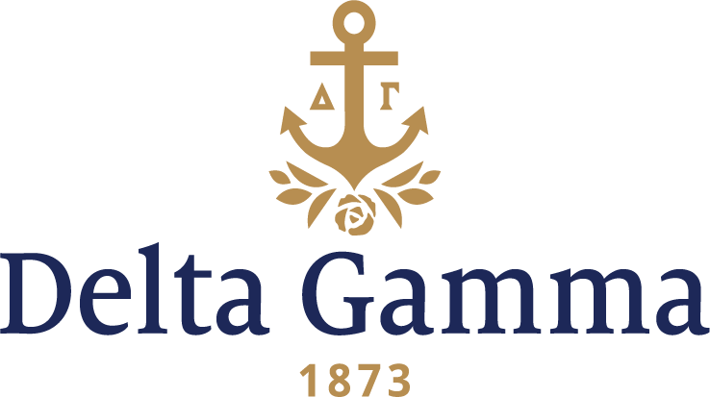

Automatic Probation Notification (APN)

Name:
Date:
Chapter:

It is the membership responsibility of every Delta Gamma to meet her financial obligations, achieve scholastic potential, comply with housing policies, and attend anchored events/meetings as noted on the Master Calendar. It has been noted that you have violated the following bylaw/standing rule:

Financial: Chapter debt outstanding for 10 days or longer
Failure to sign the Dues and Fees Contract by the due date
Failure to pay fines by due date

Scholastic: Failure to meet scholastic good standing per chapter bylaws and standing rules
Failure to submit grades by due date

Housing: Failure to meet live-in requirements
Failure to meet terms of Room Agreement
Failure to sign Room Agreement

Attendance: Two unexcused absences from meetings and anchored events
Two unexcused officer/director/Honor Board member absences from team or board meetings

Note: If more than one violation has occurred, a Statement of Obligation (SOR) is required.

In accordance with the chapter’s bylaws and standing rules, you are hereby placed on probation until and are considered in poor standing with the Fraternity and chapter. Failure to complete sanction terms will result in an SOR being filed.

Terms of probation include:
- Financial: Failure to pay chapter debt/fine probation duration is until outstanding debt/fine is paid; or failure to sign Dues and Fees Contract by the due date probation duration is until Dues and Fees Contract is signed.
- Scholastic: Failure to meet scholastic good standing probation duration is through the end of the academic term or until a mid-term grade review is completed; or failure to submit grades by due date probation duration is until a grade report is submitted.
- Housing and Attendance: Duration of a minimum thirty (30) days coinciding with the Master Calendar or until sanctions terms are completed, whichever is longer
- Forfeiture of your elected or appointed office.
- Forfeiture of your vote in chapter meetings with exception of vote to initiate.
- Loss of social privileges with the exception of anchored (mandatory) events.
- Must attend all anchored events
- Additional sanctions per chapter bylaws and standing rules:

Should you wish to appeal this automatic probation, you must send a letter of appeal to the vp: social standards and the Regional Collegiate Specialist (RCS)/Council Appointed Coordinator (CAC)/New Chapter Coordinator (NCC) within three (3) days of receipt of Automatic Probation Notification. Only the RCS/CAC/NCC may approve or decline an appeal to automatic probation. The terms of your probation will be in effect during any such appeal.

Sincerely,

Name:
Position:
cc: vice president: social standards, Honor Board Adviser

