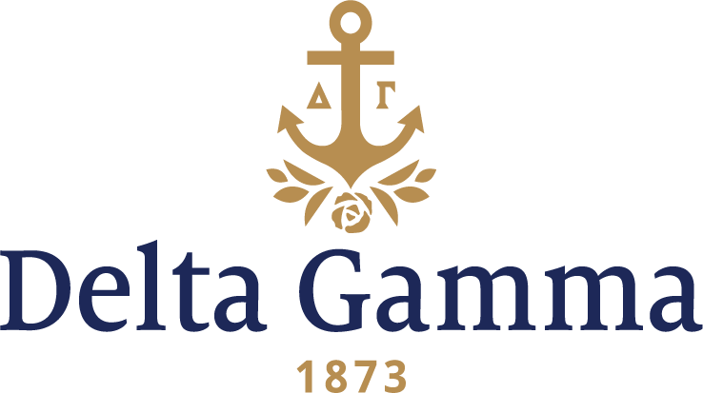

**Alpha-Mount Union**

**Fast Facts:**

* Installation date: June 16, 1882
* Closure date: December 1, 1908
* Location: Alliance, Ohio
* Region: 4

**History:**

In October of 1846, Orville Nelson Hartshorn outlined the need for a new institution in the area, where men and women could be educated with equal opportunity, where science would parallel the humanities, where laboratory and experimental subjects would receive proper emphasis, and where there would be no distinction due to race, color, sex or position. On October 20, 1846, this man organized and taught on the third floor of the Old Carding Mill in Alliance, Ohio to a “select school” of six students. The school grew rapidly under his inspired leadership and in 1849 became known as Mount Union Seminary.

In 1853 a “normal department” was added for the training of teachers. On January 9, 1858, the institution was chartered and incorporated under the laws of the State of Ohio as Mount Union College.

In September 1911, Scio University, located in Scio, Ohio, was united with Mount Union. By the articles of consolidation, the liberal arts alumni of Scio were made alumni of Mount Union. On August 1, 2010, the institution officially became known as the University of Mount Union.

Alpha chapter was installed at Mount Union College on June 16, 1882. Ida Leeper, Zoe Shimp, Lizzie Springer, Jennie Staub and Dora Zimmerman were the charter members. Alpha chapter joined the Alpha Tau Omega fraternity as the only Greek organizations on Mount Union’s campus.

By November of the next year, Alpha chapter was able to recruit seven more women, bringing the total membership to 12 women. The Alpha chapter occupied the hall of the Delta Tau Delta Fraternity.

In 1885, the number of collegiate members had decreased to six women. These dedicated and enthusiastic women held meetings every Monday night in the Sigma Alpha Epsilon Hall (formerly the Delta Tau Delta Hall).

The chapter thrived in the 1890s. As described by Stella Douglass Jose, Alpha-Mount Union, “There was no need rushing at the beginning of the year before we knew ‘who’s who’. Girls were under observation for most of the year, scholarship and activities were observed, and to be chosen at the end of freshman year was a high honor. We had no pledge pins in those days, and the announcement to the college world was a tiny knot of bronze, pink, and blue ribbon.”

Alpha chapter remained open until 1908 and had a fine record of achievements and a chapter roll of distinguished members. The number of women enrolled at Mount Union College was not adequate to maintain a chapter of Delta Gamma and it was deemed the wisest course to return Alpha’s charter to the Fraternity. Desiring above all else to remain affiliated with an organization, several collegians and alumnae affiliated with the other sorority on campus, Delta Delta Delta.