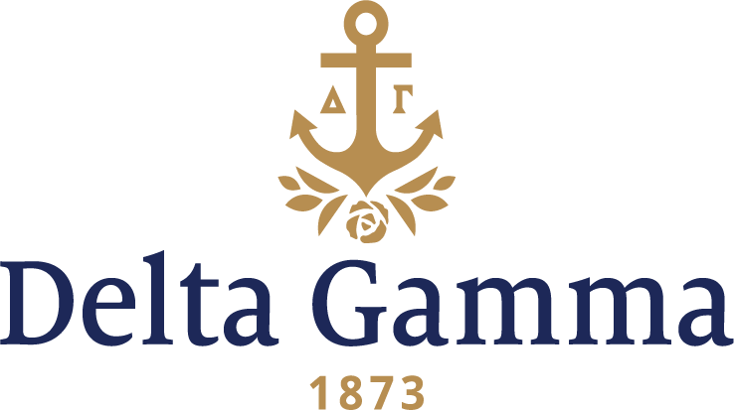

**Alpha Delta-Oregon**

**Fast Facts:**

* Installation date: October 17, 1913
* Location: Eugene, OR
* Region: 7

**History:**

Despite financial hardship, the Oregon State Legislature established the University of Oregon on October 12, 1872. Residents of Eugene struggled to help finance the institution, but they were committed. They held numerous fundraising events including strawberry festivals, church socials, and produce sales. They raised $27,500, enough to buy eighteen acres of land at a cost of $2,500 per acre. The university officially opened in 1876.

Alpha Delta chapter began as the XYZ Club in 1908 and was renamed Lambda Rho in 1909. On November 7, 1910, M. Agnes Burton, Delta Gamma’s Secretary, received a letter from Lambda Rho president, Alice Stoddard, to begin the process of affiliation with Delta Gamma. Delta Gamma was selected because it was considered by the group to be one of the three best national sororities. The women also knew another group on campus had petitioned Delta Gamma and failed, and the members felt Delta Gamma would be worth more to them than a national sorority that would be easily obtained.

Following an April 1911 visit from Agnes Burton and Ethel Turkey, *ANCHORA* editor, Lilah Clark, Lambda Rho wrote a letter to Delta Gamma stating that they were taking the advice of the Fraternity and would defer the petitioning until the next fall after recruitment. George Banta expressed his support of expansion into the University of Oregon in a letter he wrote to Fraternity President, Imogene Hand Carpenter, Omega-Wisconsin.

On October 17, 1913, as a result of a favorable report at Convention in June, Alpha Delta chapter was installed with 27 members. Delta Gamma was the 7th national sorority on campus.

Alpha Delta had many traditions early on that allowed their sisterhood to thrive. For example, in 1917, the freshmen rang the house bells repeatedly until all girls awakened, then they had a “feed” of cake in front of the fireplace. In 1925, it was customary for the pledges to awaken all their sleeping sisters and serenade them. Food in the form of pastry awaited them in front of a roaring fire. By the 1950’s the “feeds” became “firesides” at a more reasonable hour.

The women enjoyed being social, either together or with other groups on campus. In 1916, each sorority was allowed to have one dance per semester, with no more informal house dances. In 1938 the chapter was noted for giving “the best dances on campus.” They turned their house into many themes from a hotel to a ship to a gambling den and many more. These must have been open to the entire Greek system or university, as they always had the most “guests from other houses.” The women also enjoyed annual hiking outings along the banks of the Willamette River. A January 1952 quote from the *ANCHORA* stated, “friendship is a very vital force in the life of Alpha Delta chapter they have seven exchange dinners with fraternities each term…gives us an added opportunity to make people conscious of Hannah’s friendliness.”

Alpha Delta had a difficult beginning as contagious diseases were a real problem during the chapter’s early days. In the late 1910s the chapter was quarantined for a Mumps epidemic. During Thanksgiving 1927, no one could return home for the holiday as the house was quarantined due to an infantile paralysis (Polio) epidemic at the university.

Scholarship was an early priority of this chapter. The class of 1914 presented to the freshman class a silver cup to be awarded each year to the freshman earning the highest grades.

Alpha Delta joined with the Red Cross during both World Wars I and II to help roll bandages and raise money to purchase war bonds.

In 1917, Delta Gamma was the largest of eight national sororities on the UO campus with 35 members. In the 1920s and 1930s they had a lot of members involved in music and theater on campus. Many went on to professional careers.

In 1925, the idea of buying property lot was proposed. In February 1928, construction on the chapter house began at 1584 Alder Street, and the mortgage was paid off by 1944.

In 1938, each chapter was asked to compose new Delta Gamma songs and bring them to Convention. Alpha Delta believed that “rushees are unconsciously influenced by group singing and often later admit that they caught the spirit of the chapter in the enthusiastic, spontaneous music during Rush Week.” This was something they endorsed and participated in whole-heartedly. Alpha Delta is the chapter most closely connected with the origin of the song, “Hannah.” Although the specific facts are conflicting, the words to “Well, Well, Well Hannah” definitely originated at the University of Oregon, and it may have been sung for the first time at this 1938 Convention.

In 1952 the chapter wrote, “bordering one edge of the campus is the historic Millrace...canoeing on the ‘Race’ is a time-honored custom…” They would honor their pledges with a surprise house picnic where underclassmen challenged juniors and seniors to a game of football or baseball. Afterwards they gathered around a fire to roast hot dogs and marshmallows and sing. Other traditions in the 1950s included always having a plump and jolly Santa Claus presiding and distributing nonsensical gifts that were accompanied by appropriate poems. The women would have a fun night every Wednesday night where they dressed up and had cocoa and cookies in their pajamas around the fireplace. Another time-honored tradition was Turnabout Day, when underclassmen tasted the delights of being an upperclassman for 24 hours.

In the 1960s, a tradition was an annual Kidnap Breakfast. The junior class always put on Mothers Weekend and held Dads Weekend in the fall. The women also started sponsoring an exchange student who lived in the house for a year in the late ‘60s and ‘70s. She did not initiate, but was a guest of the collegians.

The Lambda Rho women bought a house in April 1909. The women moved into the new house in the fall of 1910. Until 1921 it had the special distinction as being the only women’s house on campus with two indoor bathrooms.