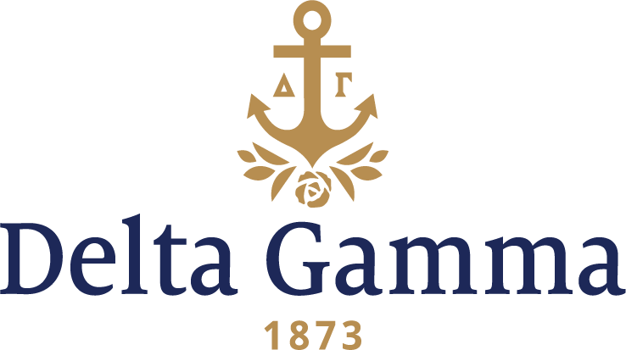

**Alpha Epsilon-Washington University**

**Fast Facts:**

* Installation date: April 27, 1914
* Closure date: May 1, 1973
* Re-installation date: May 5, 1990
* Location: St. Louis, MO
* Region: 5

**History:**

Washington University was conceived by 17 St. Louis business, political and religious leaders concerned by the lack of institutions of higher learning in the Midwest. Missouri State Senator Wayman Crow and Unitarian minister William Greenleaf Eliot, grandfather of the poet T.S. Eliot, led the effort. The university's first chancellor was Joseph Gibson Hoyt. Crow secured the university charter from the Missouri General Assembly in 1853, and Eliot was named president of the Board of Trustees. Early on, Eliot solicited support from members of the local business community, including John O'Fallon, but Eliot failed to secure a permanent endowment. Washington University is unusual among major American universities in not having had a prior financial endowment. The institution had no backing of a religious organization, single wealthy patron or earmarked government support.

During the three years following its inception, the university bore three different names. The board first approved "Eliot Seminary," but William Eliot was uncomfortable with naming a university after himself and objected to the establishment of a seminary, which would implicitly be charged with teaching a religious faith. He favored a nonsectarian university. In 1854, the Board of Trustees changed the name to "Washington Institute" in honor of George Washington. Naming the University after the nation's first president, only seven years before the American Civil War and during a time of bitter national division, was no coincidence. During this time of conflict, Americans universally admired George Washington as the father of the United States and a symbol of national unity. The Board of Trustees believed that the university should be a force of unity in a strongly-divided Missouri. In 1856, the university amended its name to "Washington University." The university amended its name once more in 1976, when the Board of Trustees voted to add the suffix "in St. Louis" to distinguish the university from the nearly two dozen other universities bearing Washington's name. Classes began on October 22, 1854, at the Benton School building.

In 1907, The Shrine of the Mystic Seven was started by a group of women led by Rosalie and Marie Watkins and Helen Pritchard. By 1909, the group changed their name to Kleo because they had more than seven members. In September 1910, after other groups went “national,” and at the recommendation of Helen’s brother, Johnny (Phi Delta Theta), the women first approached Delta Gamma.

On February 22, 1911 Kleo invited the Delta Gamma Council for tea with the Kappa Alpha Theta and Pi Beta Phi chapters, although Delta Gamma declined. On April 23, 1914, Ada May Brown, Omega-Wisconsin, Fraternity President, called Kleo to grant the group their Delta Gamma charter. Initiation and Installation were held on April 27, 1914, by members of Council, Mu-Missouri and Iota-Illinois chapters. The charter members were: Charlotte Lomax, Hortense Bowles Donnan, Hazel Forsythe, Claudia Lide, Lucy Newton Tiller, Elizabeth Nixon Hamm, Ruth Pickel, Ruth Pritchard Howells, Nellie Rogers, Julia Sisson Spiers, Ida Updike Neuhoff, Grace Bissland Watson, Sibyl Tate, Mary Voohers Williams, Alice Ernst, Dorothy Kremer Heidemann, Mary Lee Pickel, Melba Ryan and Marie Updike White. Lucy Newton became the first chapter president.

A member, Loreen Knobeloch, was initiated in November 1918 and died eleven days later of influenza. Her fiancée donated her jeweled pin to be given at each Founders Day to the freshman with highest grades.

By the 1920s, most sororities had rooms in McMillan Dormitory. Delta Gamma finally moved into the Women’s Building on the 3rd floor on November 15, 1928.

Josephine Brown was the first woman to receive the Ideal Delta Gamma Cup in 1925.

In 1973, Delta Gamma left Washington University due to the decline of the Greek community, thus the charter was held in abeyance. In March 1973, the chapter’s request was honored when Council suspended the charter.

By the early 1980s, Washington University and the Women’s Panhellenic began communication about strengthening and expanding the Greek system on campus. In March 1982, Delta Gamma declined Washington University’s offer due to a busy expansion schedule. Delta Gamma was approached again by the university and the Panhellenic officers in January 1984. Again, Delta Gamma declined the offer. Finally, in October 1985, Delta Gamma approached Washington University about possibly reestablishing on campus. They set up a visit for February 5, 1986. On April 8, 1986, the university chose another group for establishment over Delta Gamma.

In June 1989, Delta Gamma was invited to establish at Washington University in early 1990. Thus, re-establishment began at Washington University, and a total of 88 women were chosen to become members. The Initiation and Installation ceremony was held on May 5, 1990. Upon re-establishment, Delta Gamma became the 7th NPC group on campus.