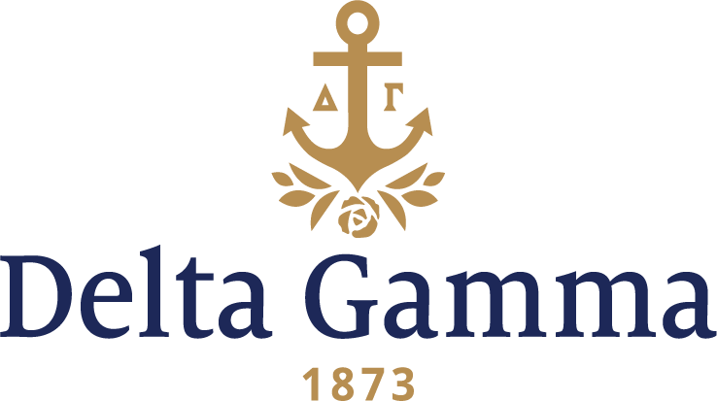

**Alpha Eta-Whitman**

**Fast Facts:**

* Installation date: September 30, 1916
* Location: Walla Walla, WA
* Region: 7

**History:**

Initially founded as a seminary by a territorial legislative charter in 1859, the school became a four-year degree-granting institution in 1883. Whitman was the first college in the Pacific Northwest to install a Phi Beta Kappa chapter, and the first school in the United States to require comprehensive exams for graduation.

The origin of Alpha Eta started in 1903. At that time, six girls formed an association they called Girls’ Ministerial Association of Whitman College or Gamma Kappa, the first sorority on campus. The object of this association was to inquire into the love affairs of all girls in the hall, but later this motto was changed to "to promote good fellowship among its members." This group existed without the official recognition of the faculty until 1911. At that time a committee of overseers decided to put fraternities on a two-year probation to prove their worth to the college. Gamma Kappa was the first secret organization to receive its charter. When approval was granted this committee encouraged the locals to petition national organizations.

Members applied for Delta Gamma with the help of Professor Ruby, who was on the faculty and a Phi Delta Theta. With the assistance of Delta Gamma member George Banta Sr. and the Delta Gammas in town from Sigma-Northwestern, Beta-Washington, Pi-Montana and Nu-Idaho, the group decided to petition Delta Gamma Fraternity for a charter. In November 1914, Louise Williams and Theo Child Colburn, both Beta-Washington; Dorothy Taylor, Nu-Idaho; and Helen Wiegard and Helen Werline, both Alpha Delta-Oregon; visited and inspected Gamma Kappa. In August 1915 the Fraternity Convention was held in Berkeley, California, and Gamma Kappa sent Marguerite Hunt as a representative. She brought back word from Mrs. Homer Tilley, a Walla Walla alumnus, that the general sentiment of the Convention was in favor of installing a chapter at Whitman. On September 30, 1916, Alpha Eta was installed with twenty-five charter members. Pearl McDonell, Beta-Washington, the Province Secretary, installed the chapter at the home of Dr. Louie Anderson. After the chapter Installation, the Phi Delts formed a torch-lit aisle through which the new initiates passed. Later that year Jessie McGilvray Treat, Upsilon-Stanford, Fraternity President, visited the chapter.

The Walla Walla alumnae have supported the chapter throughout the years. Early on the alumnae created awards for scholarship by enticing the members to read from a list of selected books. Each member was judged by two or three faculty members on the knowledge they retained of the books read. A $50 prize was awarded to the winner.

Alpha Eta generously contributed to the Belgian Relief Work in 1917 by each member contributing ten cents a week. They also held a doll sale and raised $173.85 which they donated to the American Red Cross. In 1920 they supported the League Fraternelle des Enfants de France, and also purchased war bonds.

On November 18, 1922, Fraternity President Nancy Brown Wollett visited the chapter. Shortly thereafter a national Scholarship Fund was started and the chapter was reminded of their enthusiasm during the war and asked to support it. Member Zelma Conway advanced the idea of saving Sperry & Hutchinson green stamps for it which was well received.

In March 1929 a Province convention was held in Walla Walla for the first time at the Grand Hotel. That fall, a quota system was adopted when Alpha Eta swept Rush with 29 pledges and the only other sorority took three pledges.

The highlight of the 1930s, during the Great Depression, was receiving first place in the “All College Revue,” a skit presentation. The 1940s brought back the competitive spirit of Alpha Eta when they won the All-Sports trophy, the Scholarship Cup as well as the “All College Revue.” They also had many Queens: 1948 and 1949 the chapter had May Queens; and in ’49 they had the Homecoming Queen and Varsity Ball Queen. This trend continued into the 1950s with members selected not only as queens, but seen as leaders on campus, with high scholarship and event participation.

An additional responsibility of the chapter was the adoption of Birdie, a war orphan. In 1952 they adopted a second orphan, in addition to preparing Christmas dinner and buying presents for a needy family. They also held a major event, of a Table-Setting show, to raise money for people who were blind.

During Homecoming Weekend, October 14 to 16, 1966, Alpha Eta held its 50th anniversary celebration. Fraternity President Elizabeth Coffinberry Kloppenburg, Gamma-UC Berkeley was the honored guest. Friday included an evening “welcome get-together” at the Marcus Whitman Hotel. On Saturday, there were many campus events with an informal tea in the chapter room after the football game. That night was a beautiful banquet at the Masonic Temple with lots of singing of Delta Gamma songs.

For several consecutive years in the 1980s the chapter won the intramural touch football contest. Many traditions did not last, however Pledge Pork-Out, the Choral Contest, Founders Day Brunch, the Intramural Football Contest, Senior Week and Greek Week were eagerly looked forward to annually. Alpha Eta aided the students who were blind by reading their studies to them. In 1989 the chapter also helped defray the costs of surgery for 8-month-old Michael, who was blind.

Alpha Eta held its first Anchor Splash® in the spring of 1990 the second in the fall of 1990, and it is now an annual fall project. Several members were involved in varsity sports - soccer, skiing, basketball, swimming. Chapter members also help the local alumnae vision screen. The highlights of the ‘90s were Alpha Eta celebrating their 75th anniversary in 1991 and the renovation of Prentiss Hall. The dormitory was closed for the entire school year and reopened in the fall 1992 as a beautifully renovated building.

Alpha Eta chapter of Delta Gamma Fraternity celebrated its centennial year in 2016 as the Fraternity’s 24th oldest chapter out of 146 collegiate chapters at the time.

The first chapter room was obtained in 1920. It was a room above a small store two blocks from campus. The chapter began petitioning the administration for sorority houses on campus to no avail. In 1921 they found another chapter room after a fire damaged the store. This was a rented two-room building. Still the administration denied on-campus sorority houses.

In 1924 the chapter took out an insurance policy as part of a permanent fund towards a chapter house. However, in April 1926, Dr. S.B. Penrose, president of Whitman, asked whether they wanted to rent a section in the new dormitory. This they did for $125 per year. In 1927 after Prentiss Hall was built, the chapter was given the right wing of the building with a chapter room and kitchenette below the living quarters. The alumnae supervised the quarters and made sure that all was in order. However, as an increased number of women moved into the dormitory it became filled to its capacity and many members were obliged to move into annexes.