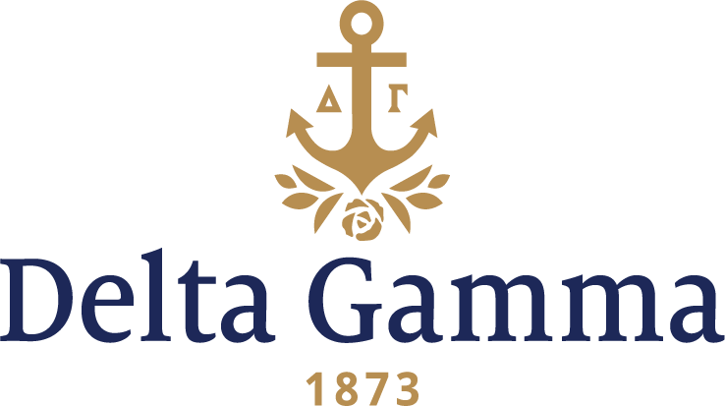

**Alpha Omega-Arkansas**

**Fast Facts:**

* Installation date: October 11, 1930
* Close date: September 23, 1992
* Re-installation date: February 18, 2017
* Location: Fayetteville, Arkansas
* Region: NCR

**History:**

The University of Arkansas was founded in 1871. By 1925 there were six national sororities and one local group on campus and fraternity women numbered at 290. Chi Omega’s first chapter was founded at the university in 1895, and in 1925 a local sorority, Delta Beta, was founded by Gertrude Gifford Campbell, a Delta Gamma initiate of Sigma-Northwestern, and Dean Martha Reid, with the desire to become a Delta Gamma chapter. In 1929 and 1930 this local group bought bonds for the building of the first sorority house on the Arkansas campus.

All their efforts were realized on October 11, 1930, when Alpha Omega-Arkansas was installed as the seventh sorority at the university.

Because of the geographical setting in Fayetteville, the chapter was the nearest to Delta Gamma’s “home” chapter in Mississippi and our Founders were invited to attend. Eva Webb Dodd and Mary Comfort Leonard were delighted and made the trip to emphasize that the beginning of the Fraternity was in the neighboring state. To have them as honored guests was the most thrilling part of the Installation. Fraternity President Mary McHarg Halstead, Sigma-Northwestern; First Vice-President Florence Cornell Bingham, Chi-Cornell; and former Treasurer Alice Perry Gradle, Xi-Michigan; and five collegiate members of Alpha Iota-Oklahoma arrived to conduct Initiation and install the chapter. At the banquet toasts were given by both Mrs. Leonard and Mrs. Dodd and everyone beamed with pride. What a beginning for Alpha Omega, Delta Gamma’s 45th chapter!

Some of the accomplishments of the chapter in its first 50 years on campus included: sponsoring ice cream socials as a fund-raiser for the Arkansas State School for the Blind, collecting eyeglasses for children in need of eye care, holding spaghetti suppers for Sight Conservation and Aid to the Blind, and sending Newsweek subscriptions to blind residents in the community.

The chapter won first prize in a local food drive and “Bounced for Books” to raise funds for the local library. All this led to receiving the coveted Community Service Award during Greek Week.

In 1983 Alpha Omega held its first Anchor Splash®.

The chapter also had a strong scholastic presence on campus. Many members were members of honorary organizations – Phi Beta Kappa, Phi Kappa Psi, Mortar Board and even a Fulbright Honors Scholar. The first woman to receive an athletic scholarship at the university was Kelly Ann Elliott, Alpha Omega, initiated in 1977.

In the 1990s the chapter was active in volunteering for the Battered Women’s Shelter and Pet Therapy. They won first place in both the sorority division of women’s intramurals and in Greek Week in 1991. They held a Mom’s Weekend for the first time this same year.

During the late 80s and early 90s many fraternities and sororities experienced a decline in numbers and several NPC groups were forced to close some of their most long standing and beloved chapters.

With great sadness, the decision was made to suspend Alpha Omega’s charter and the chapter closed on September 23, 1992. The Fraternity accepted the charter, hoping it would one day be returned.

In 2015 the university opened for extension. Delta Gamma was selected to present and in 2016 the Fraternity was selected to reestablish Alpha Omega.

The reestablishment of Alpha Omega chapter included events led by Morgan Brunelli, Alli Byrne, Jennifer Fisackerly and Emry Woelk, Collegiate Development Consultants assigned to support the chapter. “Infoviews” between potential members, Fraternity staff and volunteers, and a preference event with sisters from Alpha Iota-University of Oklahoma and Beta Kappa-University of Kansas chapters were held in the fall of 2016. The establishment events culminated in September of 2016 with the pledging of the founding members of Alpha Omega and a Bid Day celebration.

Since Bid Day, the chapter elected its first president, Grace Veneklasen, and participated in many on-campus events including winning third place in Carol of the Greeks and the NPHC Step Show.

Alpha Omega chapter and its 167 charter members join the sisterhood of over 230,000 living members with their February 18, 2017 Initiation and Installation. This day Alpha Omega celebrated becoming the 150th active chapter of Delta Gamma on college campuses.

Since their establishment, Alpha Omega has continued to maintain an active presence on the University of Arkansas campus by participating in other organization’s events and hosting Alpha Omega’s 10th annual Anchor Splash® raising almost $20,000 for Service for Sight and the Burlskids. The chapter is looking forward to getting more involved on campus, and ground breaking the lot for their future home at 625 West Maple Street.

On January 31, 2017, Alpha Omega welcomed 30 new members into Delta Gamma membership in their first spring Bid Day. Initiation for this first spring class was held on April 2, 2017.