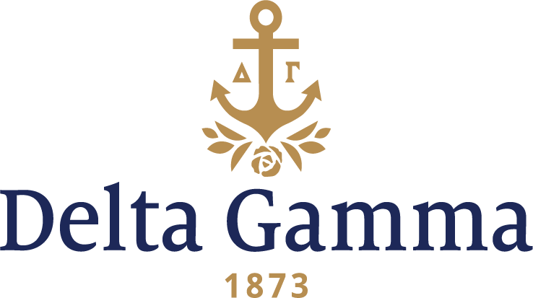

**Alpha Rho-Ohio Wesleyan**

**Fast Facts:**

* Installation date: May 10, 1924
* Location: Delaware, OH
* Region: 4

**History:**

In 1841, Ohio residents Adam Poe and Charles Elliott decided to establish a university "of the highest order" in central Ohio. To that end, they purchased the Mansion House Hotel, a former health resort with its Sulfur Spring, using funds raised from local residents. Poe and Elliott wrote a charter emphasizing "the democratic spirit of teaching,” which was approved by the Ohio State Legislature. Early in the following year they opened the college preparatory Academy and formed a Board of Trustees. Ohio Wesleyan University, named after John Wesley, founder of Methodism, opened on November 13, 1844, as a Methodist-related but nonsectarian institution, with a College of Liberal Arts for male students.

During the mid-19th century, Ohio Wesleyan focused on attracting students, adding fields of study, and fundraising, by which it significantly increased its endowment. Sturges Hall was constructed as the University's first library in 1855. In 1873, the school added the Department of Natural History housed in Merrick Hall. The Ohio Wesleyan Female College, established in 1853, merged with the university in 1877.

By 1922 the university had 100 faculty members, 900 male and 850 female students. Affiliated with the Methodist Church, it was a college of Liberal Arts, offering Bachelor of Arts and Science, as well as Associate Bachelor degrees. It was in good standing with Phi Beta Kappa, American Association of University Women and Carnegie Foundation, and recognized by the North Central Association of College & Secondary Schools. In 1884, national fraternities for women went out of existence at Ohio Wesleyan.

Phi Omega Phi, founded in 1903 as a local sorority, had been meeting secretly and waited for the university to honor the request of Ohio Wesleyan women to allow national sororities.

In 1922 several Delta Gamma alumnae from other chapters lived in Delaware. One was Mrs. J.C. Messick, Alpha-Mount Union. She began having “get-togethers” in her home with some Phi Omega Phi members, including OWU Assistant Dean of women, Wren Stanley.

On November 3, 1922, the National Panhellenic Congress of Women’s Fraternities were notified that the Board of Trustees had voted at their October meeting to allow both national and local sororities of a least 12 members to be established on campus. Thirteen local organizations were recognized.

On July 10, 1923, Phi Omega Phi petitioned Delta Gamma Fraternity to establish a chapter on the campus. Six other local groups petitioned National Panhellenic Congress.

On May 10, 1924, sixteen Phi Omega Phi collegiate members and several alumnae were initiated, and Alpha Rho chapter of Delta Gamma Fraternity was installed at Ohio Wesleyan University. Province II Secretary, Marguerite Williams, Epsilon-Ohio State, was instrumental in helping establish the chapter, and Fraternity President Nancy Brown Woollett, Phi-Colorado, and Vice-President, Alice Perry Gradle, Xi-Michigan, were present for the installation; with the assistance of Epsilon chapter, the charter members were initiated. Lucille Carroll was elected the first president of Alpha Rho and received the charter.

The first chapter room was rented from Delta Gamma Mildred Graff at 113 West Winter Street. Parents, alumnae, and collegians worked together to decorate the room.

By 1925, ten National Panhellenic sororities were on campus: Gamma Phi Beta, Alpha Chi Omega, Alpha Delta, Alpha Gamma Delta, Kappa Alpha Theta, Delta Delta Delta, Kappa Kappa Gamma, Pi Beta Phi, Chi Omega and Delta Gamma.

During the war years of the 1940s Alpha Rho contributed greatly to helping as they could with the war. Every month they bought a war bond and on Wednesday and Saturday afternoons the girls wrapped surgical dressings. They donated their savings to the Refugee Fund and helped open houses to entertain the V-5’s and V-12’s on campus.

On June 11, 1949, over 100 alumnae and collegians gathered at Magnetic Springs, Ohio to celebrate Alpha Rho’s 25th anniversary. The entire Council of Delta Gamma was in attendance.

On April 20, 1974, Alpha Rho celebrated its 50th anniversary. The Saturday luncheon attended by 200 returning Alpha Rho’s were treated to remarks by Marguerite Williams, the original Province II Secretary who helped establish Alpha Rho in 1924. The Order of the Delta Gamma Rose, the Fraternity’s highest award, was presented to featured speaker Phyllis Battelle VanHorn, Alpha Rho-1946.

Alpha Rho held its first Anchor Splash® in 1977.

In 1933 Alpha Rho moved into a house of their own at 133 West Winter Street. Mr. and Mrs. Thurman Smith were the house parents, and once more all groups worked together to make the house “charming.”

On May 25, 1950, a newly formed Alpha Rho house corporation purchased the lodge at 148 West Winter Street from Dorothy Crates Long. Built in 1901, according to County auditor records, remodeled in 1905 when it became a Presbyterian Manse, and owned by John McCullough, the tract of land was divided and a strip of land of eight feet wide was designated as a right-of-way to be used as a driveway for the two properties. Mrs. Long had purchased the property in July 1942.