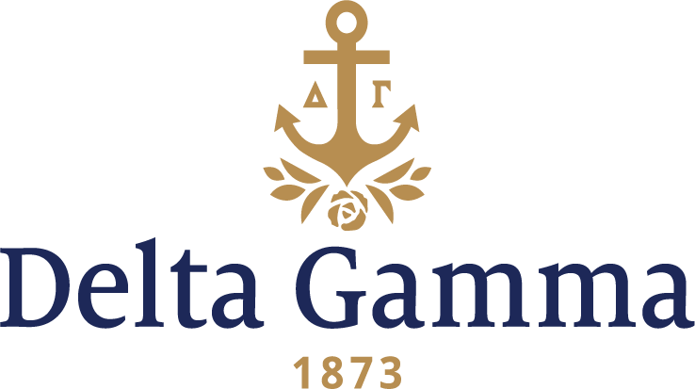

**Alpha Theta-North Dakota**

**Fast Facts:**

* Installation date: December 16, 1916
* Location: Grand Forks, ND
* Region: 5

**History:**

The University of North Dakota was founded in 1883, six years before North Dakota became a state. Grand Forks native George H. Walsh submitted the bill to the Territorial Legislature of Dakota Territory that called for the new state of North Dakota's university to be in Grand Forks. The first classes were held on September 8, 1884. The first building at UND, Old Main, housed all classrooms, offices, dorm rooms and a library. In the 1880s, UND consisted of only a few acres of property, surrounded by farms and fields, nearly two miles west of the city of Grand Forks. Students living off campus had to take a train or a horse and carriage bus, dubbed the "Black Maria", from downtown to the campus.

In 1911, on the UND campus, there were two local sororities that became national groups-Alpha Phi and Kappa Alpha Theta. The idea that a third sorority should be organized originated with two students who had been rushed by the existing groups, but who felt that a different group was needed. These girls, with six of their friends, presented the plan to the dean of women. The group was recognized as Beta Gamma Psi on December 14, 1911.

At first this new group was not interested in national affiliation, but finding it difficult to rush against the two nationals, decided to “anchor around Delta Gamma.” By the third year of existence, however, the group had become competitive. Interest in Delta Gamma came about through a student who was a member of Upsilon-Stanford. She was spending the year in Grand Forks visiting her brother, and was a good friend of the group.

The earliest correspondence in the Alpha Theta file is dated July 4, 1912. The letter is from Clara Ricketts, a charter member of Iota-Illinois, who was working in the library at the university, to Fraternity Secretary Mary Agnes Burton, Xi-Michigan. Clara wrote about how splendid the Beta Gamma Psi women were, and how the faculty thought well of them.

There are also two letters in the archives to George Banta from the president of Beta Gamma Psi, and from the dean of women, asking him to help the group secure a Delta Gamma charter.

A letter dated February 11, 1914, from Agnes Burton to Ina Currie, secretary of Beta Gamma Psi, sums up the expansion situation at the time: “There are so many petitions ahead of you which all must be decided one way or the other and it takes time. This does not sound very encouraging but I am afraid it is the only thing I can say.”

In the fall of 1916, news finally was received that a charter had been granted. On Thursday, December 14, 1916, the UND candidates for initiation into Delta Gamma took their pre-Initiation exam. A reception was scheduled for that evening, but a blizzard made it impossible to attend. On Friday afternoon, 26 former Beta Gamma Psi’s, seven freshmen women and Mrs. George A. Abbott, wife of a professor, were pledged. That evening, a formal dance was given at the university gymnasium by the new pledges. On December 16, 1916, formal Initiation and Installation of Alpha Theta chapter was held at the Phi Delta Theta lodge. Gertrude M. Corbett, Omega-Wisconsin performed both ceremonies and served as toastmistress at the banquet that evening.

In 1917, the university did not open for the fall semester due to an influenza outbreak. In January 1918, classes resumed, the chapter was settled back in their home, and the rushing season was a “grand whirl of excitement.” Fraternity President Jessie McGilvray Treat, Upsilon-Stanford, visited the chapter for the first time. The chapter held a tea for all the fraternity women, and after the tea, Mrs. Treat spoke to the Panhellenic group.

The chapter bought a $100 Liberty Bond and organized knitting for the Red Cross to assist the men serving in World War I.

By 1935, the chapter had 30 members and a lovely English Tudor chapter house. After World War II, enrollment quickly grew to more than 3,000.

In 1958, during the 75th anniversary of the University of North Dakota, Mr. Eric Severeid, noted newsman, gave the main address at Founders Day. The next year in 1959, the chapter received the Mortar Board scholarship trophy for four semesters in a row for highest scholarship average on campus.

1966 marked the 50th anniversary of Alpha Theta chapter. In 1973, the big sister program started with the North Dakota School for the Blind.

The chapter’s first Anchor Splash® was held in 1978.

The chapter is proud and honored to have received many awards from the Fraternity since its founding.