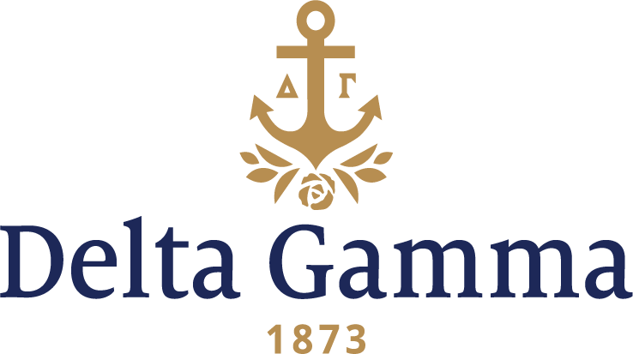

**Alpha Upsilon-Southern Methodist**

**Fast Facts:**

* Installation date: October 16, 1926
* Location: Dallas, TX
* Region: 6

**History:**

Southern Methodist University was chartered on April 17, 1911, by the five Annual Conferences in Texas of the Methodist Episcopal Church, South. SMU was established after the attempt to relocate Southwestern University from Georgetown, Texas, to either Fort Worth or Dallas was unsuccessful. Southwestern's trustees eventually moved to Dallas to establish Southern Methodist University.

The effort to establish a new university in Dallas drew the attention of the General Conference of the Methodist Church, which was seeking to create a new connectional institution in the wake of a 1914 Tennessee Supreme Court decision stripping the church of authority at Vanderbilt University. The church decided to support the establishment of SMU and dramatically increase the size of Emory University at a new location in DeKalb County, Georgia. At the 1914 meeting of the General Conference, SMU was designated the connectional institution for all Conferences west of the Mississippi River.

Classes were planned to officially begin in 1913, but construction delays on the university's first building prevented classes from starting until 1915. In the interim, the only functioning academic department at SMU was the medical college it had acquired from Southwestern University. When Southern Methodist University opened its doors in the fall of 1915 with an enrollment of 672, it was the largest enrollment of any university in America on the day of opening.

In 1916, a group of five women decided to organize at SMU as a secret society call The Pick Wick Club. In December of 1920 the desire to affiliate with a national fraternity was felt by its members and the group reorganized naming itself Rannau. The following year the Rannau president wrote to the President of Delta Gamma Fraternity expressing an interest in affiliating with Delta Gamma. Early in 1922, Rannau reorganized once more as a local named Lambda Rho. In December of that year, Lambda Rho was officially inspected by representatives of Delta Gamma but the action was deferred. Through the insistence of many people, including Sara Tilghman Hughes, Psi-Goucher (who would become the federal judge who swore in Lyndon B. Johnson as President of the United States on Air Force One after the Kennedy assassination), Delta Gamma made another inspection in January 1926 that resulted in acceptance of the group as a future Delta Gamma chapter. George Banta’s niece, Elizabeth Banta Tolle, Theta-Indiana, also is included in the recommendation of the petition book.

The closest chapter to Dallas in 1926 was Alpha Iota-Oklahoma in Norman, and the five alumnae in Dallas were worried that they might not be able to make the trip for the installation of Alpha Upsilon. The alumnae had all been out of college a few years and none had taken part in the updated ritual. The arrival of Fraternity First Vice-President, Donna Hinds Amsden, Upsilon-Stanford ceased this worry. Because of the rains in October, the roads were impassable between Oklahoma and Texas so Donna asked them to come by train even though it was more expensive.

Friday evening, October 15, 1926, the five Dallas alumnae along with Donna Amsden, pledged the large number of Lambda Rhos. The Alpha Iotas train was several hours late and didn’t reach Dallas until 10:30 a.m. on Saturday morning. On October 16, fourteen Alpha Iotas initiated the 42 Lambda Rhos and all were happy to call them “sisters” with the difficulty of the weather. At 7 p.m. they all gathered at Stoneleigh Court for the Installation Banquet. Sarah Tilghman Hughes, Psi II-Goucher, “the guardian angel of Alpha Upsilon,” was toastmistress and was delighted to introduce Fraternity President, Nancy Brown Woollett, Phi-Colorado, who made the trip for the occasion.

On Sunday about 250 guests, faculty and students at SMU, families of the new members and many Dallas friends passed down a receiving line in the University Club on the top floor of an office building in downtown Dallas. The pride and enjoyment of both Alpha Iota and Alpha Upsilon chapters was gratifying.

Through the years, Alpha Upsilon has enjoyed many successes. The chapter has consistently had alumnae who have been prominent in their communities and in the Delta Gamma leadership roles. They have been recognized at the province and regional level for their excellence in scholarship, recruitment and chapter administration. On campus, Alpha Upsilon members have consistently been leaders of Student Foundation and Student Government and have been involved in a wide array of organizations. In 1994, the chapter and alumnae raised $50,000 to start the Lectureship in Values and Ethics at SMU which continues today.