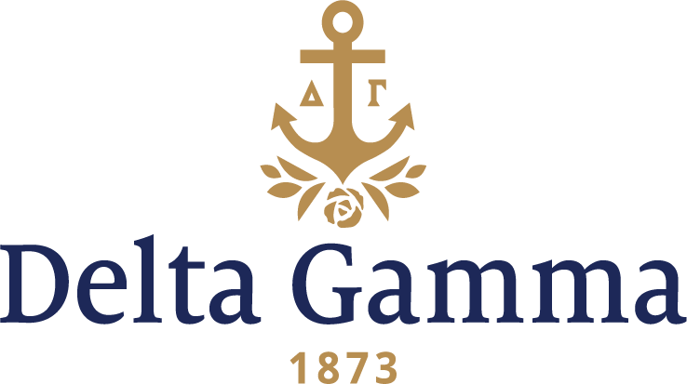

**Alpha Zeta-Lawrence**

**Fast Facts:**

* Installation date: September 11, 1915
* Location: Appleton, WI
* Region: 5

**History:**

Lawrence's first president, William Harkness Sampson, founded the school with Henry R. Colman, using $10,000 provided by philanthropist Amos Adams Lawrence, and matched by the Methodist church. Both founders were ordained Methodist ministers, but Lawrence was Episcopalian. The school was originally named Lawrence Institute of Wisconsin in its 1847 charter from the Wisconsin Territorial Legislature, but the name was changed to Lawrence University before classes began in November 1849. Its oldest extant building, Main Hall, was built in 1853. Lawrence University was the second coeducational institution in the country.

From 1913 until 1964, the school was named Lawrence College, to emphasize its small size and liberal arts education focus. The name was changed to Lawrence University when it merged with Milwaukee-Downer College. The state of Wisconsin then purchased the Milwaukee-Downer property and buildings to expand the campus of the University of Wisconsin-Milwaukee. Initially, the university designated two entities: Lawrence College for Men and Downer College for Women. This separation has not lasted in any material form, though degrees are still conferred "on the recommendation of the Faculty of Lawrence and Downer Colleges" and the university by-laws still make the distinction.

In 1903, a local sorority was permitted by the faculty of Lawrence to become Theta Gamma Delta, the second sorority on campus and one destined to become Alpha Zeta chapter of Delta Gamma. During Theta Gamma Delta’s 12 years of existence, its members were active in many campus affairs, for instance: the only woman editor of the Lawrentian during these years; five alumnae were elected to Phi Beta Kappa; and members twice held the presidency of the YWCA, a powerful organization in campus life at that time.

In the spring of 1915, the chapter began to consider trying to secure a Delta Gamma charter. A Theta Gamma Delta letter refers to Delta Gamma as the “flower of all national fraternities.” It was advised by interested Delta Gammas to contact the nearest chapter, Omega-Wisconsin for approval. Mr. George Banta Sr., Eleanor Banta Sharp, Theta-Indiana, Helen Goodwin Custer, Rho-Syracuse, and Sara Parks Treat, Sigma-Northwestern, went to a meeting of collegiate and alumnae members in Madison in April 1915, with an invitation to visit the campus at any time. Mr. Banta had shown an interest in Theta Gamma Delta from his home in Menasha, only five miles from the Lawrence campus, and provided assistance and encouragement to the group. A favorable report was turned in by three Omega chapter initiates, including Helen Van Arsdale Bebb, who spent the weekend at Lawrence, and after returning to Omega, the chapter agreed to support the petition. On August 4, 1915, after an official visit and formal petition to Council and by vote at the Delta Gamma Convention in Berkeley, California, a charter was granted. Two telegrams came to Appleton that day telling of this; one was the official notice and the other was from Mr. Banta telling of the splendid speeches that had been made in the group’s favor and the exact minute the roll call was finished. The girls of Theta Gamma Delta were happy beyond imagination; their dreams had come true.

On September 11, 1915, Alpha Zeta chapter of Delta Gamma Fraternity was installed at the home of Jewell Chase Meredith, Omega-Wisconsin. The installing officers from Omega were Rosamund Witte Smith and Miriam Noyes Barkhausen. Thirty-five were initiated – 18 collegiate petition signers and 16 Theta Gamma Delta alumnae. The Initiation was over at eight o’clock and was followed by a banquet at the Hotel Sherman, where Mr. Banta addressed the 60 guests in attendance.

Mrs. Treat was the toastmistress and Mr. Banta was an honored guest at the Installation Banquet and he spoke following the toasts. He told about Convention and the splendid future he had promised for Alpha Zeta. The banquet ended with the singing of “Dear Delta Gamma.”

For many years Alpha Zeta did not have its own chapter house. Instead it had rooms two blocks off campus on College Avenue, consisting of a large hall, two parlors and a kitchen. It was the only fraternity on campus to have rooms outside the Panhellenic House, but they planned for the day when the new, larger Panhellenic House would be built. Each year the chapter turned over a sum of money to the Appleton alumnae group to invest until it was needed. However, in 1944 the chapter invested this money in a war bond as previously some money had been spent on decorating the rooms. The chapter currently has a chapter meeting room located in the Colman Hall Panhellenic Wing.

Since these early days on campus, the alumnae chapter of Appleton has been very close to the college chapter and has helped in many ways. Originally called Alpha Zeta Rho Association it was composed of five resident alumnae and five from other chapters. Their support in seeking new members in 1915 was valuable in helping the chapter during “rush.” Originally this activity lasted 30 days on an almost daily basis. However, the following year Panhellenic decided to limit the rushing. From a letter to the January 1916 *ANCHORA*, Olive Reynolds reported that “first, the expense is to be limited. We expect to carry sugar lumps from one house to another. Then too, there will be no rushing one day each week, and there are to be no parties after 7:30 each evening of the school week…”

As Alpha Zeta grew in members on campus they excelled academically and in campus leadership. Only during World Wars I and II did activities diminish, but they committed to help the Red Cross and other relief organizations every day. “Every spare minute was spent knitting for soldiers and sailors.” They raised money for Delta Gamma’s Holland Home fund, an orphanage the fraternity sponsored in Schveningen, Holland called “des Petits Orphelins de la Guerre.” Movie benefits, rummage sales, concerts and donations from alumnae salaries were used to help this effort.

In 1926, Fraternity officers Mrs. Woollett, President, Miss Miller and Mrs. Tompkins came for a visit. Before leaving Mrs. Tompkins told the chapter about Convention and that they wanted the chapter to be Convention hostesses. The dates would be June 29 to July 2, 1926, and the location was Mackinac Island. The chapter was so excited, they wrote a poem called Alpha Zetas Beckon, inviting all Delta Gammas to the 23rd Convention. The first verse was:

*“We welcome you to Mackinac*

*Our Delta Gamma friends*

*And Alpha Zeta lovingly*

*A friendly hand extends”*

and can be found in the March 1926 *ANCHORA*.

Perhaps one of the most significant experiences of an Alpha Zeta is shared by Ruth Hudson, a charter member in 1915. Ruth lived in Manila, Philippines, in 1942 and on January 4 she joined the occupants of the apartment she lived in for passport and baggage inspection by the Japanese after seizing control of the island. Next, they were taken by auto to Rizal Stadium and expected to be sent home in three days. However, the Japanese decided to hold them longer and this could be best accomplished on the campus of University of Santo Tomas.[1] They wondered how long they must remain apart from the life they knew. Little did they realize it would become an internment camp and it would be three years before the Americans would defeat the Japanese on the night of February 3, 1945. (*ANCHORA*, March 1946)

The 1950s were a return to normalcy for the Lawrence campus. Freshman Studies, introduced by President Nathan Marsh Pusey was introduced and remains a distinctive expression of the commitment of the entire Lawrence community to the examination of ideas of abiding importance. These ideas of importance were adopted by Alpha Zeta members. They continued to be leaders on campus and participants in many activities. Members were recognized for oratory, theater, athletics, scholarship, editorial boards, student government, honorary recognition, beauty queens and in 1957 the chapter “Irish Jiggers” even placed first in the Folk-Dance Festival.

The big event of the 1960s was Alpha Zetas 50th anniversary celebration at Founders Day, April 1965. The alumnae announced a fund drive to create an annual scholarship for aid to collegians. When announcing that they had collected more than $1,000, the collegians matched the donation with another $1,000. According to an alumna “every time we do something to build the chapter, these collegians step in and share the load.” The luncheon held special significance for the chapter-for it was once the Sherman Hotel and the very site where the Installation Banquet was held in 1915.

Several annual traditions have taken place for the chapter for decades. These include “Safehouse,” a 1920s style gambling party with Delta Tau Delta during Parents Weekend; the Pledge Formal; DG Dozen, when DGs sell real or chocolate kisses to deliver on Valentine’s Day; Apple Polishers, a reception with the faculty during the second term; Spring Formal; Celebrate!, where DGs have two booths-new initiates run a face-painting booth and members sell pizza to raise money for our philanthropy; and Davenport-Giloon picnic-a BBQ with Delta Tau Delta the last day of classes to raise money for a book scholarship that is awarded to a DG and a Delt pledge through the Financial Aid office.

Alpha Zeta chapter of Delta Gamma Fraternity celebrated its centennial in 2015.

1. Santo Tomas Internment Camp was the largest of several camps in the Philippines in which the Japanese interned enemy civilians, mostly Americans, in World War II. The campus of the University of Santo Tomas in Manila was utilized for the camp which housed more than 4,000 internees from January 1942 until February 1945. Conditions for the internees deteriorated during the war and by the time of the liberation of the camp by the U.S. Army many of the internees were near death from lack of food.