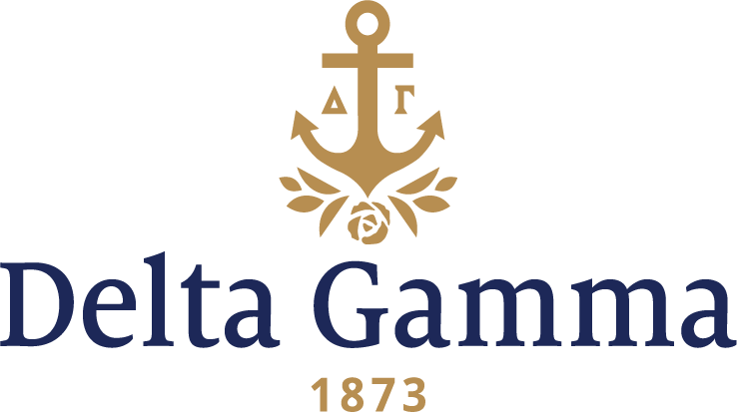

**Beta Kappa-Kansas**

**Fast Facts:**

* Installation date: April 26, 1941
* Location: Lawrence, Kansas
* Region: 5

**History:**

On February 20, 1863, Kansas Governor Thomas Carney signed into law a bill creating the state university in Lawrence. The law was conditioned upon a gift from Lawrence of a $15,000 endowment fund and a site for the university, in or near the town, of not less than forty acres of land. If Lawrence failed to meet these conditions, Emporia instead of Lawrence would get the university. The site selected for the university was a hill known as Mount Oread, which was owned by former Kansas Governor Charles L. Robinson. Robinson and his wife Sara bestowed the 40-acre site to the State of Kansas in exchange for land elsewhere. The philanthropist Amos Adams Lawrence donated $10,000 of the necessary endowment fund, and the citizens of Lawrence raised the remaining cash by issuing notes backed by Governor Carney. On November 2, 1863, Governor Carney announced Lawrence had met the conditions to get the state university, and the following year the university was officially organized. The school's Board of Regents held its first meeting in March 1865, which is the event that KU dates its founding from. Work on the first college building began later that year. The university opened for classes on September 12, 1866, and the first class graduated in 1873.

In 1926, a small group of Delta Gammas received permission to colonize on the Kansas University campus. They started a Delta Gamma Club, but because conditions were not favorable for expansion, they had to abandon their plan. Two of the six women pledged during this short colonization were eventually initiated, Charlein Opperman at Alpha Iota-Oklahoma and Jeanette Guy Harris at Alpha Kappa-Washburn.

At the 1938 Convention, Kansas University was mentioned as a field for colonization. Representatives of the Fraternity were asked to investigate the Kansas situation. They found that a rigid quota system, limiting the number of members of each group, presented an opening for a strong Delta Gamma chapter. Over 1,400 women were enrolled at the university. The nine sororities had a total membership of 300, leaving 1,100 “independents.”

In 1939, the Expansion Committee authorized Virginia Brand, Psi II-Goucher, and Marjorie Woodhead Kollman, Mu-Missouri, to find a nucleus for a Delta Gamma colony. Virginia Brand wrote: "Ever since the question was put before the Panhellenic Council last spring Delta Gamma has been the talk of the campus. Scarcely a day goes by that someone--active and alumnae members of both women's and men's fraternities, newspaper reporters, University officials--does not ask me what Delta Gamma is going to do and when. There certainly is no doubt in my mind, at least, that we are still wanted and that people think there is room for another good national women's fraternity on the K.U. campus. The girls, whom we have called our nucleus, are still interested and thrilled as they were last spring. It seems to me that if we are going to colonize now is the time."

During the National Panhellenic Congress in the fall, Council had the opportunity to talk with representatives of other groups on campus and found that some believed that our entrance would definitely injure them and mean their ultimate withdrawal from the campus. "This, of course, would be contrary to our past and present policy of inter-fraternity cooperation, a policy of which we have been very proud and which has gained us great prestige in the fraternity world." Again, colonization was postponed.

Finally, at the 1940 Convention, Council approved colonization plans as sufficient time had elapsed to conform to the principle of cooperation with other fraternities. Ruth Garvey, Iota-Illinois, was asked to select and direct the colony. Martha Schultz Davidson, Kappa-Nebraska, and Olive White Garvey, Kappa-Nebraska, were co-chairmen of a colonization committee.

Eleven collegians and one patroness were pledged on October 25, 1940, as a nucleus of the colony. A formal dinner followed at Evans Hearth with a large group of alumnae present.

Council wrote to the colony in mid-February stating they were considering installation before originally planned because the colony had been so successful. The colony still needed to fulfill Council's requirement of 25 members. Council gave the Beta Kappa colony until March 1, just ten days, to pledge at least thirteen girls. Members of Kappa-Nebraska, traveled to Lawrence to assist with rush, and provided extra enthusiasm and spirit to the colony. The goal was reached, and Installation was approved.

At 1:00 p.m. Saturday, April 26, 1941, the Initiation ceremony was performed at the home of the University Chancellor. A formal installation banquet followed at the Memorial Union Building. The banquet theme was "The Magic Mirror," appropriate as the room was walled with mirrors. A group of Wichita alumnae presented a skit in which the mirror presented each of the new initiates and prophesied the high place which Delta Gamma was to assume at Kansas University. Highlighting the banquet was a phone call to Roberta Abernethy, Epsilon-Ohio State, First Vice-President, informing her that one of the most attractive fraternity houses was to be vacated and would be available for Beta Kappa.

A reception for the new chapter was held on Sunday afternoon for more than 550 at the home of Dean and Mrs. J.J. Jakosky, 1120 W.11th St. The fraternity colors were carried out in decorations and refreshments.

The Beta Kappas were very enthusiastic about the war effort surrounding World War II. In 1941, the chapter adopted the plan of a dessert-less dinner for four weeks and the money saved went to the Red Cross. The war years showed its effect by fewer formals and most festive gatherings resembled Army-Navy celebrations. Blood banks were held and many platoons took over former fraternity houses and marched to and from classes. Women worked as Red Cross Nurses’ Aids in the hospital as the war dragged on.

Members of Beta Kappa made their presence known on campus through a variety of club, activities and honors. In 1942, the women boasted that they had members involved as: a staff member on the Daily Kansan and Jayhawker Annual papers, three members elected to Quill Club, a member in Mu Phi Epsilon – music honorary, and one in Phi Lambda Theta – education honorary. Members were also involved in: cheerleading, apprentices to the Dramatic Workshop, Women’s Glee Club and other university clubs. Two members acted as officers in the coed volunteer corps. The chapter won intramural trophies, but the major activity on most minds was the University War Fund Drive. Headed by member Eloise Penner, she was joined by Leeta Marks and Patsy Creel as Victory speakers. In 1943 Betty Beach was crowned “Sweetheart of Sigma Chi.” Betty became Betty Beach Norris, Delta Gamma’s 41st Fraternity President.

In 1945, Raquel Rios arrived from Panama and was the chapter’s first exchange student. Excitement ensued when a reconversion took place during the spring of ’45 with nearly a thousand veterans returning to the campus. On May 27, 1945, Beta Kappa initiated nine patronesses to help advise them and the chapter flourished.

In the 1980s rush was held in the spring, the first Anchor Splash® was held, and the favorite parties were the Deb Ball, Pinafore and the Cream Rose Formal. The popular hang outs were: The Madhatter, The Wheel, The Bull, Johnny’s and Louise’s West. Sports, student clubs, a new addition to the chapter house, sponsoring events for school children, all these kept the members busy as they maintained a 3.0 GPA.

In 1988 Beta Kappa received an anchor for their lawn from Anchor Savings in Kansas City. Alcohol enforcement, a remodeled tube room and winning Greek Week all these were concerns and goals into the ‘90s. The traditions, spirit and honors set by early chapter members have continued for more than seven decades at Beta Kappa.