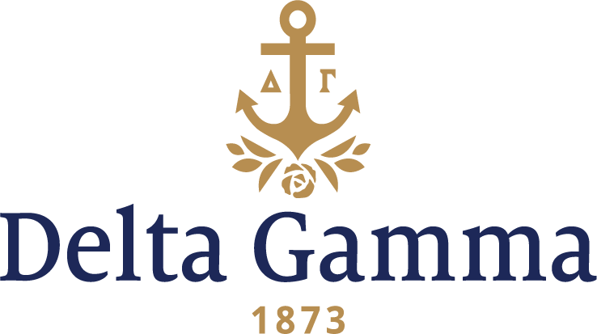

**Beta Omega-Washington State**

**Fast Facts:**

* Installation date: November 2, 1946
* Location: Pullman, WA
* Region: 7

**History:**

Washington State University began as the state’s Morrill Act land-grant college called the Washington Agricultural College and School of Science in 1890. In 1905, the state legislature approved the university’s name to be changed to State College of Washington. The university was named Washington State University by state legislative action in 1959.

In 1945, Delta Gamma had a chance to establish at what was then called Washington State College, but ultimately the opportunity instead went to Alpha Phi. The Fraternity made a formal application to the college to establish a Delta Gamma chapter on February 22, 1946. The university accepted, and Delta Gamma became the 13th National Panhellenic Council group to establish on campus.

Installation weekend began with a Fraternity round table on Friday November 1. The next afternoon, Initiation was held at the Phi Delta Theta house. The Installation banquet that evening was based on the theme, "Tales of Delta Gamma." In the morning of November 3, a model chapter meeting was held at the chapter house and in the afternoon, a formal reception was held at the home of Wilson Compton, president of Washington State.

November 1971 marked the chapter’s 25th anniversary. The chapter celebrated with seven of the original 13 chartering members of Beta Omega.

In 1982, the chapter held its first annual Anchor Splash® philanthropy event, and Sigma Alpha Epsilon won the event.

One of the biggest campus events was Winter Week, an annual carnival held in the middle of winter. Every night during this week, one of the hills on campus was lighted up and a portable ski lift was installed. This was one of the few occasions during the year that freshmen could stay out until 10:30 pm on week nights.