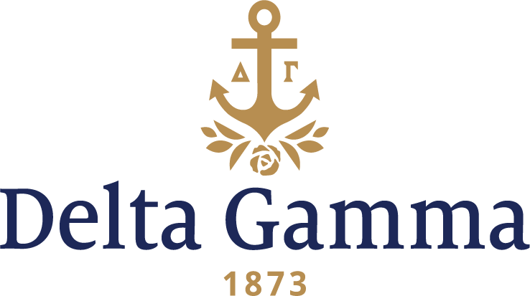

**Beta Theta-Duke**

**Fast Facts:**

* Installation date: June 1, 1939
* Closure date: June 3, 1974
* Re-establishment date: October 11, 1986
* Location: Durham, NC
* Region: 2

**History:**

Duke started in 1838 as Brown's Schoolhouse, a private subscription school founded in Randolph County in the present-day town of Trinity. Organized by the Union Institute Society, a group of Methodists and Quakers, Brown's Schoolhouse became the Union Institute Academy in 1841 when North Carolina issued a charter. The academy was renamed Normal College in 1851 and then Trinity College in 1859 because of support from the Methodist Church. In 1892, Trinity College moved to Durham, largely due to generosity from Julian S. Carr and Washington Duke, powerful and respected Methodists who had grown wealthy through the tobacco and electrical industries. Carr donated land in 1892 for the original Durham campus, which is now known as East Campus. At the same time, Washington Duke gave the school $85,000 for an initial endowment and construction costs—later augmenting his generosity with three separate $100,000 contributions in 1896, 1899, and 1900—with the stipulation that the college "open its doors to women, placing them on an equal footing with men."

William Preston Few, the president of Trinity at the time, insisted that the institution be renamed Duke University to honor the family's generosity and to distinguish it from the myriad other colleges and universities carrying the "Trinity" name.

By 1904, 54 women were enrolled in the college. In 1930, the Woman's College was established as a coordinate to the men's undergraduate college, which had been established and named Trinity College in 1924. Three years later, Delta Gamma representatives began inquiring about a possible chapter at the Duke campus.

A local sorority, Delta Chi, formed in March 1938. They were organized for a year, and then on March 13, 1939, they petitioned Delta Gamma for a charter. In May, Delta Gamma unanimously approved the establishment of a chapter, and on June 1, 1939, nine members of the Delta Chi local sorority were initiated, thus installing the Beta Theta chapter of Delta Gamma. The Installation Banquet was held at the Washington Duke Hotel, and the theme was “Delta Gamma Goes South Again.” Evelyn Culp, president of Delta Chi and colony president, was the first member initiated into Beta Theta, and since she was in a hospital bed after a serious car accident, she was given her badge in a special ceremony in the hospital.

In 1940, there was no room for the Beta Thetas to meet in the Panhellenic Building, so they were given a suite in the Faculty Apartments instead. Beta Theta was a powerhouse chapter on campus in the 1940s, with the first female editor of the Chronicle, a senior class president and the women’s student government president.

Unfortunately, by the early 1970s, interest in Greek life was at an all-time low. Beta Theta joined the ranks of groups that were unable to withstand the tumultuous times. In April 1974, Beta Theta requested that Delta Gamma suspend its charter due to low rush numbers. It was made official on June 3, 1974, when Council honored the request.

Beginning in September 1985, Delta Gamma made informational sessions to Duke University for possible re-colonization. Delta Gamma was invited to re-colonize in December 1985. During re-colonization, Gamma Alpha-Tennessee collegians were to perform skits at the informational parties, but due to snow and sleet, they were unable to show. During this process, Delta Gamma expected 70 rushees, and instead interviewed 334 women hoping to be Delta Gammas.

On February 18, 1986, Delta Gamma pledged 96 women in an official ceremony. Installation ceremonies were held the weekend of October 11-12, 1986. Initiation occurred October 11 at the Searle Center, and Beta Theta was officially reinstated.

Beta Theta held its first Anchor Splash® in 1987.

Since 1986, the chapter has been awarded numerous Fraternity Awards, including the Patricia Peterson Danielson Award on 15 separate occasions, the H.K. Stuart Spirit of Service Award, and the Frankie Ladley Wakefield Parnsassus Award for academic excellence.

In April 1994, the Dorothy Garrett Martin Lectureship in Values & Ethics was established at Duke, with Maya Angelou being the annual speaker through 2013.

Chapter members continue to hold leadership positions on campus and help the university and student body move forward with visions for change and adaptation to cultural and campus needs. Our chapter has contributed over $141,528.82 to the Delta Gamma Foundation and has over 1,700 initiates.