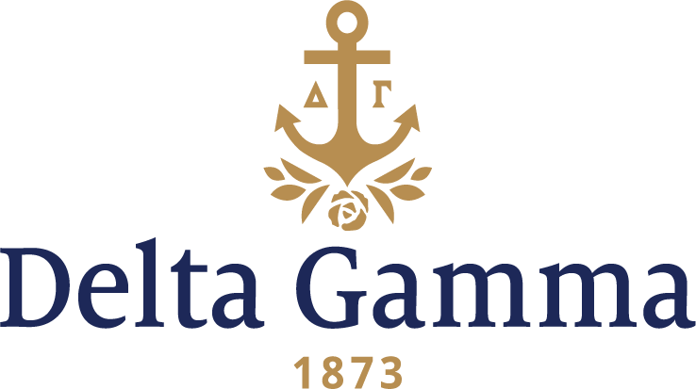

**Chi-Cornell**

**Fast Facts:**

* Installation date: March 7, 1885
* Location: Ithaca, NY
* Region: 1

**History:**

Cornell University was founded on April 27, 1865. The New York State (NYS) Senate authorized the university as the state's land grant institution. Senator Ezra Cornell offered his farm in Ithaca, New York, as a site and $500,000 of his personal fortune as an initial endowment. Fellow senator and experienced educator Andrew Dickson White agreed to be the first president. During the next three years, White oversaw the construction of the first two buildings and traveled to attract students and faculty. The university was inaugurated on October 7, 1868, and 412 men were enrolled the next day. Cornell developed as a technologically innovative institution, applying its research to its own campus as well as to outreach efforts.

Chi chapter of Delta Gamma was instituted at Cornell University on March 7, 1885, by eight women. The women were described in the June 1885 *ANCHORA* as: “our dignified Rachel Meyers, our grave Lucy Alvord, sweet Kate E. Selmser, the scribe, Fredrika Meloy, poetical Esther Sanford, wise Anna Wideman, stern Carrie Bristol, and merry Ida Brett.” They were the third sorority established at Cornell, as Kappa Alpha Theta and Kappa Kappa Gamma already existed. And then, one month later, they wrote this to the *ANCHORA*; “The great University moves on as ever, undisturbed by eight girls who have grown to the greatness of Delta Gamma.” That sentence may characterize Chi’s first century.

In 1893, Chi was the first group to leave Sage dormitory for women and establish a house of their own in Ithaca. In 1893, Chi rented the 14 Lake Street house. From 1895-1898, the chapter members lived at 1 College Place with Mrs. Olive Myers, the mother of Carrie Myers Northup, as their chaperone. In the early 1900s, maintained the house was not feasible for a period of years, so members from 1916-1920 lived at a home they had on Dearborn Place. Soon the Delta Gamma Property Association had come into being, launched a bond sale, and in 1920 bought the William Sage Mansion at 603 East Seneca Street, one of the show places of the day. It was a house of considerable interest. The Sages had made it very picturesque with many key features, including: a conservatory, fountain, parquet floors, stained glass windows, and winding stairs. This house was Chi’s home for 20 years, and Mrs. C.A. Slater, Mrs. Carpenter, Miss King and Miss Kopke acted as the girls’ house mothers.

When Chi members realized in 1940, after vaguely cogitating for a number of years on the importance

to the chapter of being nearer the new women’s residential section, that they must build immediately or

hold their position “for the duration,” it took real courage in the face of ever-darkening-economic skies

to sell, what in many respects was a very adequate house, free of debt, and assume greatly increased

responsibility. When “603” was sold in June, temporary quarters for the following college year had to

be provided. The undergraduates got into the spirit of the emergency and pledged an outstanding

group of freshmen in their little-grey-crowded house—3 Grove Place that fall. In the meantime, Ruth

Darville and her committee were busy planning a new Georgian red brick house to be built at 117

Triphammer Road in the heart of the women’s residential section of campus on a rolling plot 150 x 300

feet with the Ithaca golf course meeting the lawn in the rear. At the time of building, it was designed to

accommodate 25 undergraduates, a chaperone and a resident cook.

The Chi chapter house is still located at 117 Triphammer Street, and in 2010, the housing capacity was listed at 48 occupants.

The high standards maintained by Chi chapter in the selection of its membership are reflected by the large number of alumnae who have attained prominence. Many alumnae have continued their interest in the fraternity through their activity on local, province, national and international levels. Ithaca has been the site of several Delta Gamma meetings. The tenth national convention of the fraternity in 1897 was held there and representatives of 13 active chapters were present.

The endeavors of chapter members continues but perhaps that which they can be most proud is being known as “the friendliest group on the Hill.”