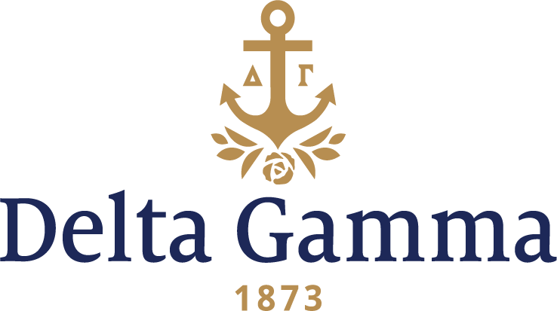

**Delta Alpha-New Mexico**

**Fast Facts:**

* Installation date: May 20, 1961
* Closure date: July 1, 1973
* Location: Albuquerque, New Mexico
* Region: 6

**History:**

The University of New Mexico was founded on February 28, 1889, with the passage of House Bill No. 186 by the Legislative Assembly of the Territory of New Mexico. The University was considered a state university when New Mexico became a state.  UNM offers bachelor's, master's, doctoral, and professional degree programs in a wide variety of fields. Its Albuquerque campus encompasses over 600 acres, and there are branch campuses in Gallup, Los Alamos, Rio Rancho, Taos, and Los Lunas.

The Fraternity’s interest in establishing a chapter at UNM begins in the summer of 1946, but it wasn’t until the early 1960s that establishment became possible. In the fall of 1960, UNM was very anxious to add another sorority to its campus. On October 16, an alumna in the Albuquerque area interviewed with campus Panhellenic, and on October 26, the College Panhellenic voted to extend an invitation to Delta Gamma. The Fraternity accepted and began making plans for the expansion.

Establishment week was set for February 5-12. The events began with an Open House held at the Pi Phi house in the evening of the 5th. On Monday, potential new members were invited to informal gatherings in the afternoon and a party that evening. On Tuesday there were more informal events and then a preference party that night. After all the events, 25 women were formally pledged on Saturday the 11th.

Installation of the Delta Alpha chapter was set for the weekend of May 19-21. Women of the Gamma Phi-Arizona State chapter flew in to Albuquerque to conduct the Initiation ceremony on Saturday the 20th, and the Installation banquet was held that evening at the Four Hills Country Club. A formal reception was held the next afternoon in the Student Union Building to introduce the new Delta Alpha women to the other students, university community, and parents. All of Delta Gamma was excited to see the first chapter in New Mexico thrive!

As the Delta Alpha chapter was establishing, the Fraternity was making plans for a chapter house. As a part of the agreement with the University to establish on campus, Delta Gamma had to have a plan for a chapter house within two years of establishment, so all were eager to begin. The women of Delta Alpha were eager to build a house because there were no other housing options available to the chapter. By 1964, the chapter had a plan and a rendering of what the house would look like, but no physical house to call their own. Fortunately, the house was completed in 1966 and dedication festivities were held on the weekend of February 18-20.

By the late 1960s, the chapter was not doing as well as the Fraternity had hoped. Their recruitment efforts had suffered in the early 1960s and by 1968, their largest member classes were soon going to graduate. By the early 1970s, their recruitment results had improved greatly, but there was still room for growth. The chapter had not yet reached quota, but all the Panhellenic groups were concerned about their numbers because there were few women participating in recruitment. The early 1970s also brought issue with chapter operations and sisterhood. Delta Alpha was rather disconnected, and their operations reflected the lack of sisterhood. Due to these concerns, Council announced its intent to suspend Delta Alpha’s charter on July 12, 1972. However, when the final vote was tallied on August 1, all of Council voted in support of Delta Alpha keeping their charter.

However, in April of 1973, the women of Delta Alpha voted to relinquish their charter. Council voted unanimously at their June 1973 meeting to honor Delta Alpha’s decision, and the Delta Alpha chapter returned its charter to the Fraternity.