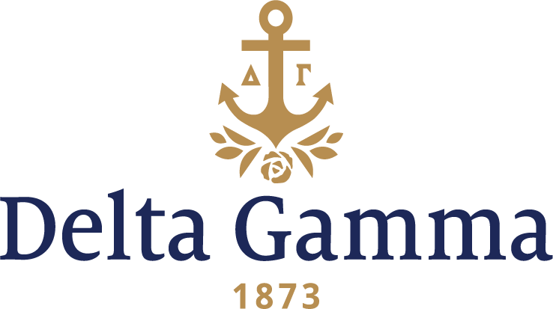

**Delta Beta-Kentucky**

**Fast Facts:**

* Installation date: March 3, 1962
* Location: Lexington, KY
* Region: 2

**History:**

As the first university in the territory that would become Kentucky, Transylvania University was the primary center for education, and became the mother of what would become the University of Kentucky. John Bryan Bowman founded the Agricultural and Mechanical College of Kentucky (A&M), a publicly chartered department of Kentucky University, after receiving federal support through the Morrill Land-Grant Colleges Act in 1865. Courses were offered at Ashland, The Henry Clay Estate. Three years later, James Kennedy Patterson became the first president of the land-grant university and the first degree was awarded. In 1876, the university began to offer master's degree programs. Two years later, A&M separated from Kentucky University, which is now Transylvania University. For the new school, Lexington donated a 52-acre park and fair ground, which became the core of UK's present campus. A&M was initially a male-only institution, but began to admit women in 1880.

Delta Beta was colonized during the fall 1961 with the help of members from Beta Mu-Bowling Green and Theta-Indiana; the colony pledged 52 women. In a show of support for the new chapter, collegiate members of the Alpha Omicron-Miami (Ohio) chapter performed the pledging ceremony. Field Secretary Nancy Weigle, Gamma Phi-Arizona State, lived with the chapter and prepared them for Initiation and Installation.

One week before Delta Gamma Fraternity’s new Executive Office building was dedicated, Council members assembled in Lexington, Kentucky for the installation of Delta Beta chapter at the University of Kentucky. Assisted by Epsilon-Ohio State, Initiation and Installation took place on March 3, 1962.

The glorious Installation Banquet at the Phoenix Hotel in Lexington was attended by University President, Dr. Frank Dickey, and Dean of women, Doris Seward. Fraternity Secretary Ruth Turpin, Alpha Nu-USC, presented the charter to chapter President Patti Muth. The presentation of Membership Certificates was done by Fraternity officers Ellen Dredge, Epsilon-Ohio State and Carolyn Moorman, Alpha Omicron-Miami (Ohio). Also helping with the installation was National Panhellenic Conference Delegate Margaret Richardson Hay, Upsilon-Stanford. “Cables, Links and Bright New Anchors” was the theme the message of Fraternity President Helen Million Preston, Xi-Michigan. Nineteen new initiates, five new Patronesses, and 33 pledges were honored and recognized by parents and guests who attended the banquet.

Due to a heavy snowstorm Council became stranded in Lexington, but decided to start their spring Council meeting while staying at the Downtowner Motel. Fortunately, they were able to make it back to Columbus by mid-week and concluded their meeting in Columbus with the dedication of Executive Offices at 3250 Riverside Drive.

The chapter rented a small house on Pennsylvania Avenue to use as a lodge and chapter house. The following year the university provided the Lydia Brown house on Harrison Avenue. By 1964 the present chapter house was completed at 450 Pennsylvania Avenue and Elsie Marcum, Gamma Theta-Florida transferred to University of Kentucky on a Fraternity scholarship to help them get established in their own resident chapter house. The first house mother, Mrs. Stone, stayed with them and moved into the new house.

While Delta Beta was the first Delta Gamma chapter in the state, Kentucky was already familiar with the Fraternity. The jeweler C. P. Barnes & Brothers in Louisville was the first jeweler to produce the anchor badge in 1877, designed by Corrine Miller, Psi-Lewis. Anna Boyd Ellington also had a cousin in Louisville who was a popular seamstress of the city and made most of Anna's dresses.

The current Delta Beta chapter house was dedicated on March 8, 1964. It is located at 450 Pennsylvania Avenue. The anchor can still be seen sitting in the front yard today.

A proud moment came in 1974 when Delta Beta decided to get involved with University Professor Dr. P.S. Sabharwal’s “Adopt-A-House” project. The women painted and cleaned up houses of elderly and poor citizens living in their adopted community along with other fraternity and sorority members.

The chapter held its first Anchor Splash® as a philanthropy event for Aid to the Blind in March 1974. Still a popular event at UK, it occurs in April and supports Delta Gamma Foundation’s Service for Sight program which impacts men and women for whom blindness is a fact. The Foundation also supports scholarships, fellowships and student loans.

The Delta Beta chapter of Delta Gamma won first in scholarship the spring and fall semesters of 1980.

In 1988, Delta Beta sponsored the establishment of the Lisa Whalen Memorial Scholarship, which is awarded each year through the Foundation. A preference is given to candidates who have been effective in alcohol and drug education. Lisa Whalen was killed that year in a tragic automobile accident.

Aiding in the expansion of Delta Gamma Fraternity in Kentucky, Delta Beta chapter assisted in the pledging of colony members at Delta Omicron-Morehead State in 1970 and Zeta Sigma-Northern Kentucky in 1993.

The chapter has not lacked for “Doing Good.” Some of their projects include reading to a proofreader for the U.S. government who is blind, timing swim meets for UK swim team in exchange for the use of the aquatic center for Anchor Splash® and helping to sponsor Sight Conservation Week by manning a table in the Student Center with informational pamphlets. They’ve sold candy, held a Hair-Cut-A-Thon, participated in heart fund drives, arthritis drives, Walk-a-thons, cancer drives, KET telethon, March of Dimes telethon, sponsored Brownie and Girl Scout troops, participated in the activities of other fraternities and sororities, and played intramurals.

For 50 years, Delta Beta has been an asset on the University of Kentucky campus and to Delta Gamma Fraternity. Their members have received many honors: Phi Beta Kappa, Mortar board, Owens, Links, Lances, Panhellenic officers, Student Government senators, Greek Steering committees, Presidents of various organizations on campus, Greek Woman of the Year, Homecoming Queen, UK cheerleaders, Fraternity sweethearts, and little sisters. They are proud to have been part of nearly every student organization on campus since their founding. Their continued level of excellence can be attributed to the support of the advisory team, the house corporation, alumnae and chapter.