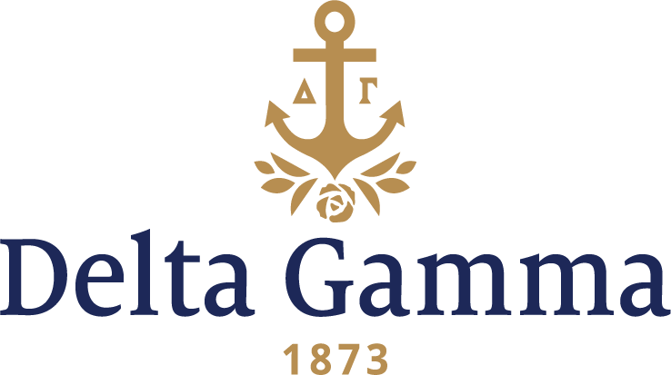

**Delta Mu-Florida Atlantic**

**Fast Facts:**

* Installation date: December 6, 1969
* Closure date: November 14, 1977
* Location: Boca Raton, Florida
* Region: 3

**History:**

Florida Atlantic University, created in 1961 by act of the Florida Legislature, opened in 1964 as the first university in the nation serving upper-division and graduate students exclusively. The University was dedicated on October 25, 1964, by President Lyndon B. Johnson, one of the few American institutions of higher learning to be so honored by a sitting President of the United States. Twenty years later, in 1984, FAU became a four-year university when the first freshman class was admitted.

Nineteen women of the Chi Delta Sorority, a local sorority at Florida Atlantic, petitioned Delta Gamma for a charter in May of 1969. On May 25, 21 women from Chi Delta became the first pledges of the Delta Mu chapter of Delta Gamma. The Initiation festivities were held on the weekend of December 5-7 of the same year. Initiation was conducted on Saturday by collegians of the Beta Tau-Miami chapter in the Regents’ Room on the Florida Atlantic campus. A formal banquet was held later that evening, and the next day a formal reception was held at the home of Esther Hurst Haines, Theta-Indiana, a local alumna.

In the spring of 1973, Delta Mu received the Panhellenic award for outstanding scholarship. Additionally, the Greek Woman of the Year was sister Diane D’Louhy. In the spring of 1976, Delta Mu was named the best organization on the Florida Atlantic campus by the Inter-Activities Board. They were similarly recognized in the spring of 1977, having been recognized at the Panhellenic banquet as the sorority of the year with the best scholarship.

Delta Mu was a strong chapter from the start and consistently recruited well. In the late 1970s, amid significantly decreased interest in Greek life, and as a result a lack of potential women to join, the chapter struggled. In August of 1977, Delta Mu voted to relinquish its charter. Council honored this decision, and a final unanimous vote in November of 1977 closed Delta Mu.