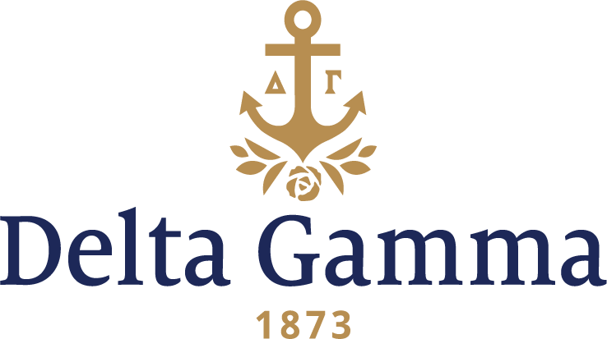

**Delta Omega-William Woods**

**Fast Facts:**

* Installation date: April 30, 1977
* Location: Fulton, Missouri
* Region: 5

**History:**

At the time of Delta Omega’s chartering, William Woods College was an all-women’s university that shared programming, special events and even classroom space with Westminster College, and all men’s institute located nearby.

On February 11, 1972, Monica Postell, Sigma-Northwestern, Field Consultant, submitted to Delta Gamma’s Executive Offices a report on William Woods College. In this report, she presented facts about the campus, the administration, and the sororities and rush procedures. There were three sororities: Alpha Chi Omega, Chi Omega, and Alpha Phi. The administration actively supported the Greek organizations. The Dean of Students was the Panhellenic Advisor, and the President of the college was also involved in rush. There were also three Delta Gamma alumnae living in Fulton.

In 1973, Megs Guyer Davies, Gamma Iota-DePauw, Province Collegiate Chairman, learned from an Alpha Phi national officer that there was definite interest in another fraternity at William Woods. She encouraged the expansion staff to pursue the possibility of expansion at William Woods.

On March 7, 1974, an interested alumnus of William Woods wrote to Dr. Cutlip, president of the college, noting that the size of the existing chapters was astounding, thus she pushed a need for another group on campus. In March 1974, Eleanor Slaughter, Alpha Psi-Mississippi, Director of Expansion, wrote to William Woods expressing an interest of expansion at the campus, but William Woods denied plans for future expansion. In February 1976, Barbara Ankenbruk, Staff Expansion Coordinator, wrote to the college once again and expressed future expansion interests. Once again they didn’t sound promising for a future opening.

On September 10, 1976, Executive Offices received a letter from William Woods stating the college was ready to add a fourth group. Delta Gamma was one of the five groups selected to make a presentation to the Panhellenic Council. On October 19-20, Mrs. Wm. S. Norris, Jr. and Barbara Ankenbruck Caldwell, Gamma Epsilon-Kent State, gave a presentation in hopes of possible establishment. The Dean of Women called on November 9, 1976, inviting Delta Gamma to establish that winter. Letters were sent to alumnae in Fulton and their support was appreciated.

Establishment took place January 30- February 6, 1977. Donna Tschappat Benner, Gamma Sigma-Houston, was designated Colonization Chairman.

Delta Omega was installed as the 101st chapter of Delta Gamma on February 5, 1977 with the pledging of 43 women at Aldridge Recreation Center by Mu-Missouri chapter members. When the pledging was over the Mu members and the new Delta Omega pledges decided they would go "scooping the loop”, a tradition where members drive around the sorority circle at William Woods and the fraternity circle at Westminster College honking their horns.

On April 29, 1977 the Inspiration ceremony performed by Mu chapter in Aldridge Hall. Thirty-one collegians and two patronesses (both alumnae of William Woods) were initiated the following morning, April 30, 1977 in Thurmond Chapel. Barbara Griswold Laederach, Lambda-Minnesota, Vice-President: Membership said, "There is a strong bond of friendship and sisterhood present in this group already that is a joy to behold." Following the Initiation ceremony, the new Delta Gammas went again to Westminster to "scoop the loop." The formal Installation banquet was held at 5:00 p.m. in the Tucker Hall Blue Room. The chapter was presented with an anchor for their house made by initiate Sara Reichert's boyfriend. A college reception was held at the Tucker Blue Room in honor of the new chapter on Sunday, May 1, from 2-4.

On February 5, 1978, the pledges celebrated their anniversary pledging day. They had a candlelight dinner and presented the chapter with a silver platter.

Delta Omega also fostered their scholarship program in the chapter by establishing “Hannahs Hush,” a period of total silence between 6:30-8:30pm three nights a week.

The chapter held its first Anchor Splash® in 1987.