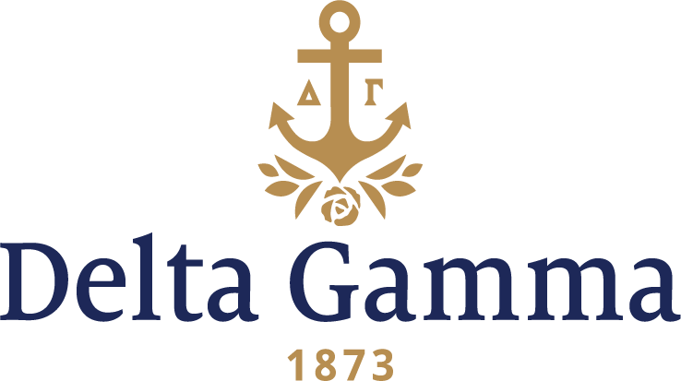

**Delta Omicron- Morehead State**

**Fast Facts:**

* Installation date: May 9, 1970
* Location: Morehead, KY
* Region: 2

**History:**

In 1969 and 1970 Delta Gamma heard from 92 different schools who were interested in Delta Gamma expanding to their campus. Many of these, including Morehead State, were former state teachers’ colleges which had become full universities.

In April, 1969 Delta Gamma received a letter from the president of Alpha Sigma Rho, the first sorority founded at Morehead. This group, founded in 1962, was originally known as the CAPA Tridents. The objectives of this organization were to promote good character, pleasant appearance, strong personality, and academic potential.

Alpha Sigma Rho was the top group on campus. Each year they sponsored the CAPA Carnival (later known as the Delta Gamma Carnival) where each fraternity and sorority set up a booth to earn money for philanthropic causes. The women served as foster parents to a Vietnamese child, sponsored a local Girl Scout Troop, and presented an annual $200.00 scholarship to a worthy freshman through the CAPA Trident Alumni Scholarship Fund. Members participated in many campus organizations and activities. (Seven members of the Homecoming Court, and the first runner-ups to Miss Kentucky and Miss Morehead State were Delta Gamma colony pledges.)

Several girls in the group traveled to Columbus in June, 1969 to meet with the members of Council who were in Columbus for Leadership School. They were promised that a team of two would visit during the fall and meet the group.

In November the Student Life Committee approved the request of Alpha Sigma Rho to petition Delta Gamma.

Since Morehead State had not been approved by Convention as a possible expansion site, it was necessary to take an area vote of collegiate and alumnae chapters within a 250-mile radius of Morehead. On January 18, 1970 Betty Davis Philley, Gamma Alpha, a Morehead, KY alumna, was notified by phone that the votes were affirmative and Delta Gamma would be adding another group in Kentucky.

It was on George Washington's birthday, February 22, 1970, that Delta Beta-University of Kentucky collegians conducted the pledging service for the new Morehead colony members.

The installation weekend started on Friday night, May 8, with an inspirational get-together in the living room of the Home Economics Building. Gamma Alpha-Tennessee members participated in the inspiration and initiation ceremonies. Initiation was held at 1:00 in the Combs Building on Saturday (May 9) for 31 collegiate members, 6 alumnae, and 5 patronesses. The respected and dedicated Alpha Sigma Rho sponsor, Nell Fair Mahaney, was initiated as a patroness. A banquet followed in the Red Room of the Adron Doran University Center with the theme "A Time for Us." Lisa Martin Palas, charter member, wrote the following words to the theme from Romeo and Juliet to express the sentiments of the women.

"A Time for us, Someday there'll be

When we'll be sister of DG

A time to share

The love we've found in CAPA Tri

To build the new

In memory of the happy years gone by

The change must come, but just in name;

The sisterhood will stay the same.

For years to come, the time will come

But don't be sad.

Remember the years in CAPA Tridents that you've had.

A time for us, today we'll be,

Together as Delta Gamma sisters, you & me."

Province X Collegiate Chairman, Rose Godwin Brown, presented the chapter with a ring made from the badge with which she was initiated as a member of Alpha Psi chapter with the understanding that the ring be passed on each year to the best pledge.

On Sunday morning Fraternity officers, alumnae, and initiates attended the First Christian Church. From 2:00 - 4:00 in the afternoon a reception was held for the chapter in the social living room of the Home Economics Building.

• Rita Speers Webb Memorial Scholarship established by chapter in 2000 to honor first chapter president