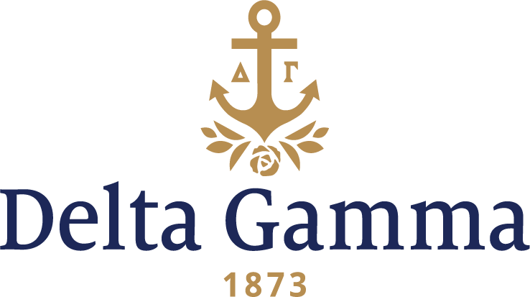

**Epsilon Delta- Washington & Jefferson**

**Fast Facts:**

* Installation date: November 17, 1979
* Location: Washington, PA
* Region: 1

**History:**

Although Washington and Jefferson is one of the nation's oldest institutions, having been founded in 1781, it has accepted women only since 1970. Two men's fraternities, Phi Kappa Psi and Phi Gamma Delta, were founded there.

This all came about because a group of determined women would, in the winter term of 1978, try once again to bring national sororities to Washington and Jefferson. These women, however, would be far more persistent, better organized and, more importantly, better able to attract students than those in the past. At meetings attended by as many as 60 women mutual interests about sororities were explored. Extensive investigations were conducted in this search for ways to assure their success in establishing sororities on their campus. Before the winter semester ended, the women agreed to invite several national sororities to visit the campus."

An "extensive investigation" involved contacting the Greek advisor at University of Pittsburgh for advice who explained the NPC expansion process. This investigation group also did research into the NPC groups and voted to invite DG and Pi Phi to colonize.

The sign reads, “Delta Gamma wants to meet you, April 8, 1979, 6:15, Student Center Lounge, Sign up Now, Dean Riesenman’s Office.” Julie Hartshorn, Epsilon-Ohio State, Delta Gamma Executive Offices Staff Expansion Coordinator; Maggie Watkins, Alpha Xi-West Virginia, staff ANCHORA Editor; Barbara Laederach, Lambda-Minnesota, and Patricia Danielson, Theta-Indiana, arrived to assist with the colonization. Invitations had been sent to female students expressing both W & J and Delta Gamma celebrated “heritage, tradition and quality” with DG adding membership also means, “lasting friendships, enduring values, intellectual motivation, personal responsibility, commitment and fulfillment and a rich heritage.” Ten members of Alpha Xi-West Virginia, arrived to help with the Colonization weekend.

The first parties, held in the Student Center, were mostly an introduction to the Fraternity – rushes filled out information sheets, each Alpha Xi took 3 or 4 women to the punch and cookie table to “mingle,” a short presentation explaining what Delta Gamma is, and a slide show of DG’s various chapters accompanied by taped singing. The potential new members left as the group serenaded them with “Hannah.”

Second parties, considered Preference parties, were held on April 10 in the Mount Vernon Room of The George Washington Hotel. All the Alpha Xi’s were dressed in black velvet skirts and cream blouses. This was a formal event, where the girls were seated at tables with place cards, mainly with Alpha Xi’s, and a Preference ceremony was held. After it was over, it had been agreed between the Dean’s office, Pi Phi and DG that Dean Ruth Riesenman would work out the placement of new members so that there would be even distribution between in forming the new colonies. We received 33 potential new members.

Susan Ruth Cornell recalls, “The women of Alpha Xi, WVU, held our preference party. It was held at the George Washington Hotel. They wore floor length, velvet skirts and cream blouses. Maggie Watkins, herself an initiate of Alpha Xi, introduced us individually as we ascended the stairs. I can still hear her - Ladies of Alpha Xi, I present to you, Linda Andrews - we were lined up in alpha order. As each of us was introduced, an Alpha Xi member came forward and escorted us into the room. We were served those "flower brownie sundaes" and ginger ale. We received a cream rose which we got to take with us - that made a big difference to me because the Pi Phi gave us burgundy carnations which we had to throw into a mirror pond and make a wish for Pi Phi.”

On April 11, at 7 PM, the Pledging ceremony took place, followed by a reception in the Student Center Lounge put on by the local alumnae. The local chairman, alumna Mrs. Joan Kerr Challburg, Beta Chi-Denver, Mrs. Laederach, Mrs.Danielson, and Mrs. Watkins, along with the new Colony members formed a receiving line as they were introduced to the university community. The colonization team stayed for meetings and training with both advisers and the chapter, holding two pledge meetings before leaving.

On Saturday morning, November 17, 1979, twenty-seven women and two patronesses were initiated as members of Epsilon Delta chapter by 25 members of Epsilon-Ohio State.

An Installation luncheon was held at the Valley Brook Country Club. Parents and friends of the initiates, members of the school administration and staff, Delta Gamma officers and alumnae and collegians from the Pittsburgh area attended the luncheon. (Epsilon chapter members had to hurry back to Columbus for the Ohio State-Michigan annual football game.) Toastmistress was Maggie Watkins and Fraternity President Elizabeth Beach Norris, Beta Kappa-Kansas, spoke of Delta Gamma’s credentials as a leader in the fraternity world, and reminded the initiates of the special qualities of the three founders. Dr. Howard Burnett, president of Washington and Jefferson College, welcomed guests and emphasized the college’s dedication to academic excellence. The charter was presented by Mrs. Norris to Linda Andrews, chapter president. Louise Less Joslyn, Rho-Syracuse, Director of Colonies, was present for the weekend activities and she and Staff Expansion Coordinator, Chris Herklotz, Delta Omicron-Morehead State, attended a model chapter meeting on Sunday afternoon. Province II Alumnae Chairman, Doris Sprong, Beta Iota-Purdue, presented gifts and ‘lucky bucks’ to the new group and read numerous greetings from Delta Gamma officers and alumnae. Local chairman for the installation was Joan Kerr Challburg, Beta Chi-Denver. Many members of the Pittsburgh-South Hills alumnae chapter contributed their time and talents to the chapter and were on hand for the installation. Marilyn McGarity Minford, Alpha Rho-Ohio Wesleyan, was luncheon coordinator.

Epsilon Delta chapter of Delta Gamma Fraternity became our 103rd chapter and the chapter held its first formal rush for freshman in February 1980. They pledged thirteen more women bringing the chapter total to 40 members. They attended their first Founders Days celebration with local alumnae on March 15 and on April 11 held their first “Anchor Splash.” A chapter house on Beau Street became our chapter house and the alumnae spruced it up for us even though it would be torn down to build a W&J building at the end of the school year. where we held our first fall rush, adding seven more pledges to our chapter. In February they added 24 more pledges, again enlarging the chapter.

February 1981, first Cream Rose Formal is held at the Fireside Room of the Hilton in Washington, Pennsylvania.

1983, Epsilon Delta develops the morale of its members by including in each meeting a “Garden Report.” The public relations committee presents a flower to members for their helps contribution to members and on campus from week to week.