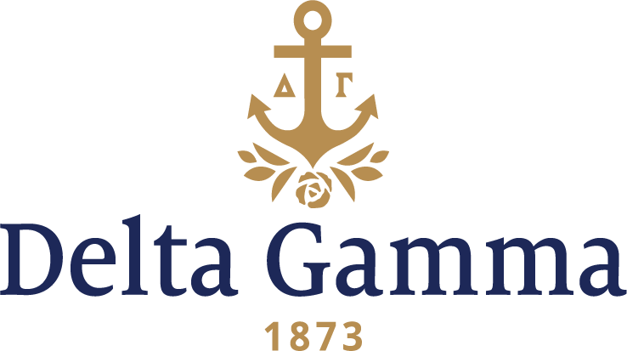

**Epsilon Mu-William & Mary**

**Fast Facts:**

* Installation date: February 20, 1982
* Location: Williamsburg, VA
* Region: 2

**History:**

In 1693, King William III and Queen Mary II granted a charter to establish “the College of William and Mary in Virginia.” Many of America’s early leaders were educated at William and Mary, and therefore has been called “the Alma Mater of a Nation.” The College closed in 1881, and reopened in 1888 with a state grant of $10,000. Since 1906, it has been a state institution with a Board of Visitors appointed by the governor. It became coeducational in 1918.

For many years Delta Gamma has been on record, by correspondence with the dean of women, as being interested in a chapter on the William and Mary campus. Delta Gamma made contact as early as 1936 with Virginia Rowe Holmes, Chi-Cornell, who was the historical botanist of Colonial Williamsburg. She was highly regarded by members of the faculty and was a close friend of the dean of women. For many years, the Board of Visitors of William and Mary decided that no more fraternity groups would be invited to the campus. Delta Gamma hoped that someday the policy would change. Later contact was established with Mrs. William G. Harkins, the wife of the librarian at William and Mary, whose Delta Gamma heritage dated back to her grandmother’s friendship with the Delta Gamma Founders.

There were rumors in the ‘60s that William and Mary were considering adding another national sorority. In 1981, Delta Gamma and two other National Panhellenic Conference groups were invited to make a formal presentation for fall establishment. Delta Gamma received the invitation to establish and 29 women were pledged on October 9, 1981 with an additional 9 women pledged at the first meeting. Delta Rho-Virginia Tech assisted with a preference party and the formal pledging ceremony.

The new chapter advisory board, chaired by Judith Callahan Peele, Epsilon-Ohio State, dedicated themselves to developing a close-knit caring chapter. The Virginia Beach alumnae chapter became “Aunt Hannah’s” to the new members. New chapter memories included a winning Homecoming float, “Get to Know Delta Gamma” party at the Pub, and the “Setting Sail” new member dance. Kappa Delta, Chi Omega, and Sigma Chi all welcomed Delta Gamma to campus with varied events.

Installation weekend began with a beautiful inspiration ceremony ending with the reading of The Diamond. Initiation was held Saturday, February 20, 1982, in the Great Hall of the Sir Christopher Wren Building, the oldest academic structure in the United States in continuous classroom use. Members of the Gamma Pi-Roanoke conducted Initiation for the 29 charter members. Following the ceremony, the Richmond alumnae served lunch. A reception and dinner were held in the evening at the Williamsburg Hilton. Fraternity President Elizabeth Beach Norris, Beta Kappa-Kansas said, “It was a perfect Installation in every way.”

Epsilon Mu was the first chapter to win the George Banta Award at the 1984 Convention. They won the award again in 1986. In 1993-94 the chapter won the Philanthropy Award/ Scholarship Award by William and Mary Director of Student Affairs.