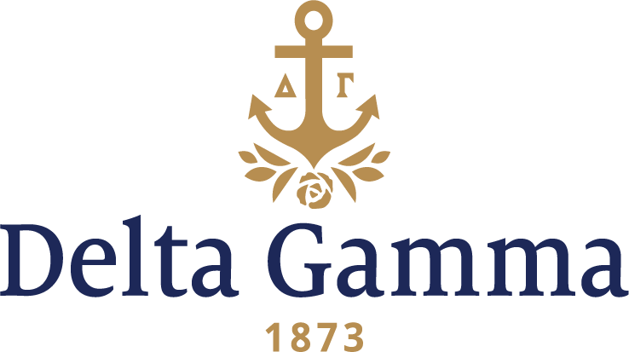

**Epsilon Nu-James Madison**

**Fast Facts:**

* Installation date: May 1, 1982
* Location: Harrisonburg, VA
* Region: 2

**History:**

Founded in 1908 as a women's college, James Madison University was established by the Virginia General Assembly. It was originally called The State Normal and Industrial School for Women at Harrisonburg. In 1914, the name of the university was changed to the State Normal School for Women at Harrisonburg. At first, academic offerings included only today's equivalent of technical training or junior college courses; authorization to award bachelor's degrees was granted in 1916. The university became the State Teachers College at Harrisonburg in 1924 and continued under that name until 1938, when it was named Madison College in honor of James Madison, the fourth President of the United States whose Montpelier estate is located nearby in Orange, Virginia. In 1946, men were first enrolled as regular day students. In 1966, by action of the Virginia General Assembly, the university became a coeducational institution. In 1976, the university's name was changed to James Madison University.

Epsilon Nu is part of a big growth phase that took place in the ‘80s. Delta Gamma Fraternity was invited to establish at James Madison on February 12, 1982. Members of Delta Rho-Virginia Tech and Epsilon Gamma-Virginia helped with recruitment, and ultimately pledged 51 women. Delta Gamma Fraternity was the ninth NPC group on campus. Beth Merritt, a transfer from Virginia Tech and fourth year student at James Madison, served as a special counselor to the group during the establishment period to prepare members for Initiation.

Fraternity President Judy Van Scoyk Barnhart, Gamma Iota-DePauw, and Executive Director Maggie Hess Watkins, Alpha Xi-West Virginia, helped establish the chapter, and remembered that during the Epsilon Nu pledge parties, there was an escaped convict on the loose. He was running along the railroad tracks through campus with the police chasing him; the campus was on lockdown, and all of the women could see the chase through the window of the campus building where they were bunkered down.

The charter members were initiated on April 30 in a ceremony conducted by Delta Rho. On the next day, Epsilon Nu was officially installed with 49 new initiates. The charter was presented to the chapter’s president, Holly Bachand by Fraternity President Judith Van Scoyk (Waymire) Barnhart, Gamma Iota-DePauw. Director of Colonies Nancy Stephens Rumble, Beta Iota-Purdue worked with local alumnae and was very much involved with the activities of the new chapter.

Upon Installation, the chapter was immediately involved on campus. Epsilon Nu held its first Anchor Splash® on campus in 1983. The chapter was the first fraternity/sorority organization at JMU to organize a fundraiser where the entire campus was invited to participate. Other activities such as a Sweetheart Ball only added to the positive exposure on campus.

Epsilon Nu was awarded several awards during the University’s annual Greek Sing and two women were chosen for Order of Omega, a national Greek Honor Society. The chapter’s reputation as being a new, unique and unpredictable sorority to the students and faculty of James Madison grew to 85 members in two years and every member was proud of their chapter.

Epsilon Nu continued to be sensitive to the community at large. In 1991 they dedicated their Greek Sing with “Celebrate America with DG” as the theme, dedicated to the United States troops in the Persian Gulf. Once again, they walked away with awards and more sisters into the Order of Omega.

In 1999, Epsilon Nu sponsored its first Kid’s Skate in November in conjunction with the local Big Brothers/Big Sisters organization. They paid weekly visits to their adopted “Grandma”, Miss Sallie, and others at the local retirement center and continued to grow and be recognized on campus for their commitment to service and sisterhood.

The chapter held several unique events. Epsilon Nu held its first Anchor Dash 5k in the arboretum during philanthropy week, as well as other events like DG Carnival and Scoops for Sight to benefit the Foundation.

After Installation, the university granted Epsilon Nu temporary housing for 18 of the new sisters on campus in the Hillside trailers, and then in 1986 was granted new housing at the Hunters Ridge Condominiums. On October 31, 1987, the new Epsilon Nu house on Greek Row was dedicated. The chapter is still located there today, and it houses 28 women. In 2013, the basement level received a complete remodel.