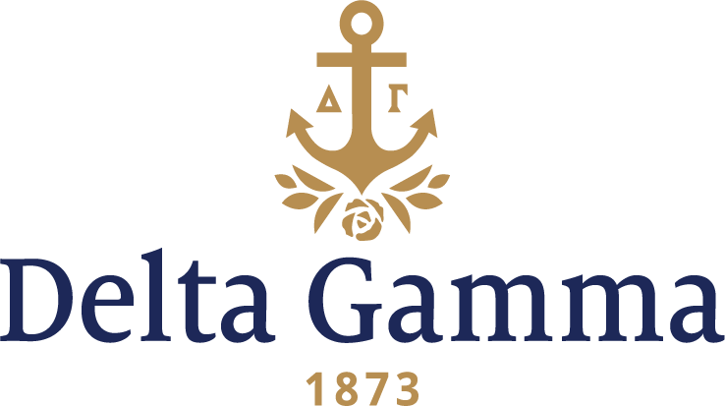

**Eta Delta-North Florida**

**Fast Facts:**

* Installation date: November 13, 1999
* Location: Jacksonville, FL
* Region: 3

**History:**

The university was founded in 1969 after 1,000 acres midway between downtown Jacksonville and the Jacksonville Beaches were set aside for the campus. Until this time, the only publicly funded institution of higher learning was Florida Community College in Jacksonville. Construction on classrooms and buildings began in 1971 and UNF opened in the fall of 1972 with an initial enrollment of 2,027 juniors, supported by 117 faculty and more than 150 staff. Originally, like the other Florida state institutions opened around this time, UNF was designated as a "senior" college, meaning that it would enroll only upperclassmen and graduate students. Freshmen and sophomores were admitted for the first time in 1984. Enrollment at UNF exceeded 10,000 in 1995.

The Sorority Interest Group, also known as SIG, was founded in the fall of 1997 by Beth Slater, and the first meeting was held February 12, 1998. Initial interest was slow, but as with all good things, grew as word spread and new members joined. In only a year and a half of existence the ladies of SIG had created the beginnings of very well-organized sorority. A constitution was composed in March 1998, and meetings were held every week to discuss ideas, make plans for recruitment and promote new membership. The long hours paid off and the SIGs felt their first bit of acceptance to the Greek Community when the Sigma Chi’s hosted a barbecue for the ladies in September, 1998. The first set of SIG officers were elected September 20, 1998. Committees were set up in line with what was thought to be “typical” sorority fashion and included areas such as promotion, community service, sisterhood, chapter care, and Panhellenic respect.

SIGs participated in a variety of activities during the 98-99 school year including Homecoming and Greek Week. Their potential for Greek affiliation was also expressed when they held their first retreat at St. Augustine Beach, FL. The weekend was filled with studies of the Panhellenic guidelines, activities to build sisterhood, and an evening with a special ceremony. Peach colored roses were given to each woman to symbolize friendship. The colors of SIG were also revealed; white meant sisterhood, blue stood for integrity, and green meant generosity.

Participation in fall rush had been stagnant in previous years, causing a few insightful members of the fraternity and sorority community to ponder the need for a new sorority to get things jump-started. The SIGs worked hand in hand with Greek Affairs Coordinator, Joe Petri, and the Panhellenic president, Rae Wilder. The persistence and dedication of Wilder was a major factor in the community opening for establishment by a national organization. In April, 1998, the first meeting of the Panhellenic Extension Committee was held.

Spring 1999 was an exciting semester for SIG as letters of interest for expansion were sent out by Panhellenic and were answered by four strong national sororities: Alpha Omicron Pi, Delta Gamma, Delta Zeta, and Kappa Delta. In March, four remarkable ladies represented Delta Gamma and made a presentation to the ladies of SIG. Officers of Panhellenic Council and the SIGs made an official vote on March 29th and the vote for Delta Gamma was unanimous. On April 1, 1999, Delta Gamma confirmed its choice to accept the invitation of Panhellenic.

On April 20, 1999, 24 ladies were pledged into the Eta Delta new chapter. The ceremony was followed by a reception with 60 guests congratulating the new members. Members from Gamma Theta-Florida and Gamma Mu-Florida State chapter were also on hand. Eta Delta’s first rush was held in September 1999. The PR promotions, planned for the week before recruitment, were ruined by Hurricane Floyd, and UNF was officially closed for two days. The strong colony would still go on to pledge 30 women. Installation and Initiation was held on Saturday, November 13, 1999 and 51 new members were welcomed to Delta Gamma Fraternity.