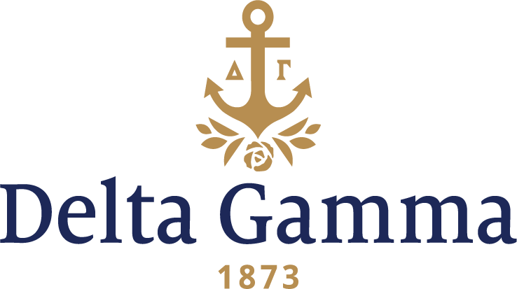

**Eta Kappa-North Carolina State**

**Fast Facts:**

* Installation date: November 17, 2002
* Location: Raleigh, NC
* Region: 2

**History:**

The North Carolina General Assembly founded NC State on March 7, 1887 as a land-grant college under the name North Carolina College of Agriculture and Mechanic Arts. After opening in 1889, NC State saw its enrollment fluctuate and its mandate expand. In 1918, it changed its name to North Carolina State College of Agriculture and Engineering, or North Carolina State for short. During the Great Depression, the North Carolina state government, under Governor O. Max Gardner, administratively combined the University of North Carolina, the Woman's College (at Greensboro), and NC State. This conglomeration became the University of North Carolina in 1931. In 1930, the first female enrolled as a freshman, and by 1945, 58 women were enrolled on campus.

On September 24, 2002, the Delta Gamma expansion team set up displays at Tally Student Center, and on September 25, began interviews of 133 women as potential new members for Eta Kappa chapter. A preference party was held at the University Club with help from Beta Theta-Duke collegians on September 26. On September 27, the Pi Alpha ceremony took place in Bragaw Hall, and 86 women were welcomed into Eta Kappa new chapter of Delta Gamma Fraternity. On November 17, 2002, Initiation and Installation took place at McKimmon Conference Training Center. Fraternity President Maureen McCulloh Hollmeyer, Gamma Rho-Wittenberg, presented the charter to new chapter president Lindsay Gentry, and officially welcomed Eta Kappa as Delta Gamma’s 143rd chapter.

The chapter strongly supports the Foundation and holds events that help raise money towards the philanthropy. Such events include Anchor Splash® and an annual cornhole tournament. The women also volunteer at Prevent Blindness North Carolina, and assist at Brighton Gardens Assisted Living Center.

By 2008, the chapter was recognized by NC State as Sorority of the Year and Most Outstanding Sorority for the 2007-2008 academic year. The chapter won this award again in 2014 and 2015.