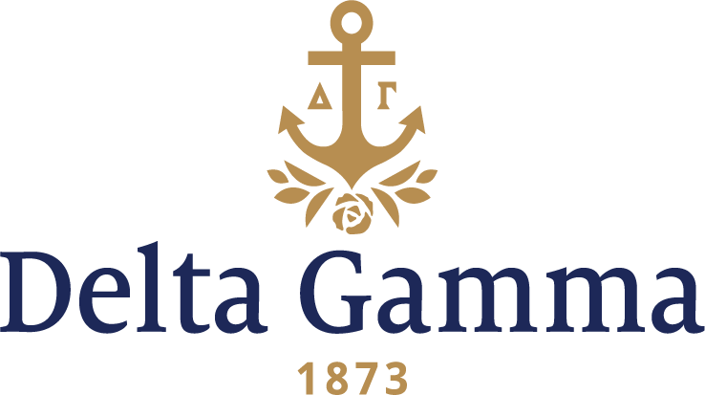

**Eta Lambda-New Mexico State**

**Fast Facts:**

* Installation date: December 5, 2004
* Location: Las Cruces, New Mexico
* Region: 6

**History:**

In 1888, Hiram Hadley, an Earlham College-educated teacher from Indiana, started Las Cruces College. One decade later, the Territorial Assembly of New Mexico provided for the establishment of an agricultural college and agricultural experiment station with Bill No. 28, the Rodey Act of 1889. Designated as the land-grant college for New Mexico under the Morrill Act, it was named the New Mexico College of Agriculture and Mechanic Arts. Las Cruces College then merged with the New Mexico College of Agriculture and Mechanical Arts, and opened on January 21, 1890. It began with 35 students and 6 faculty members. In 1960, in move to better represent its operations, New Mexico A&M was renamed New Mexico State University by a state constitutional amendment.

From the Winter 2004 *ANCHORA*, “DG Gains Strong Presence in New Mexico: Delta Gamma Becomes Sixth NPC Group at New Mexico State”:

“Delta Gamma’s newest chapter, Eta Lambda, was warmly welcomed as it joined the thriving Greek community at New Mexico State University in December 2004.

The happy process began in early September when Delta Gamma presented to prospective new members in the open house round at NMSU’s formal recruitment. This preview generated much excitement on campus and paved the way for a successful colonization later in the month.

The enthusiastic colonization team included Fraternity President Shari Souser Malone, Gamma Epsilon-Kent State; VP: Membership Pamela Fellows Jamieson, Alpha Delta-Oregon; Director: Expansion Shaun Fisher Young, Mu-Missouri; Council Appointed Coordinator Merry Houser, Gamma Epsilon-Kent State; Collegiate Recruitment Consultant Erica Jensen-Beta Delta-Colorado College; Staff Director of Expansion and Consultants Tracey Doebling Williams, Beta Sigma-Maryland; and Collegiate Development Consultants Allison Neswold, Tau-Iowa, and Christy Bergman, Epsilon Theta-Tampa.

Advisory team chairman Barbara Stedje Wise, Gamma Xi-Texas Tech; Region 6 Housing Director Mary Jo Devine Carver, Mu-Missouri, as well as several members of the Eta Lambda house corporation and advisory team provided additional assistance to the colonization team.

Fifty-five collegians from Gamma Phi-Arizona State performed a beautiful preference ceremony- always a highlight of the colonization process. Their “stars” ceremony, with a silver-and-black theme, highlighted the inviting outdoor patio area, as well as the gorgeously decorated lodge.

The result: a proud group of 39 new members (including one legacy) pledged Delta Gamma. A reception followed the Pi Alpha ceremony. Representatives from many other campus Greek groups attended and several brought flowers and gifts.

As the holiday season began, Eta Lambda celebrated with Initiation and Installation December 4-5. On Saturday, 30 collegians and one alumna were initiated as charter members of Eta Lambda chapter. A group of alumnae, including advisers, house corporation board members, local Las Cruces alumnae and members of the El Paso alumnae group, enhanced the special ceremony.

The Installation team members were Malone, Houser, Jensen, Williams and Neswold, plus National Panhellenic Conference Director Barb Bartlett Probst, Gamma Epsilon-Wichita State, and Collegiate Development Consultant Jenna Daugherty, Alpha Tau-Butler.

A Sunday evening banquet capped off the Installation festivities. More than 100 attendees, including many of the new initiates’ family members and friends, enjoyed Delta Gamma music by Fraternity pianist Barbara Probst. David Hotz, Assistant Director of Campus Activities and NPC Outstanding Panhellenic Advisor 2003, brought university greetings. There were many gifts for the new chapter: the President’s gavel, given by Council; the President’s badge from the Region 6 Team; more than $4,000 from the Share in the Future program; a plaque commemorating the chartering from the Office of Greek Life; a flag flown over the U.S. Capitol in honor of Eta Lambda from Vice-President: Collegians Beth Bell Searcy, Gamma Epsilon-Virginia and several others that added special meaning to the occasion.

Malone commented, ‘Our newest sisters are all beautiful women with so much potential to ‘Do Good’ at NMSU!’

Delta Gamma joins five other sororities on campus. In 2003, the National Panhellenic Conference recognized the NMSU Panhellenic Council with the Leadership Award and the Overall Excellence Award.”