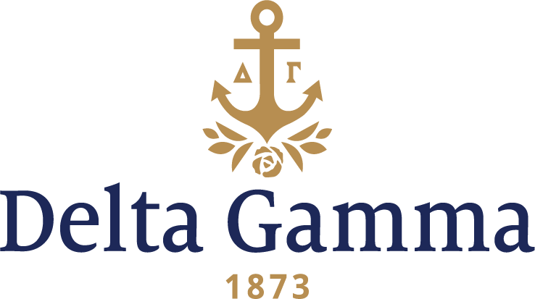

**Eta Omicron-Arkansas, Fort Smith**

**Fast Facts:**

* Installation date: April 14, 2007
* Location: Fort Smith, AR
* Region: 3

**History:**

The University of Arkansas, Fort Smith was originally established as Fort Smith Junior College in 1928 with 34 students. It eventually expanded and took over its current name and identity as a premier regional university when it joined the University of Arkansas system in 2002.

Eta Omicron was established in February 2007 along with Gamma Phi Beta as the first two sororities on campus. Members from Alpha Iota-Oklahoma and the Council of Delta Gamma arrived to conduct the intensive interview process. After the young women experienced preference night, bids were handed out to those who would become the charter members. The chapter was installed April 14, 2007 with Shari Souser Malone, Gamma Epsilon-Kent State, Fraternity President, presenting the charter. Thirty women were initiated.

In the fall of 2009, Eta Omicron hosted its first Anchor Bowl. In the fall of 2010, they hosted Anchor Slam.

In January 2012, House Corporation rented an apartment for chapter guests, composites, the charter and other valuables.

In the fall of 2012, Eta Omicron introduced a new foundation event: A Night for Sight.

As of 2017, the Eta Omicron chapter of Delta Gamma is one of eight Greek organizations on campus.