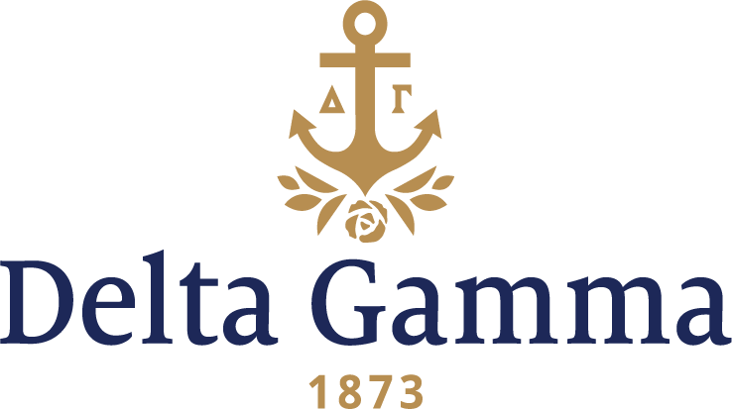

**Eta Theta- Saint Louis**

**Fast Facts:**

* Installation date: November 18, 2001
* Location: Saint Louis, MO
* Region: 5

**History:**

Saint Louis University traces its origins to the Saint Louis Academy, founded on November 16, 1818 by the Most Reverend Louis Guillaume Valentin Dubourg, Bishop of Louisiana and the Floridas, and placed under the charge of the Reverend François Niel and others of the secular clergy attached to the Saint Louis Cathedral. Its first location was in a private residence near the Mississippi River in an area now occupied by the Jefferson National Expansion Memorial within the Archdiocese of St. Louis. It was the first institution of higher learning west of the Mississippi River.

Already having a two-story building for the 65 students using Bishop Dubourg's personal library of 8,000 volumes for its printed materials, the name Saint Louis Academy was changed in 1820 to Saint Louis College. In 1827 Bishop Dubourg placed Saint Louis College in the care of the Society of Jesus, not long after which it received its charter as a university by act of the Missouri Legislature. In 1829 it moved to Washington Avenue and Ninth at the site of today's America's Center by the Edward Jones Dome.

In 1867 after the American Civil War the University purchased the site of its current campus- Lindell's Grove, which was the site of the Civil War "Camp Jackson Affair".

The first building on campus, DuBourg Hall, began construction in 1888, and the college moved to its new location in 1889.

Other Greek organizations on the campus at the time Eta Theta chapter of Delta Gamma Fraternity colonized included Alpha Delta Pi, Gamma Phi Beta, Kappa Delta, and Sigma Kappa.

On Sunday, September 9, 2001 the Eta Theta colony of Delta Gamma pledged 126 women. Other Greek organizations on the campus at the time of the colonization of Eta Theta included: Alpha Delta Pi, Gamma Phi Beta, Kappa Delta, and Sigma Kappa. The average size of the other NPC groups being 128, Delta Gamma was excited with the results of the expansion team. These team members consisted of Carmela Martini, Kate Paulson, Debbie Evans, Debbie Link, Mandy Schermer, Amy Killian, Katie Hopper, Shannon Gilligan, Kara Hayman, Pamela George, Cyrena Fedele, Melanie Friesen, and Vicki Nixon. Chapter members from Iota- Illinois, Mu- Missouri and Alpha Epsilon- Washington traveled to lend a hand in the fast-paced process of forming a colony. On bid day, a barbecue was held for the new members hosted by the Saint Louis Alumnae group and Carol Welsch, the Region 5 Alumnae Programming and Recruitment Specialist. This colonization was the first time that Delta Gamma had conducted both a typical colonization with regularly scheduled interviews while at the same time participating in formal recruitment.

In October members elected their first chapter management team and a strong group of directors. They planned a successful fireside and chapter retreat where the women learned more about themselves, their sisters and Delta Gamma.

Many members from various class ranks were actively involved on campus and created a positive image for the new chapter. Members volunteered at the St. Louis alumnae chapter’s annual Christmas tree sale lot and started their own Campbell’s soup label collection. They planned their first Anchor Splash® and participated in other Greek philanthropic projects.

On November 18, 2001, Eta Theta chapter of Delta Gamma Fraternity was formally installed as the fraternity’s 141st chapter. One-hundred six colony members were initiated at an evening banquet in the Millennium Hotel. Doris Flint, Fraternity President, and Vicki Nixon, Vice-President Communications, presented the charter to the new chapter and its president Maureen Noonan. Family, friends, alumnae and Panhellenic representatives welcomed the chapter to campus, acknowledging the outstanding supporting role of Wendy Born, Council appointed Coordinator, and Kary Bachert, Chairman of the Advisory Team.

The next fall, the chapter welcomed fifty-three more women to the chapter in their first formal recruitment, becoming the largest chapter on SLU’s campus. The chapter held its first Presents, Parents Weekend and Cream Rose Ball. They began helping at the Shining Light Tree Lot- a now favorite pastime, raising money for the Delta Gamma Center, and held their second Anchor Splash®.

Each semester since installation has been full of social events for the women of Eta Theta. Just to highlight a few favorites, they host: Presents, Date Party, Crush Party, surprise Date Dashes, and a Formal each year. They hold a successful Anchor Splash® and maintain one of the highest GPA’s of any organization on campus.