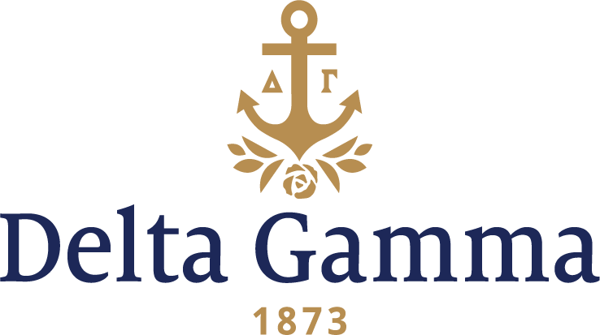

**Eta Upsilon-Drexel**

**Fast Facts:**

* Installation date: January 9, 2016
* Location: Philadelphia, Pennsylvania
* Region: NCR

**History:**

In founding Drexel University, Philadelphia financier and philanthropist Anthony J. Drexel launched a tradition of innovation. Mr. Drexel envisioned an institution of higher learning uniquely suited to the needs of a rapidly growing industrial society and of the young men and women seeking their place in it. Mr. Drexel’s vision was officially realized in 1891 with the establishment of the Drexel Institute of Art, Science and Industry. Originally a non-degree-granting institution, Drexel began conferring the Bachelor of Science degree in 1914, when its 18 departments were organized into four schools. In 1927, the Commonwealth of Pennsylvania granted Drexel the privilege to confer the Master of Science degree, and in 1965, the Doctor of Philosophy degree.

It is to this college community that Eta Upsilon Chapter of Delta Gamma Fraternity welcomed the opportunity to join with an October 2015 establishment. With 31 recognized Greek-letter organizations on campus, over 1,700 Greek undergraduate members, and tracing the history of the Greek community to the year 1900, Delta Gamma has continued the long-standing Drexel traditions of excellence in its members through academics, friendship and service to the community since their establishment.

On January 9th, 2016 Eta Upsilon and its 67 charter members became Delta Gamma Fraternity’s 147th collegiate chapter. At the Installation of Eta Upsilon, Maddie Hertz, first chapter president, received the chapter’s charter from Fraternity President Stacia Skoog, Beta Zeta-Denison. Grace Acuña, Gamma Xi-Texas Tech and Abigail Whalen, Theta-Indiana, Collegiate Development Consultants who oversaw the development of the chapter, shared with the founding members of Eta Upsilon, “Beginning with infoviews, our extension team was blown away by the caliber of women interested in Delta Gamma. They described you all as leaders, driven, intelligent, determined, involved, and curious. They described you as Delta Gammas,” and ended their message with the task to “always remember this day and know you have infinite value to each other, the Fraternity, us, and the future”.

Since Eta Upsilon’s establishment, the chapter has worked hard to establish itself on Drexel’s campus, as well as have an impact in the community. During the 2017-2018 school year, Eta Upsilon worked closely with neighboring chapter Zeta Chi-Delaware to plan a joint Founders Day celebration. The two chapters also supported one another by attending the other’s philanthropy events.