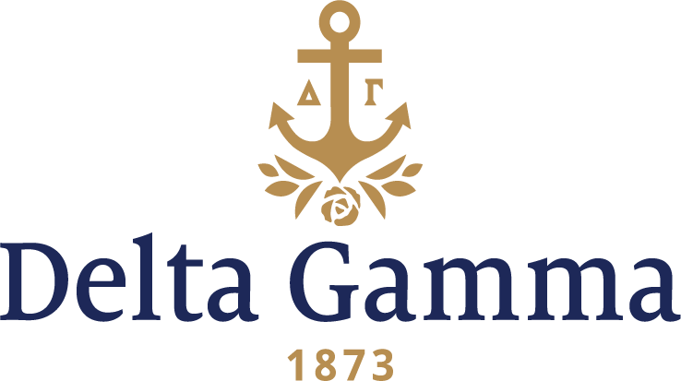

**Gamma Alpha-Tennessee**

**Fast Facts:**

* Installation date: May 10, 1947
* Location: Knoxville, Tennessee
* Region: 2

**History:**

Blount College was founded in 1794 as an all-male institution. In 1807, the college became a state institution and was renamed East Tennessee College. Two years after, in the wake of financial issues, the college closed for several years. By 1920, the college had reopened, and with improved finances, was able to purchase 40 acres just west of downtown to establish a campus on what is now known as “The Hill”. With passage of the Morrill Act in 1862, East Tennessee University became a land-grant institution and was renamed the University of Tennessee. By 1946 the university served 3,434 students, 1,355 of whom were women.

In the fall of 1946, the University of Tennessee was open for extension to add to the nine NPC organizations on campus already. After several interviews with the Dean of Women, Miss Harriett C. Greve, and several other University officials, the chapter was colonized on October 10, 1946 with 10 members. May 10, 1947, the Gamma Alpha chapter was installed with 17 founding members. Susan Langstaff, chapter president, received the charter for Gamma Alpha. The initiation was held at the Zeta Tau Alpha room of the Panhellenic building, and a banquet followed at the Andrew Jackson Hotel with the theme “Delta Gamma Fashionata.” A formal reception was held at the Sigma Alpha Epsilon house the following afternoon. Pledge fees at the time were ten dollars and the initiation fee was fifty dollars, while monthly dues were a mere six dollars!

One of the most outstanding occasions for Gamma Alpha that year was their first formal of the series to come. The theme was “Diamond Jubilee.”

In 1952, the original painting for the March of Dimes poster was presented by artist John Falter to the nation’s armed forces. Gamma Alpha’s Marie Diamond accepted the poster on behalf of the United States Marine Corps.

In 1968, Gamma Alpha became the second chapter nationally to host Anchor Splash® to raise money for Delta Gamma’s philanthropy as well as promote relations with the fraternities. The first philanthropy event involved only fraternity pledges. The big brothers were only allowed to help with one event- the Pajama Race, which involved the big brothers wearing ski pajamas over their swim trunks, swimming the length of the pool and handing them off to the little brothers to do the same. Gamma Alpha is given credit to making Anchor Splash the incredibly successful philanthropy event that is known nationally today.

In 1977, 30 years after colonization, Gamma Alpha’s Nancy Ann Minn became the first woman to hold the office of student body president at the University of Tennessee. Gamma Alpha also received city-wide publicity for our “Beat Bama” pep rally, the largest ever on campus. Delta Gamma was awarded the spirit trophy for the football season in recognition of all our continued support of the university. Anchor Splash, All Sing, and Chapter programs such as firesides and apple-polishers were a tremendous success for Tennessee’s Delta Gammas as they brought the chapter the award of Most Innovative Programming at the Greek Awards Banquet.

1981, the University of Tennessee Delta Gamma’s took top honors for Foundation Work, community service, and rush at the Province Four Leadership School. They were also named Most Outstanding Chapter in the Province.

In recent years, Gamma Alpha has only prospered. In two thousand and two, Gamma Alpha initiated forty-three new members into our chapter. We won first place overall in Homecoming with Alpha Gamma Rho fraternity, third place in Carnicus, first place in Greek Week and then won the biggest award on campus- the ACE cup.

In the spring of 2011, Gamma logged over one hundred hours of volunteer work with Vision Camp.

In the fall, Gamma Alpha had full IFC participation in Anchor Splash and sold over 400 Anchor Splash t-shirts.

In the fall of 2014, Gamma Alpha moved into their new home in Sorority Village. The house features a workout room, huge closets, a coffee bar, and a large sunroom that overlooks the Tennessee River.