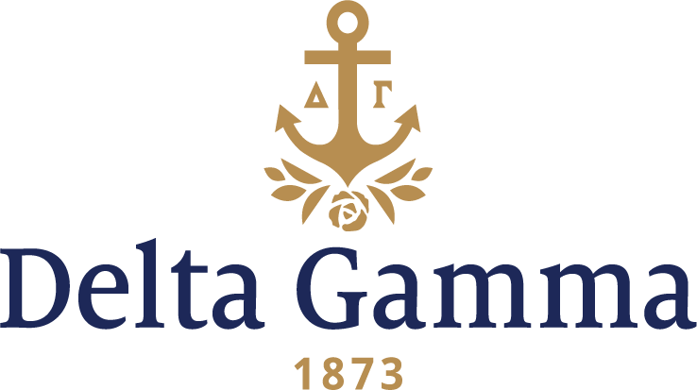

**Gamma Lambda-Cal State, Fresno**

**Fast Facts:**

* Installation date: May 5, 1951
* Location: Fresno, CA
* Region: 8

**History:**

Fresno State was founded as the Fresno State Normal School in 1911. The original campus was what is now Fresno City College. In 1956, Fresno State moved its campus to its present location in the northeast part of the city, and FCC bought the old campus and moved back in. The college became Fresno State College in 1949, when it was authorized to grant bachelor's degrees. It became a charter institution of the California State University System in 1961. In 1972 the name was officially changed to California State University, Fresno.

A local sorority known as Agenda formed in 1918. Agenda was one of the first local groups to establish on the Cal State, Fresno campus, and was very active on campus from its start. The group changed its name to Omega Chi Omicron several years after its founding.

Cal State, Fresno opened for extension by national sororities in June 1950. During the fall of 1950, Omega Chi Omicron and several other groups on campus listened to the extension presentations of many national sororities. When Omega Chi Omicron heard the Delta Gamma presentation, they knew that was the organization with which they wished to affiliate.

Omega Chi Omicron officially petitioned the Fraternity for a charter in December 1950, and in February 1951, the group received word that the Fraternity had accepted their petition.

The women of Omega Chi Omicron travelled to San Jose State to be officially pledged in a ceremony conducted by the president and vice-president of Gamma Eta-San Jose State. Gamma Lambda was officially installed on May 5, 1951. Delta Gamma is the oldest existing member of the National Panhellenic Conference at Fresno State.

Members support the Foundation by volunteering at the Valley Center for the Blind, Walter Elementary School, and at a local retirement community.

In 1976, the chapter celebrated its 25th anniversary at the Founders Day luncheon.

Gamma Lambda held its first Anchor Splash® in 1980.

Gamma Lambda’s chapter house was the first house built on the sorority mall in 1962.