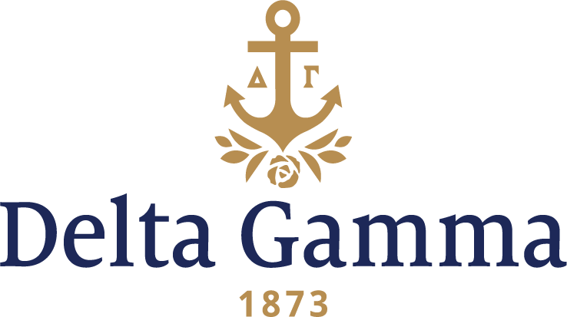

**Nu-Idaho**

**Fast Facts:**

* Installation date: September 6, 1911
* Location: Moscow, ID
* Region: 7

**History:**

The University of Idaho is the state's flagship, land-grant and primary research university. Formed by the territorial legislature on January 30, 1889, the university opened its doors in 1892 on October 3, with an initial class of 40 students. The first graduating class in 1896 contained two men and two women. It presently has an enrollment exceeding 12,000, with over 11,000 on the Moscow campus. The University of Idaho was the state's sole university for 71 years, until 1963, and its College of Law, established in 1909, was first accredited by the American Bar Association in 1925.

In 1899-1900, the Beta Sigma local sorority was founded at the University of Idaho. Beta Sigma was inspired by Mrs. Frederick Padelford, who held the group to the high ideals of scholarship and humanity, and advised it in the critical organization period. On December 27, 1906 the corresponding secretary of Beta Sigma wrote to Ruth Rosholt, Secretary of Delta Gamma. The letter stated:

*“After careful thoughts and investigation the Beta Sigma sorority of the University of Idaho has decided to work for a chapter from Delta Gamma and I write you this to ask for forms of charter petition and blanks. We earnestly hope that we can meet the requirements of Delta Gamma and that all our efforts will finally be crowned with success.”*

This petition and two others dated 1908 and 1909 were turned down. Ruth Rosholt wrote on June 22, 1907,

*“At the national convention of Delta Gamma it was voted to refuse the petition of Beta Sigma. This decision has nothing to do with the personnel of the girls or the standing of the college. The fraternity establishes chapters slowly and has within the last two years already established two.”*

This is an example of the very conservative expansion philosophy of Delta Gamma in the early years.

Two more petitions were submitted by Beta Sigma. One petition dated January 22, 1910 was a 30-page professionally printed booklet which included photographs of the petitioning members, pictures of campus buildings, letters of recommendation and extensive information about the University of Idaho. Included with the petition was a letter from the Dean of Faculty, which noted, “you have attracted your membership to some of the highest types of young women, prominent in the best features of college life, including scholarship.” The following year, Delta Gamma accepted the fifth petition of Beta Sigma to become a chapter.

Saturday, September 16, 1911 was the date of the Installation of Nu chapter. Delta Gamma was the second National Panhellenic Conference chapter to establish at the university. Initiation was held at the house rented by Beta Sigma. In the afternoon, 10 upper classmen were initiated. In the evening, assisted by the brand-new members, six sophomores and freshmen were initiated. The charter members were: Lillian Clark, Minnie Kiefer, Beryl Johnson, Louise Sebree, Beatrice Swain, Eva McFarland, Elizabeth Redway, Jewell Bothewell, Mattie Herr, Lydia Lohline, Geneal Hague, Mary Peteina, Alice Cooper, Lucile Robards, Margaret Neuman and Hazel House. Following Initiation, a banquet was held at the girls’ dormitory. The toastmistress at the banquet, Mrs. Ramage, noted how it was the university which made the Fraternity possible so that only by loyalty to the college can one be truly loyal to the highest teachings of the Fraternity.

Leadership has long been a part of Nu’s culture. In 1912, just one year after Installation, Delta Gammas held three of four class officer positions available to women on the campus, and two Delta Gammas were the lead in the school’s theater production, as well as another two Delta Gammas serving as editors of the school paper.

Nu’s first philanthropic work included supporting a Belgian re-building fund and sponsoring a French orphan of the war.

In fall 1981, Nu held its first Anchor Splash®.

In April 1986, Nu celebrated its 75th anniversary. Festivities included a brunch, a formal dedication ceremony of the newly renovated house, house tours, and a formal banquet.

Nu held a centennial celebration in 2011, with Fraternity President Beth Searcy speaking.

The women first met in a home with two rooms in an office building downtown. In 1913, after leasing a house for two years, 20 members moved on campus and secured a house built specifically for a fraternity (next door to Phi Delta Theta). In 1920, the chapter moved to another house, conveniently next door to the Phi Delts again. In 1940, this mortgage was burned. Nu was the first sorority at Idaho to have its own house.

The Nu chapter house underwent a renovation that was completed in 1986.