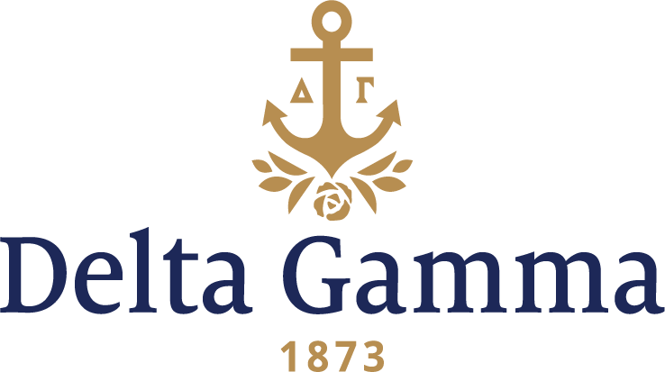

**Theta Beta-Case**

**Fast Facts:**

* Installation date: April 4, 2004
* Location: Cleveland, OH
* Region: 4

**History:**

Western Reserve College was founded in 1826 in Hudson, Ohio, which, at the time, was the region's most populated area and named for the Connecticut Western Reserve, out of which the area arose. Western Reserve College, or "Reserve" as it was popularly called, was the first college in northern Ohio. By 1875, a number of other schools had been established nearby, and Cleveland had emerged as clearly the dominant population and business center of the region. In 1882, with funding from Amasa Stone, Western Reserve College moved to Cleveland and changed its name to Adelbert College of Western Reserve University.

The Case School of Applied Science was issued a charter by the state of Ohio in 1882. The school moved to University Circle in 1885. Over time, the Case School of Applied Science grew to encompass a broader vision, adopting the name Case Institute of Technology in 1947 to reflect the institution's growing stature.

Case Western Reserve University was created in 1967, when Western Reserve University and Case Institute of Technology (formerly Case School of Applied Science), institutions that had been neighbors for 81 years, formally federated.

Delta Gamma’s interest in the Case Western campus predates the modern university, dating back to one of its founding institutions, Adelbert College.

In the spring of 1883, Cornelia W. Beardslee, a student at Adelbert College, later to become Case Western Reserve University, was initiated into Delta Gamma at Buchtel College in Akron, Ohio. She then decided to start a Delta Gamma chapter at her own school, about 13 years before any other sorority came to Adelbert College. Theta chapter initiated five other girls in November 1883, and in December became the 10th chapter of Delta Gamma in the nation, only 10 years after Delta Gamma itself was founded. They chose Theta as their letter after a previously failed chapter that was only in existence for two years. Unfortunately, the Theta chapter was closed in 1888 due to Adelbert College’s termination of coeducation, only five years after its founding.

Soon after, Theta chapter alumnae formed the first Delta Gamma alumnae chapter. Theta alumnae chapter only existed for 3 years and in 1891, they returned their charter because only three alumnae remained in Cleveland.

In September 2003, exactly 120 years after Theta II chapter was founded, Delta Gamma returned to the Case Western Reserve University campus. On September 28, 2003, the Theta Beta new chapter, named in honor of its predecessor, welcomed nine new members. With the help of the nearby chapters of Eta-Akron, Beta Mu-Bowling Green, Gamma Epsilon-Kent State, Zeta Rho-Ohio, Alpha Rho-Ohio Wesleyan, Epsilon-Ohio State and Beta Nu-Carnegie Mellon, the Theta Beta colony participated in its first recruitment and successfully pledged 17 new members. On April 4, 2004, the Theta Beta chapter became Delta Gamma’s 142nd chapter nationally with the initiation of thirty-eight new members.

On April 4, 2004, Theta Beta new chapter of Delta Gamma Fraternity at Case Western Reserve University in Cleveland, Ohio was installed with the initiation of 38 women. This made Delta Gamma both the oldest and the newest sorority on campus.

Since gaining chapter status, Theta Beta chapter has grown remarkably on its campus. Delta Gamma was the first group to paint the Wall with the advertisement of their annual philanthropy event, Anchor Splash®. Three Delta Gammas have been named Homecoming Queen in recent years and for four consecutive years, Theta Beta, partnered with Sigma Nu, won the Homecoming Float contest.

Multiple Theta Betas have served on the Executive Board of the National Panehellenic Council at Case Western. The chapter has also received the Pytte Cup for many years.

In the spring of 2014, the chapter held its first ever Pancake Night for Sight to raise awareness and money for Service for Sight.

The growth of Theta Beta was recognized at the 2010 Convention, when the chapter was awarded the Most Outstanding Chapter in the nation. At the 2012 Convention, the chapter received the Patricia Peterson Danielson award for chapter excellence, as well as awards for excellence in finance and recognition for its Golden Anchor program. The chapter received the Frankie Ladley Wakefield Parnassus award for excellence in scholarship, programming, and philantrophy, along with the Patricia Peterson Danielson award at the 2014 Convention. They also received the Excellence in Scholarship for Region 4 and were runners up for the Barbara Griswald Laederach Recruitment Award.

*See also Theta II-Adelbert*