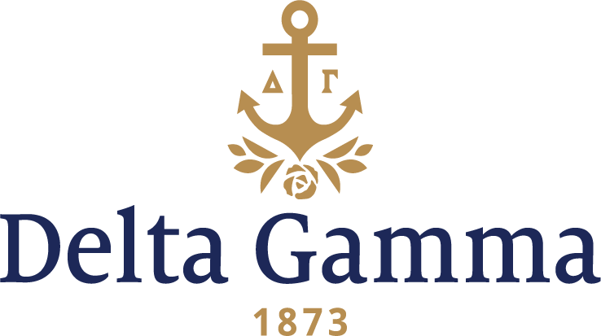

**Theta Gamma-UNC Wilmington**

**Fast Facts:**

* Installation date: April 7, 2018
* Location: Wilmington, North Carolina
* Region: NCR

**History:**

The University of North Carolina Wilmington opened its doors on September 4, 1947, as Wilmington College. At the time, the school operated as a junior college, offering freshman-level courses to 238 students during the first school year, 75 percent of whom were veterans returning from military service following World War II. Wilmington College became a senior college on July 1, 1963, when the North Carolina General Assembly passed legislation allowing the school to offer a four-year curriculum and award bachelor’s degrees. Six years later, July 1, 1969, the name of the school was changed to The University of North Carolina at Wilmington, making UNCW the fifth campus of the University of North Carolina system.

Since the early ‘60s, fraternity and sorority life has been an active part of UNCW student life. Beginning with a few members in a couple local organizations, the community has grown to over 1,600 members in 30 unique fraternities and sororities totaling about 12.2 percent of the undergraduate population.

The establishment of Theta Gamma chapter included events led by Meghan Roberts, Zeta Gamma-Richmond and Morgan Brunelli, Alpha Iota-Oklahoma, Collegiate Development Consultants assigned to support the chapter. “Infoviews” between potential members, Fraternity staff and volunteers, and a preference event with sisters from Eta Kappa-North Carolina State were held in January 2018. The establishment events culminated in spring 2018 with the pledging of the charter members of Theta Gamma-UNC Wilmington and a Bid Day celebration.

The chapter selected Mimi Hill to receive its charter from 2014-2018 Council Trustee: Collegians, Aleesa Miller Ross, Gamma Xi-Texas Tech.

Theta Gamma and its 52 charter members join the sisterhood of over 230,000 living members with their April 7 Initiation and Installation. Theta Gamma celebrates becoming Delta Gamma’s 201st chapter since 1873, and the 151st active chapter of Delta Gamma on college campuses today.