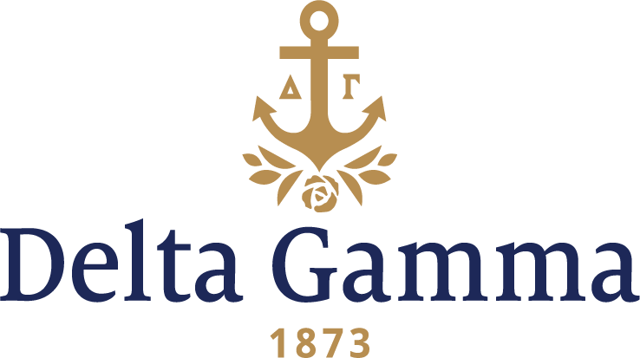

**Upsilon I-Bolivar**

**Fast Facts:**

* Installation date: October 1878
* Location: Bolivar, Tennessee
* Region: 2

**History:**

Bolivar College was a women’s college located in Bolivar, Tennessee. There is very little information to be found about the college, but women educated there were considered to have received a very “liberal” education.

If there is little information on Bolivar College, there is even less about the Upsilon I chapter there. The Upsilon I chapter was chartered in October of 1878. It was one of five chapters chartered before 1883 to still be active in that year.

The chapter closed in 1881, but the exact reason for which is unknown. The exact closure date for Bolivar College is undocumented, so perhaps the two are related.