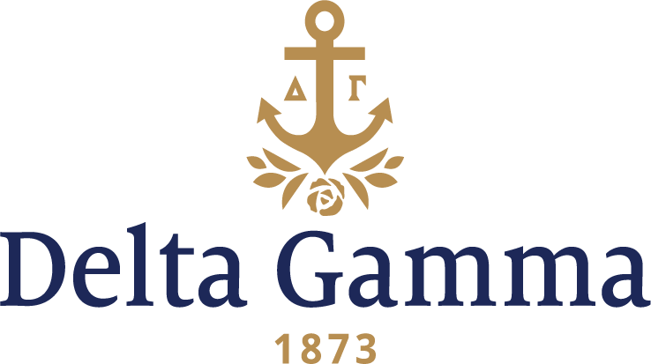

**Zeta Alpha-Villanova**

**Fast Facts:**

* Installation date: September 20, 1986
* Location: Villanova, PA
* Region: 1

**History:**

Villanova University has been sponsored by the Augustinian Order since its founding in 1842. The University traces its origins to old Saint Augustine’s Church in Philadelphia, which the Augustinians founded in 1796, and to its parish school, Saint Augustine’s Academy, established in 1811. Today, the University is comprised of five colleges: Liberal Arts and Sciences (Villanova College), Engineering, School of Business (formerly known as the College of Commerce and Finance), Nursing and the School of Law.

On October 4, 1982 a special group of Villanova women decided to join together and form a local sorority to add to their college experience. They chose the name Tau Kappa Delta. At the first chapter meeting of the year, the TKDs discussed whether to remain a local sorority. An official vote was conducted, and the TKDs began making plans to affiliate with a national organization.

Word of TKDs desire to affiliate with a local sorority reached the Fraternity. Delta Gamma sent the women information about the Fraternity’s purpose and foundation, and an expansion team was invited to give a presentation on September 26, 1985. In October of 1985, the Fraternity was notified that Villanova’s Panhellenic Association had voted Delta Gamma as the first chapter to be offered the opportunity to expand to campus in the fall of 1986. The Fraternity was thrilled!

The pledging of the women of Tau Kappa Delta occurred on March 11, 1986, in a small chapel on campus. Fifty-three women were recruited, and of these women, 47 were initiated on September 20, 1986. At last, the Zeta Alpha chapter of Delta Gamma was officially installed!

In the first eight years after their Installation, Zeta Alpha grew to be one of the largest chapters on campus. They gained the respects of peers, faculty, community members, and the other Greeks.

Throughout the life of the chapter, Zeta Alpha has received the Patricia Peterson Danielson Award 11 times. They have also been recognized with the Founders Award for Division III in 2004, and the H.K. Stuart Spirit of Service Award-Collegiate in 2014.