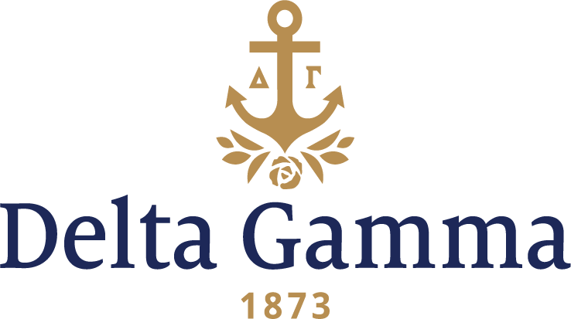

**Zeta Chi-Delaware**

**Fast Facts:**

* Installation date: November 5, 1994
* Location: Newark, DE
* Region: 1

**History:**

The University of Delaware traces its founding to 1743, when Presbyterian minister Francis Alison opened up his "Free School" in his home in New London, Pennsylvania. The school changed its name and location several times, ending up as the Academy of Newark in 1769 (chartered by the colonial government). Since Delaware was part of the Pennsylvania colony until 1776, the academy was denied charter as a college in order to prevent its competing with the University of Pennsylvania (then known as the College of Philadelphia). In 1833, the Delaware General Assembly passed "An Act to Establish a College at Newark", and the next year, Newark College opened. It changed its name in 1843 to Delaware College and it merged with the Academy of Newark. The school closed from 1859 until 1870, and Newark Academy separated from the college in 1869. It reopened in 1870 due to the support of the Morrill Land-Grant Acts. In 1921, Delaware College was renamed the University of Delaware, and it officially became a coeducational institution in 1945 when it merged with the nearby Women's College of Delaware.

Delta Gamma Fraternity was invited to establish at the University of Delaware in September 1994. The Fraternity Colonization Team arrived on campus from September 18 to 21, 1994, to establish the Zeta Chi new chapter. Assisted by chapter members from Beta Sigma-Maryland, open house parties were held on campus in the Rodney Ball Room of the Perkins Student Center. Various Council members and Directors joined Fraternity President Margaret Gorsline, Gamma Epsilon-Kent State; Executive Director Margaret Hess Watkins, Alpha Xi-West Virginia; Coordinator of Expansion Anne Gojdics; Coordinator of Resource Development Laurie Watson, Delta Kappa-South Florida, and Colony Consultant Chrissy Werner Sheets, Eta-Akron, in conducting interviews and introducing Delta Gamma to the potential new members. Preference night saw collegians from Zeta Alpha-Villanova performing their cream rose ceremony encouraging friendship.

By Bid Day on September 21, 1993, women accepted the invitation to become Delta Gamma charter new members at the pledge ceremony held at the Blue and Gold Faculty Club. Following the ceremony, a reception was held where the University guests welcomed Delta Gamma to the campus. The new chapter joined nine sorority groups and 20 men’s groups already established on Delaware’s campus.

Six weeks later Zeta Chi, under the direction of Council Appointed Coordinator Susan Herndon Shue, Beta Rho-George Washington, and Colony Consultant Chrissy Werner, prepared for Installation. It was a beautiful sunny weekend as the ceremonies began. Friday night featured a Candlepass where the 85 members to be initiated shared their bonds of sisterhood and friendship as they prepared to become Delta Gammas. Initiation was held the next morning at the Masonic Lodge in Newark, Delaware. Approximately 240 guests gathered that afternoon for the Installation Banquet which took place at the exquisite Hotel DuPont in Wilmington. The charter was gratefully received, and the new chapter expressed appreciation for the many “Share In The Future” gifts from collegiate and alumnae chapters as well as members of Council and Cabinet.

Zeta Chi chapter has grown and changed in many ways since being installed at the University of Delaware, but they have always held true to the values that our Fraternity founders instilled when they created Delta Gamma in 1873. Though they began as a small chapter, they have made their presence known on campus.

The chapter holds their annual Anchor Splash® philanthropy event in the spring at the university pool.

In the past, Zeta Chi enjoyed working with Zeta Alpha-Villanova in preparation for recruitment. In 2018, the chapter was excited to plan a joint Founders Day celebration with Eta Upsilon-Drexel.

Zeta Chi actively participates in the annual campus dance marathon UDance benefiting the Andrew McDonough B+ Foundation. The 24-hour dance marathon unites the entire Delaware community in the fight against pediatric cancer. In 2018, Zeta Chi helped the Delaware community raise more than $2 million for the B+ Foundation.

From CMT and chapter meetings, to retreats, date parties and assorted sisterhood events; from laughter, tears, smiles and frowns, the most important aspect of this chapter is the incredible strength of sisterhood. Together, Zeta Chi works hard to promote their positive image to the fraternity and sorority community and works even harder at maintaining their sisterly bonds. Zeta Chi has made a lasting impression on the Delaware campus by simply "doing good".