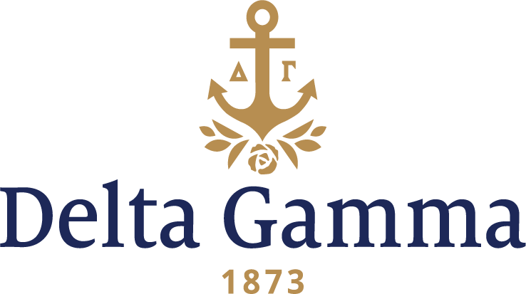

**Zeta-Albion**

**Fast Facts:**

* Installation date: March 9, 1883
* Closure date: November 24, 1987
* Re-installation date: December 13, 1992
* Location: Albion, MI
* Region: 4

**History:**

In the spring of 1883, a group of seven women in Albion College petitioned the Fraternity for a charter through Sigma-Northwestern because one woman was the sister of a Sigma charter member. After an investigation of the college, a charter was granted and through the efforts of Claribel Parr, Sigma-Northwestern, the group was instructed in the purpose and forms of Delta Gamma, and the oath was administered. The new chapter adopted the name of Xi which was changed to Zeta through an error, but this latter name was retained.

Meetings were held in a room rented in a private home, but in 1884 a committee was sent to President Fiske who recognized Delta Gamma and granted the use of a room on the third floor of his home. Zeta remained here for two years and initiated 28 women.

In 1887, college authorities gave the chapter the use of three rooms in the Central Building, Robinson Hall. The women of Zeta were living together in the College Dormitory in the fall of 1886 where Mrs. Campbell, the mother of Jennie Campbell Lovejoy was the housekeeper. They furnished their own rooms and bought a piano for the living room. This was their first attempt of a chapter house which they named Zeta Home.

From Audrey Kenyon Wilder in the 1918 ANCHORA:

*“Situated among the venerable oaks of College Grove is the lodge, dear to the heart of every Zeta alumna, initiate, and pledge. This unassuming, but hospitable-appearing structure, occupies a unique place in Delta Gamma history because it is the first home ever built and owned by a Delta Gamma chapter. To Mary Lownsberry Kellogg (Mrs. A.R.), 1891, belongs much of the credit for this Lodge. Zeta believes its home to be unique for another reason; it is thought she is the one chapter owning and supporting a house which, under college rules, can be used only for regular meetings and occasional social functions. When one considers that the house contains eight rooms, this is no small undertaking for a chapter of about thirty members.”*

Since the building of the lodge in 1891, both the collegiate Delta Gammas and alumnae have had a share in the up-keep of the building, modernizing both the inside and outside in accordance with the passing years. The alumnae, during different periods, have refurnished the Lodge, built on to the living room by enclosing the porch, and added modern plumbing.

On May 9-11, 1899 Zeta hosted the 11th National Convention of Delta Gamma Fraternity, welcoming 150 guests.

An event of collegiate interest and one that is traditional with Delta Gamma is the annual Football Party. The first one recorded was in 1900 when the new athletic field was purchased.

During World War I, the Zeta lodge was used as a student hospital.

Zeta celebrated their 50th anniversary in 1933. More than 130 Delta Gammas were present at the dinner at the home of alumna Belle Clark Dean, Zeta-Albion. The first toast was given by a junior of Zeta, and four toasts followed, one to each decade with living pictures representing each toast.

The chapter held its first Anchor Splash® in fall 1979.

Zeta maintained a chapter at Albion, but in 1987 Zeta chapter members asked to relinquish their charter, which after a Council vote, was effective November 24, 1987.

As Albion’s first sorority, Zeta chapter returned to campus to re-establish in September 8-11, 1992, with 25 prospective new members.

Frances Lewis Stevenson, Zeta-Albion was Installation Chairman, and after a beautiful Inspiration ceremony on Saturday night. Twenty-three new members were initiated Sunday morning, December 13, 1992.

Four years after re-establishing, the chapter won the George Banta Collegiate Award at the 1996 Convention.

Zeta has received the Patricia Peterson Danielson Award twice.

Prior to closure, the chapter built a new lodge that was completed in 1966. The chapter was able to re-occupy the lodge upon its re-establishment.