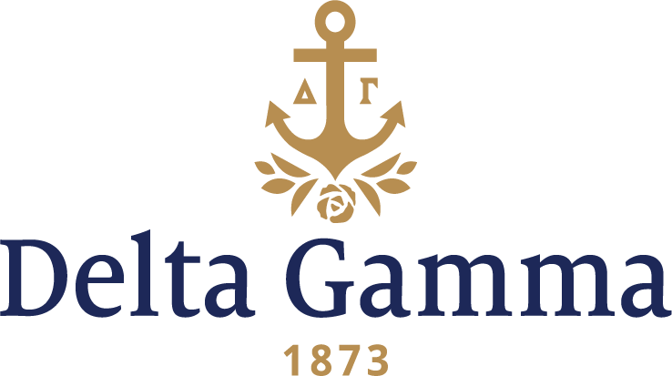

**Zeta Nu-Montevallo**

**Fast Facts:**

* Installation date: February 2, 1991
* Location: Montevallo, AL
* Region: 3

**History:**

The university opened in October 1896 as the Alabama Girls’ Industrial School (AGIS), a women-only technical school that also offered high school-level courses. AGIS became the Alabama Girls’ Technical Institute in 1911, further adding "and College for Women" in 1919. The school gradually developed as a traditional degree-granting institution, becoming Alabama College, State College for Women in 1923. The school became coeducational after lobbying by the school's supporters resulted in the Alabama Legislature passing a bill on January 15, 1956 to remove the designation "State College for Women". The first men entered the school that same month. On September 1, 1969, Alabama College was renamed the University of Montevallo.

Delta Gamma first wrote to the University of Montevallo in February of 1988 expressing interest in establishing a chapter. Two years later the university invited a new Panhellenic Conference chapter to establish. At the time, there were four NPC groups on campus, and all four were over chapter total and too large for their chapter facilities.

In April 1990, Delta Gamma was asked by the university to be one of three groups to make a presentation to the selection committee. Delta Gamma was the overwhelming choice. The Birmingham alumnae were delighted to become the new chapter advisors. Patsy Harbour Martens, Delta Lambda-Mississippi State, was appointed by Council as coordinator of the establishment efforts.

On September 26, 1990, 58 young women attended an open house party held in the Student Union Building in Farmer Hall. The following day, 52 young women were interviewed individually by the colonization team. That night, 45 women were invited to attend the preference party. Members from Gamma Alpha-Tennessee conducted a lei ceremony. On September 29, 40 bids were extended, and all were excepted. That afternoon, the pledge ceremony took place. The excitement of the charter members was shared with the local alumnae, faculty members, and Panhellenic representatives.

On Saturday, October 6, 1990, Zeta Nu held its first retreat. Colony Development Consultant Beth Bell Searcy, Epsilon Gamma-Virginia lead the activities. The retreat took place at the lake house of Jamie Davis in Pell City. This day was set aside to learn about Delta Gamma and to become better acquainted with each other as sisters.

Zeta Nu’s first social events included a mixer with Chi Omega on October 2, a pool party with the brothers of Pi Kappa Alpha in mid-October, and a boxers mixer with Pi Kappa Phi on November 19. The “twin” party was held on October 22. The purpose of “twins’ was to give the girls a special sister since “Big Sisters” were not possible. The first winter formal was held at the Downtown Club on December 7; the theme was “Under the Mistletoe with Delta Gamma.”

Zeta Nu was very active in supporting the Foundation during the fall semester. A campus-wide “spec search” collected 62 pairs of eye glasses that were donated to the Eye Foundation. Letters were sent to our troops in the Middle East. Several members donated blood during the campus blood drive. During the Christmas season, Delta Gamma decorated a Christmas tree and participated in the Festival of Trees. Through this project, Delta Gamma raised $500 for the Alabama Children’s Hospital.

On February 2, 1991, Zeta Nu was installed as a chapter. The Initiation ceremony was held at Lakeside Baptist Church, and was conducted by the Council of Executive Offices, including the Fraternity President Marilyn Monroe Fordham, Nu-Idaho, VP Development Barbara Bartlett Probst, Gamma Upsilon-Wichita State and VP Alumnae Patricia Proctor Bradley, Beta Theta-Duke. A joint Installation banquet was held at The Club in Birmingham where both Zeta Nu and Zeta Xi-UAB were presented their charters.

Fall 1991 saw the Initiation of the Spring pledge class. Shortly thereafter, on September 9, Zeta Nu completed their first formal recruitment and gained 24 pledges.

On November 1, the women held the university’s first Anchor Splash®. With this, Zeta Nu became the 100th chapter to sponsor this fundraising event for the Foundation. Activities for the event included a banner contest and Most Beautiful Eyes, as well as several swimming events. Approximately $1500 was raised for Sight Conservation and Aid to the Blind.

Founders Day in 1992 was celebrated as a black-tie event at the Wynfrey Hotel in Riverchase. The event was to honor Art of the Eye, an art exhibit sponsored by Delta Gamma and the Birmingham alumnae. The art displayed was credited by individuals who were visually impaired, ranging in age from elementary school to adulthood. The exhibit was shown at the South Central Bell Headquarters Art Gallery in Birmingham from March 2-27.

In the 1992 fall semester, only after two years of being of campus, Delta Gamma had the largest pledge class on campus. In the spring of 1993, Delta Gamma was the largest sorority on campus and number one in scholarship.