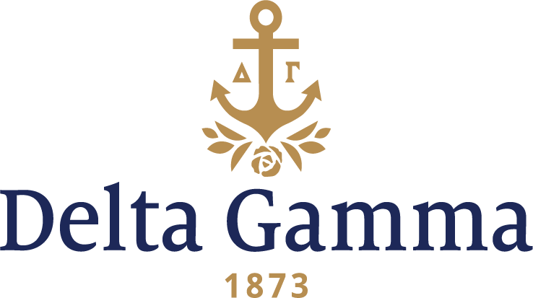

**Zeta Sigma- Northern Kentucky**

**Fast Facts:**

* Installation date: August 14, 1993
* Location: Highland Heights, KY
* Region: 2

**History:**

Northern Kentucky University began in 1948, when an extension campus for the University of Kentucky was opened in Covington, Kentucky, known as the UK Northern Extension Center. After 20 years in operation as an extension center for UK, it became an autonomous four-year college under the name Northern Kentucky State College (NKSC). The main campus moved from Covington to Highland Heights, Kentucky, in 1972. NKSC awarded its first bachelor's degrees in May 1973. Rapid expansion resulted in the school being upgraded to university status in 1976.

In the 1990s, Northern Kentucky was the only university in the state and local area whose rush numbers increased during the difficult economic times. Rush had increased each year by about 25%, and the fall of 1992 was the largest sorority rush they had at date.

The Panhellenic Council of Northern Kentucky had been interested in adding a fourth National Panhellenic Sorority for several years. At a September 1, 1992 meeting, the Council voted to pursue expansion through an interest group that was organizing- Sigma Gamma Tau. On October 3, 1992, seven women began the interest group Sigma Gamma Tau. They held their own rush during November 2-4, and increased to twenty women. Betty Mulkey, Student Organization Coordinator, helped the group organize. The letters SGT stood for Sisters Growing Together. The mascot was the giraffe signifying the desire to stretch themselves as college students and to stick their neck out for each other.

The networking began. It was at AFA in Washington that Betty Mulkey gave Fraternity President Marilyn Fordham an interest group profile booklet. On the last page was the quote “coming together is a beginning, keeping together is progress, working together is success.” David Strauss, The Ohio State University Greek Advisor, who was acquainted with both Delta Gamma and Northern Kentucky, highly recommended to both parties the expansion partnership. In December, Anne Gojdics, Coordinator of Expansion, and Mary Sterling, Coordinator of Resource Development, made an investigation visit to Northern Kentucky. Anne and Mary came back to Columbus impressed with the group.

The Delta Gamma expansion team made a presentation on February 5 with three collegians of Alpha Omicron- Miami participating. The invitation to colonize was received on February 17, and for the first time in the history of Delta Gamma a response was faxed by Barbara Probst, Vice President: Development. Her first sentence was “How would you like to wear the Greek letters ΔΓ!” The last sentence was “You will NEVER regret your decision to become members of one of the finest of ALL women’s fraternities… DELTA GAMMA!”

Colonization was held March 22-25, 1993. The colony held an informal rush and increased their numbers enough for a charter. With the help of members of Sigma Gamma Tau (future chapter members of Zeta Sigma chapter), and collegians from Delta Beta- Kentucky, the colonization team selected twenty- one women for membership, bringing the colony to a total of thirty-nine. The pledge ceremony and a reception were held on Thursday, March 25 at the University Center Ballroom. The president of the colony was Katie Heywood. Sue Kesterson, CAC, made the fourth-degree curtain for the chapter.

A shortened five-week pledge period led to initiation on August 14, 1993 when thirty-three women were initiated. A ceremony was held at the Quality Inn Riverview Hotel, overlooking the Ohio River and Cincinnati. Participation by five Council officers represented the Fraternity’s strong support of the new chapter. Local support of the chapter was demonstrated at the Friday night Inspiration Ceremony by the chapter advisers who had worked with colony members throughout their pledgeship. A beautiful Saturday morning held the chapter’s initiation of the thirty-three women. Upon installation, Zeta Sigma became Delta Gamma’s 134th collegiate chapter. At the Installation Banquet, held shortly after initiation, toastmistress Barbara Bartlett Probst, Vice President: Development, introduced special guests, including Northern Kentucky University President Dr. Leon Booth and his wife Nancy, Dean of Students Bill Lamb, and Student Organization Coordinator Betty Mulkey, among others. Marilyn Monroe Fordham presented the Zeta Sigma chapter charter and president’s gavel to Katie Heywood. A total of 117 guests were in attendance that weekend. One week later they held their first formal rush as DGs at Northern Kentucky University. Twenty-five women were pledged.