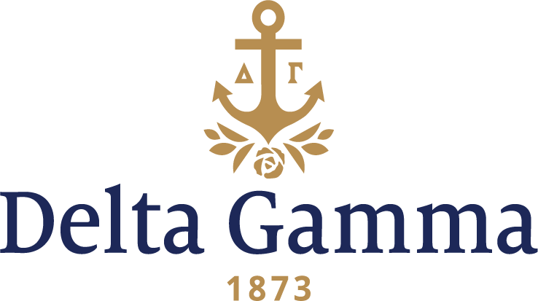

**Zeta Upsilon- Furman**

**Fast Facts:**

* Installation date: March 27, 1994
* Location: Greenville, SC
* Region: 3

**History:**

Furman Academy and Theological Institution was established by the South Carolina Baptist Convention and incorporated in December 1825 in Edgefield. With 10 students meeting at Edgefield, it held its first classes January 15, 1828, but moved to the High Hills of the Santee (now Stateburg, South Carolina) in 1829 because of financial difficulties. When the school was threatened with financial collapse again in 1834, the Reverend Jonathan Davis, chairman of the Board of Agents, urged the board to move the school to his native Fairfield County, South Carolina. It was not until 1851 that South Carolina Baptists were able to raise the necessary funds for the removal of the school to Greenville, South Carolina. After the 1991-92 academic year, Furman ended its affiliation with the Southern Baptist Convention and became a private, secular university.

On June 28, 1993, Executive Director Margaret Watkins received a letter from Carol Daniels, Advisor of the Inter-Club Council at Furman, saying that the university had changed its charter, and now allowed national Greek letter social fraternities and sororities on campus. All NPC groups were urged to take a look at the university’s system. Watkins replied positively and VP: Development, Barbara Probst, and staff coordinator, Anne Gojdics, explored the opportunity.

On November 23, 1993, Delta Gamma was invited to present on January 8-9, 1994 where 7 local groups were interested in interviewing Delta Gamma. Delta Gamma presented to 5 groups and the presentation team was impressive- 9 of the fraternity’s finest alumnae Cabinet and staff members, and the chapter president of Epsilon Kappa- Clemson.

A local organization, Nesedha, was founded by thirteen women on April 9, 1983, and was a group of sister stars. The Nesedha chapter was selected to become Zeta Upsilon of Delta Gamma and the colony formally established on January 10, 1994 with the pledging of 42 women. The formal petition was submitted February 10, 1994.

The colony members consistently ranked number one in scholarship on campus, and they exhibited an intense interest in community service.

On March 27, 1994, Zeta Upsilon chapter was installed at an Installation dinner at the Greenville Hilton Hotel, Greenville, SC. Fraternity President Marilyn Monroe Fordham presented the charter. Fifty-one collegiate members and nine Patronesses were initiated during the weekend ceremonies.

Delta Gamma’s success is recognized on the Furman campus; the sisterhood is known for its diversity, enthusiasm and genuineness. In 2014, the chapter celebrated its 20th year anniversary at Furman.

In 2014, the chapter celebrated when Chelsea Jasper won Greek Woman of the Year, Dainee Gibson won Greek Emerging Leader, Katherine Allenbach won Best Smile on Campus, and Marybeth Snodgrass won Club Sports President of the Year.