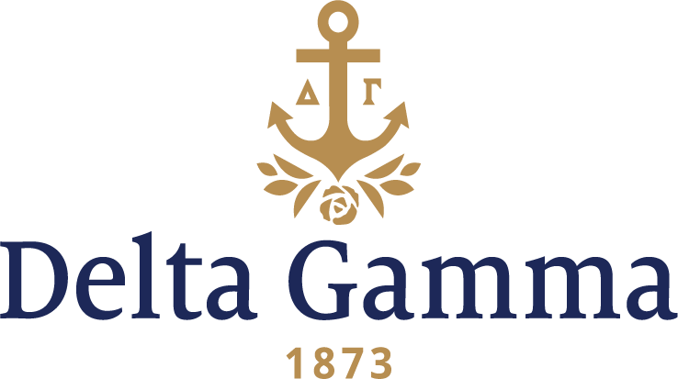

**Alpha Xi-West Virginia**

**Fast Facts:**

* Installation date: February 18, 1922
* Location: Morgantown, WV
* Region: 2

**History:**

The Morrill Land-Grant Colleges Act was passed in 1862 and signed into law by President Abraham Lincoln. This allowed federally controlled land to be granted to states for the purpose of establishing higher education institutions with a focus on agriculture and engineering. The West Virginia State Legislature voted on February 7, 1867, establishing the Agricultural College of West Virginia. The following September, the college opened to students. On December 4, 1868, the State Legislature passed an act that renamed the school as West Virginia University. The first Fraternity was established in 1890, and the first woman to graduate from the University did so in 1891. Today, WVU enrollment has reached nearly 30,000 students.

Members of Delta Sigma Sigma, a local sorority organized in 1918, petitioned Delta Gamma for a chapter just before the holidays in 1920. This enthusiastic group of women worked hard to establish the highest scholarship of the campus sororities, and a reputation for outstanding campus leadership. The Delta Sigma Sigmas rented the Nat Burdette house on Spruce Street and opened it as the new Delta Gamma house.

On February 18, 1922, the pledging of 38 girls took place in the morning under the direction of Alpha Chi-Penn State. That afternoon the pledges took Fraternity exams, and 31 women were initiated as charter members of Alpha Xi chapter. Mary Largent was elected the first president. That evening at 8 p.m., 66 people attended a beautiful banquet and the charter was received. Upon installation, Delta Gamma became the fifth national sorority on the campus. Local women and faculty wives acted as sponsors, including: Mrs. E.H. Knowlton, Mrs. Hubert Hill, Mrs. Samuel Morris, Mrs. Walter South and Mrs. S.H. Fielder.

A special bond was formed between the women of Alpha Chi and Alpha Xi chapters of Delta Gamma. Before leaving on Sunday afternoon, the Alpha Chis held a model fraternity meeting for the newly-installed chapter and the Dean of Women entertained them for a noon dinner in the women’s dormitory. They were treated to tea at a new patroness’s home before boarding the train back to State College, Pennsylvania.

On April 29, 1922, Initiation was held for eight women. The first official rush was held in the 1922-1923 year, and 13 women were pledged.

A house corporation was formed June 11, 1924, with Nell Landam Leonian as its first president. A second house was soon rented at 17 Grant Avenue in Sunnyside, where most of the fraternity and sorority houses were located at the time. The home housed 11 women, but was later sold for $15,00, torn down and a private dormitory was then built on the lot.

In the early ‘30s, the campus center was changing and a house at 581 Spruce Street was rented to house ten women and the housemother. By 1936, the size of the chapter made larger living quarters desirable. Few houses were available to rent, but a property located on Prospect Street became the home for 12 women and the housemother.

The university was expanding and talk of sororities building houses was big news. In 1930, Alpha Xi held a raffle for the first time to raise money for a new house. They raffled off a pewter cream and sugar set. In 1939, a group of Delta Gammas, with chapter member Elizabeth Allen as ring-leader, found the perfect lot for the new Delta Gamma house. With some maneuvering by Nell Leonian, the lot at 652 Price Street was purchased for $3500. Alpha Xi had only $1,200 to pay toward the lot, but with a loan from National Council and a local bank, Edward J. Wood and Son of Clarksburg was commissioned to design the house. Though the lot was purchased in March 1940 and the house started in the summer, it was not ready for occupancy in the fall as hoped. A house on College Avenue was rented for the school year. With pressure from the seniors, who were determined to live in the new house, they moved in during May 1941.

In an effort to get alumnae financial support, the Alpha Xi Newsletter was born. Each girl, when initiated, pledged to pay $100 to the House Corporation after she finished school. Many who had not paid their pledge did so with the reminders in the newsletters. In the ‘50s, class reunions at the Founders Day celebration promoted interest and reports of the get-togethers and gave others news of their sisters. In the ‘60s, a collegiate and alumnae newsletter really kept the women informed. By 1967, there were so many lost addresses and the cost of mailing was too high for the chapter to maintain the newsletter, and therefore it ceased printing.

In 1944, a group of women living in the house approached the house corporation about buying the lot immediately above the property, but money could not be raised. However, in 1954, the university acquired all the property around the Delta Gamma house. Dr. Stewart, president of the university at the time, was very cooperative and a trade of the lower side of the lot for the property just behind the house gave them a nicely sized parking lot. The deal included grading and gravel on the lot in exchange for permission for contractors to park equipment there during construction of Arnold Hall dormitory.

Throughout the years, Alpha Xi has been very involved in aiding those who are visually impaired. In 1950-51, alumnae were very helpful in raising money for the blind program. Some fundraising projects included selling gift napkins, address books, Christmas cards, wrappings, and children’s books. In 1955, thanks to the annual bridge benefit and a successful rummage sale, enough money was raised to pay the tuition of a student who was blind and enrolled in the College of Law. Another project was the purchase of a black Labrador retriever, Dugan. In the winter of 1968-69, the chapter held hoagie sales to raise money for Dugan’s training. During his disciplined four-month training program in Rochester, Dugan learned to be a pair of eyes, and was then assigned to a man who was blind that had previously lost his dog.

Alpha Xi held their first Anchor Splash® in the 1970s and raised thousands of dollars for the Monongalia Blind Organization in Morgantown. The money was also used to buy encyclopedias printed in braille. In 1983, money was spent on a computer to aide children who were going blind.

The quota system for sororities, and rapid growth of the university, made the house inadequate for housing only 20 women. In 1963, they planned to add rooms for fifteen more women, remodel and expand the living and dining rooms, add an adequate kitchen, new bathrooms and chaperone’s quarters. Work started as soon as school was out in the spring, but with unforeseen delays the women could not move in until November 9, 1963. In March 1964, the Founders Day banquet was held at the house and the addition was formally dedicated. The chaperone’s suite was furnished by special friends of Nell Leonian’s to honor her for her many years of service as house corporation president (1924-1950).

After the addition to the house in 1963, Dr. Paul Price had the stone wall (below the parking lot) built as a memorial to his wife, Helen Tapp Price. Also, at the time the house was built, Olivia Kendrick Hastie, paid for the crest which is embedded in the chimney facing Price Street. The anchor, which is displayed on the front lawn, was donated by the government. The anchor came off the U.S.S. West Virginia.

In the fall of 1964, Alpha Xi chapter had a first on the WVU campus and of all Delta Gamma chapters when they had houseparents as chaperones. At the suggestion of the Dean of Women, “girls don’t want the mother image when they come to college,” Barbie and Ralph Bean handled the new situation well. A trained manager, Betty Jo McWhorter, was hired to take care of running the house, and Mary Toth became the official cook.

In April 1984, the alumnae of WVU and Alpha Xi had their first reunion in a long time. The local alumnae planned and organized a Founders Day weekend for the collegians. More than 270 alumnae came to see the burning of the mortgage on the house. As a special guest speaker, Maggie Hess Watkins came from Executive Offices to speak in front of her Alpha Xi sisters.

2002 was a large year in which the chapter celebrated its 80th anniversary with homecoming weekend honoring the chapter’s alumnae; they took a big step into the future with the commissioning of a chapter website; and the chapter room was updated with new paint and upholstery, and the chapter recreation room was also updated with new furniture, paint and a new television. Also, Alpha Xi noted alumnae Margaret Hess Watkins, former Delta Gamma Executive Director, and Betsy Inch Fouss, former Delta Gamma Executive Director, were honored for their outstanding membership by being presented a certificate which stated that Alpha Xi chapter had created a fully funded honorary scholarship for its current and future members in their names.