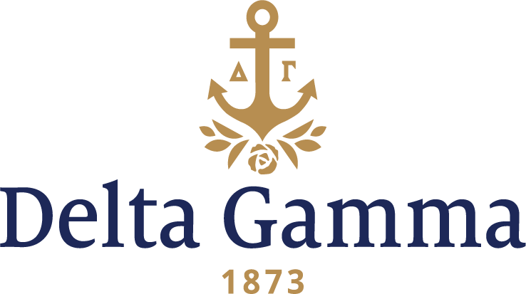

**Epsilon Tau-Central Florida**

**History:**

Epsilon Tau is our E.T. chapter, having been assigned the Greek letters when the movie was as popular as it is today.

Delta Gamma was on file as being interested in with what was then Florida Technological University as early as 1975. Several years of contact between Delta Gamma and the university followed laying the groundwork for expansion.

The Central Florida alumnae were thrilled when Delta Gamma received a letter from the University of Central Florida in April, 1984 from the Panhellenic President and Assistant Dean of Students stating the need for a new national group due to the rapid growth of enrollment. The letter also mentioned the development of Greek Park with 21 lots available for lease from the university by the Greek organizations.

Delta Gamma was one of five NPC groups asked to make an official presentation. Patty Danielson, who led the presentation team as National Panhellenic Conference Delegate, said: "EVERYTHING about this site is positive for Delta Gamma...fine institution, growing enrollment, supportive administration, enthusiastic alumnae, capable PCC, supportive Panhellenic, good rush numbers, etc."

June 7, 1984: "The Panhellenic Council at the University of Central Florida invites the Delta Gamma Fraternity to colonize on our campus. The presentation was most impressive, and we feel Delta Gamma will be a valuable addition to our Panhellenic system."

Colonization started Monday, September 24 with information parties and ended on Saturday, September 29 with the pledging ceremony. The colonization team was June Weaver, NPC delegate, Maureen Syring, Fraternity Vice-President: Membership, Patty Danielson, and Lou Ann Sommers, Staff Expansion Coordinator. Members of the Orlando alumnae chapter and Gamma Theta chapter assisted. Hurricane Isadora arrived on Thursday, September 27, but the colonization proceeded as planned. This was the first colonization at the university as the other groups had pledged locals.

The quality of the women that interviewed for the colonization was outstanding! On Saturday, 33 girls were officially pledged. Six other women who signed Preference sheets were scheduled for a later pledging. Following the ceremony, the group went outside with helium balloons to do a "wish and release" ceremony. Colony Advisory Board Chairman was Sue Abraham, House Corporation and Installation Chairman was Betty Shaw, and the Council Appointed Coordinator was Charlene Wieteska. Tami Balding, Field Consultant, was assigned to work with the colony for two weeks.

An inspiration ceremony was held Friday night, January 25, 1985 at the home of Peggy Green, rush adviser. The poem, "I am a Delta Gamma" was read by Maureen Syring who presented the president's pin on behalf of the Clearwater Alumnae Chapter and asked that it be passed around the room with each person briefly telling what Delta Gamma meant to her.

Saturday morning, January 26, 1985 initiation was held at the Marriott Inn, Orlando Airport. Delta Kappa and Epsilon Theta members jointly performed the ceremony. Epsilon Theta chapter officers performed the ritual, and Delta Kappas acted as sponsors (along with four Gamma Mus) for the 29 charter members.

An installation luncheon, described as "pure joy" by Maureen Syring, was held following the ceremony. Throughout the program, referrals were made to the E.T. theme. Carol Lambdin, former Clearwater President, presented each initiate with a hand painted pin box on behalf of the Clearwater alumnae.

A reception for the campus and other friends was held after the luncheon.

On August 14, 1988 Epsilon Tau moved into their new 7,000 square foot house situated on 1.66 acres.

The chapter organized their first Anchor Splash in the fall of 1984. It continues to be a chapter tradition.