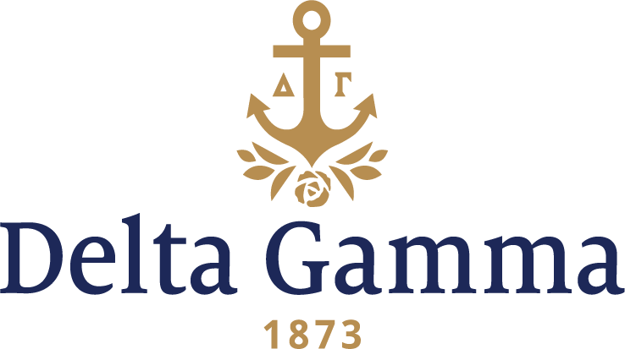

**Gamma Psi-Emory**

**History:**

Delta Gamma's interest in Emory goes back to 1953 when it was rumored that women would be admitted. In 1955 two Delta Gamma transfers from Florida State organized the "Anchora Club" with the intention to petition Delta Gamma for membership as soon as university requirements were met.

Gamma Psi was the first Delta Gamma chapter in the state of Georgia. The chapter was a part of the largest sorority installation ever held. Ten Panhellenic groups were installed on May 8, 1959.

The highlight of the first year as Delta Gammas was placing first on campus in scholarship. For this the chapter was honored with a scholarship award at the 1962 Convention.

The spring 1965 ANCHORA reported Gamma Psi as the first Greek group on campus to honor the Emory administration. With the help of the Atlanta alumnae, an elaborate tea was held at the Panhellenic House and was attended by 400 persons.

Regarding the withdrawal of the charter on March 1, 1968, "Council has been most impressed with the cooperativeness of this chapter; nevertheless, the character of the campus and lack of progress on housing has made this move necessary."

The effort to bring Delta Gamma back to Emory originated with the Panhellenic Council's determination that another group was needed on campus. Four organizations were asked to present, and Delta Gamma was selected.

Reinstatement of Gamma Psi chapter, and initiation of the colony members, were held on October 21, 1989. Maureen Syring, Fraternity President, presided at this event. Also in attendance were Delta Iota collegians who assisted with the initiation ceremony, twenty-nine Atlanta alumnae, including five Gamma Psi alumnae, and the president of the chapter when the chapter was withdrawn. It was an emotional day for new and old Gamma Psi members.

The 1990-91 year ended with first place in Sigma Chi Derby Week, and the Greek Positive Image, Most Improved Chapter, Best Sorority President, and Best Sorority Adviser Awards.

Foundation activities included making tactile books, babysitting, and holiday parties for children from the Center for the Visually Impaired. The chapter also sponsored Delta Gamma Vision Week - It's Worth Seeing! The week included reading to a graduate blind student and conducting campus vision screening. Anchor Splash was an annual chapter activity enjoyed by many on campus. The 1993 Anchor Splash raised $2,000.