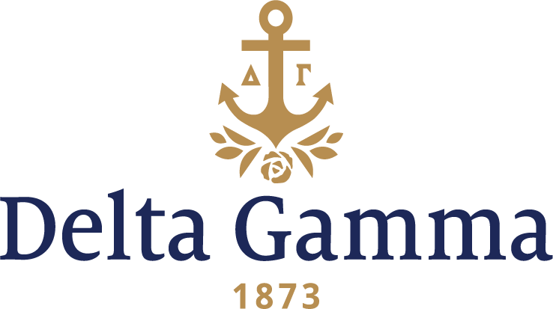

**Zeta Rho-Ohio University**

**History:**

Ohio University, founded in 1804 in Athens, was the first university in the State of Ohio and the Northwest Territory. The university became coeducational in 1868 and graduated the first woman in 1873.

Delta Gamma had been interested in Ohio University as a future expansion site for several years. Petitions for a chapter were received from women at Ohio University in 1897 and 1908. However, it wasn’t until 1991 that the Ohio University Panhellenic Council made the decision to add another sorority to the campus. Delta Gamma and Kappa Kappa Gamma were selected from eight applicants to make a presentation to the Council. The official letter inviting the fraternity to colonize arrived at Executive Offices on January 29, 1992.

Over three hundred women showed up for the Delta Gamma rush parties during the fall quarter. A pledge class of 153 women was selected and was pledged on Saturday morning, October 3 in the Baker Center’s 1804 Lounge. This was the largest colony pledge class in the history of Delta Gamma at the time.

On October 4, 1992, the Zeta Rho colony met for the first time. Susie Hoyt, Council Appointed Coordinator, led the meeting with the help of Tracey Doebling, Collegiate Development consultant. Tracey maintained an apartment in Athens and spent most her time working with the colony members. Kim Armstrong, a senior, was elected Colony President.

Several weeks after colonization the women of Zeta Rho were excited to hear that the Fraternity Housing Corporation had purchased the Stalder home at 40 North College Street as their chapter house. This house on sorority row was the very house Delta Gamma representatives looked into as a housing possibility in 1966 on an expansion visit at the university. Built circa 1880, the building is part of the Ohio Historic Inventory of historic homes and considered an Athens Landmark.

On March 6, 1993, one hundred twenty-one collegians and six patronesses were initiated as charter members of Zeta Rho chapter. The lovely ceremony, conducted by Fraternity President Marilyn Monroe Fordham, was held in Galbreath Memorial Chapel followed by a luncheon at Nelson dining hall where the charter was presented to Kim Armstrong.

Between colonization and initiation, the new colony was very active on campus, participating in Homecoming and philanthropy events. After initiation, they held their first Anchor splash in May and participated in Greek Week. They pledged 25 more women in their first informal rush that spring. Maintaining a 3.10 grade point average, the chapter numbered 146 members and Merideth Greschuk was elected President before the end of the 1993 school year.

Local alumnae who helped in establishing the new chapter were: Nada Smith Kerr, Epsilon, the enthusiastic supporter of expansion at Ohio University dating to 1966; Marlene Rudy, Gamma Epsilon, wife of Joel S. Rudy, Dean of Students, who organized a new alumnae group; and Jan Lavery, Alpha Lambda, the first Advisory Board Chairman.

By 1996 Zeta Rho was well established on campus. The chapter boasted Panhellenic Vice President, three members on Greek Program Board and three named fraternity sweethearts. They won first place in OU’s Greek Week and pledged 47 new women during fall recruitment. This class of new members surprised the Zeta Rho chapter by providing the gift of an official ship’s anchor for the lawn of their chapter house.

Strength and leadership has continued throughout the years with the chapter having initiated 1,066 members since 1991 As a past president said, “Zeta Rho definitely takes pride in what we have become and where we are headed.”