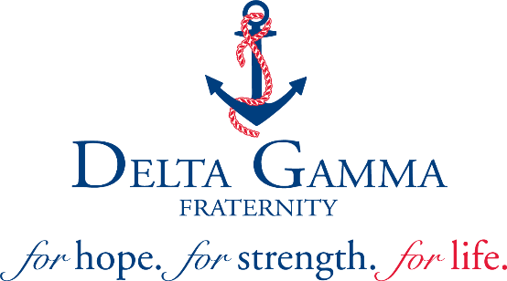

Chapter Visit Report

Date of Visit:
Region:
Chapter-School:
Chapter Status:
Reason for visit:

Meetings Attended:
 | General House/Chat Session with Chapter |  | CMT
 | New Member Meeting |  | Honor Board
 | Advisory Team |  | HC Board
 | Alumnae Group |  | Fraternity/Sorority Adviser
 | Other:

Officer Reports: Strengths
President
(CMT operation, committees, officer transition, overall chapter operations)
vp: social standards
(Risk management and programming, Honor Board, events)
vp: finance
(Procedures, budget, officer contracts, APNs/SORs, DRS)
vp: communications
(BLSR, roster updates, PR plan, social media, chapter brand and relations)
vp: programming
(Calendar, sisterhood events, chapter retreat, required programming)
vp: member education
(Member education, new member pursuit, scholarship programming/awards, formal/informal rituals)
vp: membership
(Recruitment, COB, Recommendation, MSC, retention)
vp: Panhellenic
(Community image, interfraternal relations, FSA, community programming)
vp: Foundation
(Foundation Awareness, service opportunities, fundraising)
Advisory Team
(Number of advisers, adviser training, advisory/collegiate relationship)
Chapter (overall)

Officer Reports: Areas for Improvement
President
(CMT operation, committees, officer transition, overall chapter operations)
vp: social standards
(Risk management and programming, Honor Board, events)
vp: finance
(Procedures, budget, officer contracts, APNs/SORs, DRS)
vp: communications
(BLSR, roster, PR plan, social media, chapter brand and relations)
vp: programming
(Calendar, sisterhood events, chapter retreat, required programming)
vp: member education
(Member education, new member pursuit, scholarship programming/awards, formal/informal rituals)
vp: membership
(Recruitment, COB, Recommendation, MSC, retention)
vp: Panhellenic
(Community image, interfraternal relations, FSA, community programming)
vp: Foundation
(Foundation Awareness, service opportunities, fundraising)
Advisory Team
(Number of advisers, adviser training, advisory/collegiate relationship)
Chapter (overall)

Visit Summary:
Note any areas for follow-up, needs for CDC, and include the regional team’s plans/recommendations.

