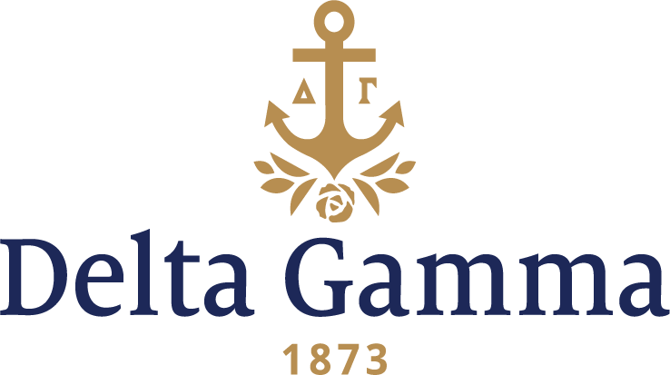

Request for Service Animal in Training Waiver

Policy: Service Animals - Delta Gamma house corporations prohibit animals and pets on the chapter property, including the house and grounds. Service animals in training are permitted on chapter property, subject to the oversight of the chapter management team and the House Corporation. Service animals include guide dogs, signal dogs, or other animals individually trained to do work or perform tasks for the benefit of an individual with a disability. Only one service animal in training at a time is allowed to be on chapter property. Waivers to this policy may be granted by the Council.

Submit to: The Office of Housing/FHC at DGhousing@deltagamma.org

Due: At time of the completion/signing of the rooming agreement or at least 4 weeks prior to the date the service animal will be on the property.

Name:

Chapter/House Corporation:
School/University:

Address:
City:
State/Province:

Zip Code:
Phone Number:

Email:

- Housing Accommodation:
House
Lodge
Annex
Apartment
Other
If other, please explain:

- Ownership:
House Corporation
Landlord
University/College

- Is the house director on site? Yes No

- Do you have a signed Room Agreement? Yes No

- Type of Service Animal in Training (Breed, Species):

- Period of time Service Animal in Training would be on property:

- Organization sponsoring the training:

- Type of training that will be conducted with the Service Animal:

- Documentation attached from the organization sponsoring the training, certifying that this animal has been approved to participate in the program. Yes No

- Service Animals in Training must be supervised at all times. If left unattended in a room, it must be properly crated or properly contained.

- The individual in charge of the service animal is responsible for the proper removal of all animal waste.

- This request may require you to pay full rent for a single occupancy room. If a single occupancy room is not available, you may be required to pay the full cost for a double occupancy room.

- This request may be reevaluated and/or denied at a future date if it imposes an undue financial and administrative burden, or it if will fundamentally alter the nature of the housing services, or if it is no longer reasonable.

- Any additional information:

I have read, understood, and agree to the foregoing conditions of this waiver.

I agree to indemnify, hold harmless, and defend Delta Gamma Fraternity, Delta Gamma Office of Housing, Delta Gamma Fraternity Housing Corporation, the local House Corporation, the local Chapter, and/or Delta Gamma's agents against all liability, judgments, expenses (including attorney's fees), or claims by third parties for any injury to any person or damage to property of any kind whatsoever caused by my Service Animal in Training.

Signature:
Date:

