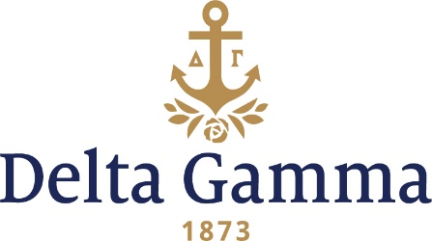

Waiver Application for Social Events with Alcohol with Adjusted Venue

Questions or Concerns - Please contact your Operations Coordinator at Executive Offices:

Jordon Ratliff | All Regions | jordon@deltagamma.org
The purpose of this form is to determine if your chapter is eligible for a specific procedure waiver as outlined below, and to provide a written request for the waiver, including supporting documentation.

For the purpose of this form, “Adjusted Venue” shall be defined as the public areas of men’s fraternity facilities which are Inter/Nationally recognized as a chapter house and insured by the Inter/National organization. This does not include annex houses and unofficial fraternity facilities.

Note: Delta Gamma chapters are prohibited from holding events with organizations that are not recognized by the College/University that hosts the chapter or the chapter’s Inter/National Organization.

Deadline to Submit: This form is to be completed on a rolling deadline and submitted to your Operations Specialist at Executive Offices (see email addresses above). Approved waivers are re-evaluated each year.
Chapter: ___

School: ____

Term start date (or date of first event, whichever earlier): Month /Day /Year

Date form submitted: Month /Day /Year

As the College/University official who advises the Fraternity and Sorority Community, I am confirming that the collegiate chapter president has reviewed this waiver with me and I certify that (choose one):
Yes, the College/University policies, IFC/NPC policies and the college Panhellenic policies allow/do not prohibit an event such as the aforementioned Delta Gamma Fraternity adjusted venue event.
No, the College/University policies, IFC/NPC polices and/or the college Panhellenic policies do not allow/prohibit an event such as the aforementioned Delta Gamma Fraternity adjusted venue event.

Name of College/University official: __

Signature of College/University official: ___________________ Date: ____________

Title: __
E-mail Address: ___ Phone Number: ___

Please submit the following application materials along with this form:

Attach a copy of the 1) College/University’s, 2) college IFC/NIC’s and 3) the college Panhellenic’s policies on events with alcohol and risk management with this application. These policies should be detailed and include information about events with alcohol in men’s fraternity facilities. If any of the aforementioned parties have no policy regarding events with alcohol please attach a written letter from the appropriate College/University official to confirm.

Additionally, the chapter should submit a letter of justification stating why a waiver is necessary for the chapter. This should include detailed information regarding why waiving this procedure will allow the chapter to better manage its risk associated with events with alcohol and how this waiver would better accommodate your campus culture. This is due with the rest of the waiver application materials.

A procedure waiver may be granted to a chapter ONLY if the chapter is able to demonstrate that the College/University and the Fraternity and Sorority governing bodies have a policy which meets Delta Gamma’s adjusted venue procedure or that no prohibitive policy exists. The granting of a waiver is at the discretion of your ATC, RCS, RD, CDS, and Operations Specialist. This application will be re-evaluated each academic year and the chapter will be notified each year regarding their approval status.

As chapter president, my signature indicates that I believe the chapter can handle the increased responsibility associated with this privilege.

Name (Chapter President): ____

Signature (Chapter President): ____________________ Date: __

E-mail Address: ____

As ATC, my signature indicates that I believe the chapter can handle the increased responsibility associated with this privilege.

Name (ATC): ___

Signature (ATC): ________________________________ Date: ___

E-mail Address: ___

