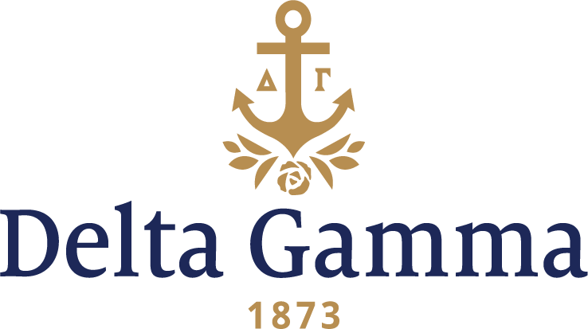

**Alpha Lambda-Drake**

**Fast Facts:**

* Installation date: April 30, 1921
* Location: Des Moines, Iowa
* Region: 5

**History:**

Drake University was founded in 1881 by George T. Carpenter, a teacher and preacher, and Francis Marion Drake, a Union General in the Civil War. Drake was originally affiliated with the Christian Church (Disciples of Christ) although no religious affiliation is officially recognized today. The first classes convened in 1881 with 77 students and one building constructed, Student's Home.

In 1883 the first permanent building, Old Main, was completed. Old Main remains an important building on campus today, housing administration offices, Levitt Hall and Sheslow Auditorium; the site of many United States Presidential Debates, among other events. In 1920, due to a housing crisis, the university allowed social fraternities to use Greek letter emblems and affiliate with national offices.

In February 1920, as soon as the university approved affiliation with national groups, Iota Alpha Omega, a local group founded in 1906, petitioned Delta Gamma under the sponsorship of Des Moines alumnae chapter. This local group had been interested in Delta Gamma for several years as many IAΩ members had joined Delta Gamma after transferring to other universities. Two other Drake locals were petitioning Kappa Kappa Gamma and Kappa Alpha Theta.

Representatives of Delta Gamma, Kappa Alpha Theta and Kappa Kappa Gamma met during the summer in Chicago and agreed that in the event each of the national organizations accepted petitions from the local groups, the "three fraternities will enter Drake together if at all." The agreement was made to "demonstrate that there is democracy and cooperation among fraternities."

On March 23, 1921, the president of Des Moines alumnae chapter received a telegram which announced, "Drake petition granted; congratulations to all." That evening the members of Iota Alpha Omega received ribbons of bronze, pink and blue.

Saturday morning, April 30, 15 members were initiated at the home of Louise Brockett Weitz, Tau-Iowa. Assisting in the installation were 25 collegians from Tau- Iowa, two from Alpha Kappa-Washburn, two from Kappa-Nebraska, and four from Alpha Epsilon-Washington. A joint Panhellenic Tea was held in the afternoon in the Cotillion Ballroom. Chi Omega was also represented at the reception as it had announced affiliation with a local just one week before the installations. An installation banquet was held that evening at Hotel Fort Des Moines. The Alpha Lambdas "donned cunning little tangerine caps in the shape of ducklings with long black bills" and the toastmistress announced that "Drake and the Little Ducklings had arrived at the Smiling Pool of Delta Gamma in the Green Forest of the fraternity world."

From the June 1921 *ANCHORA*: "Never did a chapter of Delta Gamma start under happier auspices than has Alpha Lambda. Think of a new chapter with a readymade, thoroughly organized group of alumnae standing ready to back it on all occasions. Think of an installation banquet at which fourteen chapters are represented, and think of installing on the same day as Kappa Alpha Theta and Kappa Kappa Gamma with the very best of Panhellenic spirit existing."

Alpha Lambda has been housed in nine residences. In 1944 they leased the Peak Mansion at 1080 22nd Street. It included one dozen ceramic-tiled bathrooms, a master suite with fireplace, a large

coach house and a portico supported by four Corinthian columns. The March 1947 *ANCHORA* featured this house on the cover.

Campus traditions include "Sweetheart Sing," a competitive songfest started in 1935. Alpha Lambda has won this event several times, and was the winner of the sorority division the first two years.

The Betty Haskins Memorial Award was established in 1938 to honor Mary Elizabeth Haskins, Alpha Lambda's 10th president, who died shortly after graduation.

Anchor Splash®, a popular campus event, was first hosted by Alpha Lambda in the spring of 1978.

In their nearly 100 years at Drake, members of Alpha Lambda chapter have built a strong legacy of academic excellence, campus involvement, leadership, sisterhood and service. They are currently one of Drake’s largest sororities and consistently hold a sorority GPA above the Panhellenic average and the all university average. Throughout their history, Alpha Lambda has been one of the strongest chapters in Drake University's fraternity and sorority community. In fall 2015, they raised more than $10,000 during their philanthropy event benefitting the Delta Gamma Foundation and Service for Sight.