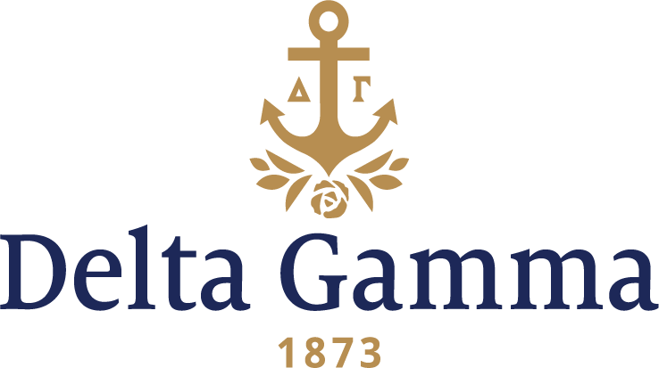

**Alpha Pi-Arizona**

**Fast Facts:**

* Installation date: October 7, 1923
* Location: Tucson, AZ
* Region: 6

**History:**

*The University of Arizona*

“Our University is one of the youngest of the state Universities, opened to students in 1891, and has as its head, Dr. Marvin, the youngest college president in the United States. Tucson is a city of twenty-seven thousand inhabitants, while the enrollment for this year is about fifteen hundred. This University has enjoyed the most rapid growth of any state University during the last ten years, an increase of 97%. Its location favors the development of a school for Mines and Departments of Astronomy and Spanish. Our campus is a new field for national fraternities, the first woman’s fraternity having been placed here only six years ago. We have in order of their installation: Pi Beta Phi, Kappa Alpha Theta, Kappa Kappa Gamma, Gamma Phi Beta and Chi Omega. The men’s fraternities in the same order are: Kappa Sigma, Sigma Alpha Epsilon, Sigma Nu, Sigma Chi and Phi Delta Theta.”

-Wandyne O’Connor, ‘24

From the November 1923 *ANCHORA*:

“Miss Blanche Garten, Kappa-Nebraska, Fraternity Installation Officer, and Miss Flora Munger, Zeta-Nebraska, arrived late Wednesday night, and Miss Lillian Titcomb, Upsilon-Stanford, secretary of Province VII, came the next morning. In the afternoon these ladies with the Delta Gammas of Southern Arizona held the pledging service at the home of Mrs. J.F. McKale, Zeta-Albion. Dr. Titcomb gave us our fraternity examinations that night. On Friday at our installation ball we Pi Alphas proudly displayed our bronze, pink and blue pledge ribbons; this was truly a “pledged dance.” The feature of the evening was a solo “The Omega Toast” accompanying the unveiling of a golden anchor with bronze, pink and blue-ribbon streamers.

But this dance did not cause as much excitement as dances usually do, for it was overshadowed by the approaching initiation ceremony. The alumnae practiced all morning at Mrs. McKale’s while we grew more and more nervous. We were really to get what we had worked for and dreamed about so long. We could hardly realize it. Every alumna of Alpha Gamma (the local sorority that petitioned Delta Gamma for a charter) was back; one even coming from Honolulu, so the approaching ceremony had more meaning for this reason. We went through the service which means so much to all of you and to us with a feeling of awe. Our anchors symbolize a great deal to us who have worked so hard to wear them. At the installation banquet we all relaxed and were entertained by the visitors and town Delta Gammas who arranged all the details of the party. The toasts made us realize that we were in the bonds of Delta Gamma and that these bonds would strengthen with the years.

Mrs. Wright entertained the following morning at a breakfast at her unique and beautiful home on the desert. We cannot describe it to you. Pueblo style, on the Arizona Desert—there is no desert like it—it overlooks the deep canyon of the Catalina Mountains. Our visitors were able from that vantage point to know the real Arizona.

The afternoon gave an additional opportunity to see another typical scene, the old Spanish mission of San Xavier del Bac. A little later we were bidding goodbye at the station to our sisters whom we had known such a short time but knew so well.”

In 1927, Alpha Pi won the University Scholarship Cup for having the highest-grade point average on campus for three consecutive years. The 1940s held the first annual alumnae-pledge dinner and alumnae-senior dinner. The 1950s saw the first annual Delta Gamma Shipwreck party, the first annual party for children from the Arizona School for the Deaf and Blind, and the Province X Scholarship Improvement Award in 1956. The 1960s began the Red Wart tradition when graduating seniors “initiate” the juniors into their senior year. The seniors arrive at one of the meetings with red noses and capture all the juniors. When the juniors return they also have red noses.

The chapter celebrated its fiftieth anniversary, and fifteen charter members and seven founders returned to Tucson to celebrate the chapter’s fiftieth anniversary. Dorothy Betts Marvin received the Order of the Delta Gamma Rose in 1973 for her work as a club administrator, civic leader and author. In 1974, the chapter received a certificate of appreciation from the Joseph P. Kennedy Foundation for work with Special Olympics.

Alpha Pi held their first Anchor Splash® in April of 1982.

Alpha Pi received the first-place Most-Improved GPA from Dean of Students 1992-93. In 1995, they teamed up with Beta Theta Pi to Adopt-A-Highway.

1998 was a big year. Alpha Pi celebrated 75 years as a Delta Gamma chapter, and supported the Delta Gamma Foundation with funds raised from Anchor Splash®, car washes and judging a baby pageant. They also donated money towards a liver transplant, participated in vision screening, and received the Province 17S Outstanding New Member Program Award & Excellence in Rush Award.

The 2000s were full of excitement. Alpha Pi continued Anchor Splash® in the fall, and held Anchor Slam in the spring, and then Anchor Ball in 2002. They also volunteered for Service for Sight projects, and collected eyeglasses and toys for “Toys for Tots.” Members participated in: Eller Scholars, Project Soar, Project Shine, cheerleading squad, Arizona Angel Football, Recruitment Hostess, Resident Hall Government, AZ Rugby team, and Junior Greek Woman of the Year in 2002.