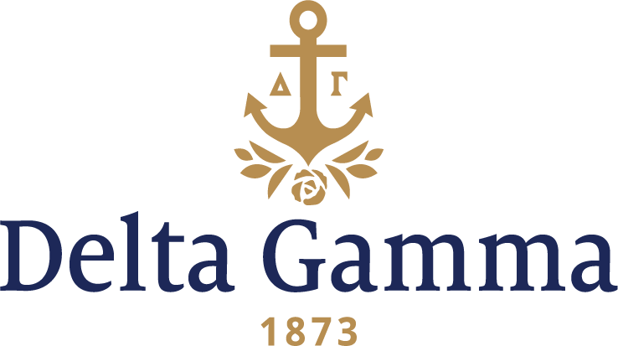

**Beta Epsilon-American**

**Fast Facts:**

* Installation date: March 21, 1936
* Location: Washington, D.C.
* Region: 2

**History:**

American University was chartered by Congress in 1893. Epsilon Kappa organized itself on the campus of American University on November 25, 1929, and then in 1935 began petitioning Delta Gamma for a charter. They were granted a charter in 1936 with eight members. On March 21, 1936, an installation banquet was held for 39 initiates at the Shoreham Hotel with about 125 participants. A tea followed on Sunday at the Sulgrave Club with nearly 400 guests in attendance. Members of Omicron-Adelphi, Rho-Syracuse, Chi-Cornell and Psi II-Goucher chapters and Baltimore, New York, Philadelphia and Washington alumnae chapters were present at the Installation, and many “braved devastating floods to attend.” Marguerite Winant, Omicron-Adelphi, was the Fraternity President at the time and presided over the Installation.

Beta Epsilon’s first meeting room was in Gray Hall (a women’s dorm). Campus sororities were later moved to suites in the Letts-Anderson dormitories.

Beta Epsilon is the 49th chartered chapter of Delta Gamma Fraternity, and was the first Delta Gamma chapter in the District of Columbia. Beta Epsilon was the second National Panhellenic Conference group on campus; Phi Mu was the first. Beta Epsilon participated in the installation of Beta Rho-George Washington and Beta Sigma-Maryland.

In 1944, 12 Beta Epsilon women sold stamps to raise money for the war totaling $2,219. In 1947, the dean of women confided to alumna, Frances Lewis Stevenson, Zeta-Albion, a field secretary at the time, “Every girl who went through rush at AU this fall put Delta Gamma down as her first choice.”

Beta Epsilon boasts their involvement in intramural sports, social events and commitment to service as high points of their chapter on the chapter website.